

Appendices

Table of Contents
Appendix A: Email Logs 2
Appendix B: Meeting Minutes 73
Appendix C: Analysis Diagrams 89
Appendix D: Project Management 94
Appendix E: Economic Feasibility Analysis 108
Appendix F: Tracking Gantt Chart 115
Appendix G: Security Policies 118
Appendix H: Data Flow Diagrams (DFD) 148
Appendix I: IDEFO Diagrams 156
Appendix J: Use Case Diagrams 160
Appendix J: Use Case Description 165
Appendix K: Legends 171
Mavs
May 13, 2019 – June 15, 2019


Appendix A: Email Logs

Group Clarification
3 messages

Christopher Kozeny <ckozeny@unomaha.edu> | Mon, May 13, 2019 at 12:15 PM
To: Erik Eiler <eeiler@unomaha.edu>, John Manzo <jmanzo@unomaha.edu>, Joe Cremeens <jcremeens@unomaha.edu>
Hey Guys,

I just wanted to get an idea of a group name for us. I was going to send the email to Dr. P with our group name, members, and contact information but wanted to clarify this first.

Something simple works for me, such as:
Mavs
Team Hardware
Database Dudes (Lol)
etc, etc...

Let me know if you like any of these or have any ideas, since honestly it's arbitrary what we pick anyways.

Thanks
Cj

John Manzo <jmanzo@unomaha.edu> | Mon, May 13, 2019 at 12:29 PM
To: Christopher Kozeny <ckozeny@unomaha.edu>, Erik Eiler <eeiler@unomaha.edu>, Joe Cremeens <jcremeens@unomaha.edu>
Keeping it simple is fine with me—“Mavs” works. Otherwise, I defer to group.
John

Joe Cremeens <jcremeens@unomaha.edu> | Mon, May 13, 2019 at 12:46 PM
To: Christopher Kozeny <ckozeny@unomaha.edu>
Cc: Erik Eiler <eeiler@unomaha.edu>, John Manzo <jmanzo@unomaha.edu>
I'm good with "Mavs" too, if no one has a preference!

Group Project: "Mavs"
2 messages

Christopher Kozeny <ckozeny@unomaha.edu> | Mon, May 13, 2019 at 2:50 PM
To: Leah Pietron <lpietron@unomaha.edu>
Cc: John Manzo <jmanzo@unomaha.edu>, Joe Cremeens <jcremeens@unomaha.edu>, Erik Eiler <eeiler@unomaha.edu>
Hello Dr. P,

My team and I have congregated and made some decisions. Firstly, our team name will be denoted simply as "Mavs," which will consist of the following members:

Christopher Kozeny
ckozeny@unomaha.edu

John Manzo
jmanzo@unomaha.edu

Joe Cremeens
jcremeens@unomaha.edu

Erik Eiler
eeiler@unomaha.edu

Please let me know if you have any questions or concerns, as I will be the Milestone Manager for this first upcoming Milestone.

Thanks,
Cj

Leah Pietron <lpietron@unomaha.edu> | Mon, May 13, 2019 at 3:44 PM
To: Christopher Kozeny <ckozeny@unomaha.edu>
Cc: John Manzo <jmanzo@unomaha.edu>, Joe Cremeens <jcremeens@unomaha.edu>, Erik Eiler <eeiler@unomaha.edu>
Thanks

Get Outlook for iOS

From: Christopher Kozeny <ckozeny@unomaha.edu>
Sent: Monday, May 13, 2019 2:50 PM
To: Leah Pietron
Cc: John Manzo; Joe Cremeens; Erik Eiler
Subject: Group Project: "Mavs"

Getting Approved
2 messages

John Manzo <jmanzo@unomaha.edu> | Mon, May 13, 2019 at 4:19 PM
To: Joe Cremeens <jcremeens@unomaha.edu>, Christopher Kozeny <ckozeny@unomaha.edu>
Cc: Erik Eiler <eeiler@unomaha.edu>
Hello All,
Because there is a possibility our initial project proposal will be rejected, I’ll be sure to send Dr. P the SSR and SR by 1pm Tue (5/14).
John

Joe Cremeens <jcremeens@unomaha.edu> | Mon, May 13, 2019 at 5:53 PM
To: John Manzo <jmanzo@unomaha.edu>
Cc: Christopher Kozeny <ckozeny@unomaha.edu>, Erik Eiler <eeiler@unomaha.edu>
Sounds good, thank you! Also, I was wondering regarding the delegation of tasks for milestone 1, what my responsibilities are? I apologize again for heading out before we all finished. My current work schedule is 9:45am to 6:30pm M-F on the third floor of PKI.

-Joe

Delegation of Duties
1 message

Christopher Kozeny <ckozeny@unomaha.edu> | Tue, May 14, 2019 at 11:14 AM
To: Erik Eiler <eeiler@unomaha.edu>, Joe Cremeens <jcremeens@unomaha.edu>, John Manzo <jmanzo@unomaha.edu>
Hey guys. I just wanted to pass on the list that I had made after class for everyones duties this week.

Cj
Running Document
RRM
Intro
Title Page

John
Activity Diagrams
SSR
SR
Logo

Joe
Client Documents

Shafiq
Project Charter

Erik
Change log
Email log
Group meeting minutes
Issues log

The only ones remaining are the milestone divider and the appendix divider. Once we get a few days in and get a better feel for who has what done, we'll delegate those out as well since they won't be hard. I'll get Shafiq's information from him and begin including him in the emails.

If you guys have any questions or clarifications, please let me know.
Cj

MS Visio & Project
1 message

John Manzo <jmanzo@unomaha.edu> | Tue, May 14, 2019 at 2:35 PM
To: Christopher Kozeny <ckozeny@unomaha.edu>, Erik Eiler <eeiler@unomaha.edu>, Joe Cremeens <jcremeens@unomaha.edu>, Shafiq Jahish <sjahish@unomaha.edu>
Cc: Leah Pietron <lpietron@unomaha.edu>
Hi All,
Using my UNO creds, I was able to download, install, and activate Visio and Project from the new Imagine link.
https://aka.ms/devtoolsforteaching
I don’t know how long the licenses will last, but as of now, both programs appear to be available and fully functional.
John

Project Logo
4 messages

John Manzo <jmanzo@unomaha.edu> | Tue, May 14, 2019 at 1:41 PM
To: Christopher Kozeny <ckozeny@unomaha.edu>, Erik Eiler <eeiler@unomaha.edu>, Joe Cremeens <jcremeens@unomaha.edu>, Shafiq Jahish <sjahish@unomaha.edu>
Hi All,
I’ve uploaded variants of the logo to our Canvas group folder:
https://unomaha.instructure.com/groups/15980/files/folder/Logo
Feel free to hit me with any concerns or critiques if you think adjustments should be made.
John

Christopher Kozeny <ckozeny@unomaha.edu> | Tue, May 14, 2019 at 2:05 PM
To: John Manzo <jmanzo@unomaha.edu>
Cc: Erik Eiler <eeiler@unomaha.edu>, Joe Cremeens <jcremeens@unomaha.edu>, Shafiq Jahish <sjahish@unomaha.edu>
Looks great John. I went with the grey and black variant for the RRM. SSR looks good, and I’m confident our project will be accepted.

Erik Eiler <eeiler@unomaha.edu> | Tue, May 14, 2019 at 3:41 PM
To: Christopher Kozeny <ckozeny@unomaha.edu>
Logos look good to me! Do we want the colored versions on the title and dividers? Then use the grey for other places?

Christopher Kozeny <ckozeny@unomaha.edu> | Tue, May 14, 2019 at 9:16 PM
To: Erik Eiler <eeiler@unomaha.edu>
I'll go with colored for the title page and dividers. I got a start on the RRM - I'm going to get some feedback from her regarding the roles and get the running document going. On the template, 'Project Manager' is pre-populated. I'm not sure if i'm supposed to make up titles for us to go in the other spots, or if just our names go there instead.

Side note - Getting a replacement laptop tomorrow after class, so I'll have my head on a little more straight once I have my space. It's always something!

Cj

Approved Docs, Signature Scan, Logo Colors, Zoom Meeting
4 messages

John Manzo <jmanzo@unomaha.edu> | Wed, May 15, 2019 at 12:00 PM
To: Christopher Kozeny <ckozeny@unomaha.edu>, Erik Eiler <eeiler@unomaha.edu>, Joe Cremeens <jcremeens@unomaha.edu>, Shafiq Jahish <sjahish@unomaha.edu>
Hi All,
Here’s the info requested this morning and the URL for our Thu Zoom meeting.
Approved Versions:
- SSR v1.2
- SR v.1.1
Sponsor Signature: Attached
Logo Colors:
- Text: 052b46
- Silhouette: 09222e
- Ribbons: 76cae4
Zoom Meeting (Thu at 6pm): https://unomaha.zoom.us/j/411290180
John
sponsor_sig.png
87K

Shafiq Jahish <sjahish@unomaha.edu> | Wed, May 15, 2019 at 8:31 PM
To: John Manzo <jmanzo@unomaha.edu>
Cc: Christopher Kozeny <ckozeny@unomaha.edu>, Erik Eiler <eeiler@unomaha.edu>, Joe Cremeens <jcremeens@unomaha.edu>
Good afternoon,

attached is what i have for Project Charter so far.
since English is my fifth language, would one of you please review and see the wording and grammar?
Let me know if I need to change anything.

Thank you
Shafiq

Project Charter_Mavs.docx
36K

John Manzo <jmanzo@unomaha.edu> | Wed, May 15, 2019 at 9:10 PM
To: Shafiq Jahish <sjahish@unomaha.edu>
Cc: Christopher Kozeny <ckozeny@unomaha.edu>, Erik Eiler <eeiler@unomaha.edu>, Joe Cremeens <jcremeens@unomaha.edu>
I just gave it a quick read, Shafiq—your English is quite good. You should call “MS word” “MS Word 2013” and change “system” to “database application” or “application.”
After those changes, it would be best to get the doc to Dr. P for her comments. She’ll identify any addition sentence structure or verbiage she wants changed.
John

Shafiq Jahish <sjahish@unomaha.edu> | Thu, May 16, 2019 at 8:02 AM
To: John Manzo <jmanzo@unomaha.edu>
Cc: Christopher Kozeny <ckozeny@unomaha.edu>, Erik Eiler <eeiler@unomaha.edu>, Joe Cremeens <jcremeens@unomaha.edu>
Thank you John,

I made the changes and sent it to Dr. P
--
Thank you
Shafiq Jahish
Management Information System
College of IS&T UNO
(402) 321-7078
sjahish@unomaha.edu

Running Document
3 messages

Christopher Kozeny <ckozeny@unomaha.edu> | Wed, May 15, 2019 at 7:32 PM
To: Erik Eiler <eeiler@unomaha.edu>, Joe Cremeens <jcremeens@unomaha.edu>, John Manzo <jmanzo@unomaha.edu>, Shafiq Jahish <sjahish@unomaha.edu>
Hey guys,

Just wanted to let you know that a rough version of the running document has been uploaded. I'm going to add some color (maybe a subtle border to each page), get some documents input, and work on the dividers. I started with some placeholders and getting the formatting, TOC, title page, etc. set up so we can just plug and play from there. Take a look and let me know if there's any changes you think should be made. I'm open to any and all criticism!

This is as far as i will be going for tonight. I have a final tomorrow I've been studying for and the rest of the night will be dedicated to that.

Thanks
Cj

Joe Cremeens <jcremeens@unomaha.edu> | Wed, May 15, 2019 at 7:41 PM
To: Christopher Kozeny <ckozeny@unomaha.edu>
Cc: Erik Eiler <eeiler@unomaha.edu>, John Manzo <jmanzo@unomaha.edu>, Shafiq Jahish <sjahish@unomaha.edu>
I've also uploaded v1.0 of the Client Documents. I'll be sending it over to the professor for revision as well.

Christopher Kozeny <ckozeny@unomaha.edu> | Thu, May 16, 2019 at 8:53 AM
To: Erik Eiler <eeiler@unomaha.edu>, Joe Cremeens <jcremeens@unomaha.edu>, John Manzo <jmanzo@unomaha.edu>, Shafiq Jahish <sjahish@unomaha.edu>
---------- Forwarded message ---------
From: Christopher Kozeny <ckozeny@unomaha.edu>
Date: Wed, May 15, 2019 at 8:49 PM
Subject: Re: Running Document
To: Joe Cremeens <jcremeens@unomaha.edu>

Client Documents look good to me. Also, because of this final, I will be leaving class around 8:55. I'll keep working after the test and we'll catch up on Zoom.

Cj

Zoom meeting
3 messages

Joe Cremeens <jcremeens@unomaha.edu> | Thu, May 16, 2019 at 7:04 PM
To: Erik Eiler <eeiler@unomaha.edu>, Joe Cremeens <jcremeens@unomaha.edu>, John Manzo <jmanzo@unomaha.edu>, Shafiq Jahish <sjahish@unomaha.edu>, Christopher Kozeny <ckozeny@unomaha.edu>
Hey!

Checking to see if we're still doing the Zoom meeting.

-Joe

Shafiq Jahish <sjahish@unomaha.edu> | Thu, May 16, 2019 at 7:05 PM
To: Joe Cremeens <jcremeens@unomaha.edu>
Cc: Erik Eiler <eeiler@unomaha.edu>, John Manzo <jmanzo@unomaha.edu>, Christopher Kozeny <ckozeny@unomaha.edu>
We are all on it now

John Manzo <jmanzo@unomaha.edu> | Thu, May 16, 2019 at 7:05 PM
To: Joe Cremeens <jcremeens@unomaha.edu>, Erik Eiler <eeiler@unomaha.edu>, Shafiq Jahish <sjahish@unomaha.edu>, Christopher Kozeny <ckozeny@unomaha.edu>
We’re in progress now: https://unomaha.zoom.us/j/411290180

Accepted Documents
3 messages

Christopher Kozeny <ckozeny@unomaha.edu> | Thu, May 16, 2019 at 9:37 PM
To: Erik Eiler <eeiler@unomaha.edu>, Joe Cremeens <jcremeens@unomaha.edu>, John Manzo <jmanzo@unomaha.edu>, Shafiq Jahish <sjahish@unomaha.edu>
Hey everyone,

I noticed a lot of documents got submitted for review tonight. If any of you got them back please send them my way. I'd like to put them in the running document once they're approved so i don't have to go back and make changes after the fact. I imagine she will understand if I waited for finalization (given the work day), but I'll go over the document at the walkthrough anyways. Approved files will be the only thing missing.

Shafiq Jahish <sjahish@unomaha.edu> | Thu, May 16, 2019 at 9:41 PM
To: Christopher Kozeny <ckozeny@unomaha.edu>
Cc: Erik Eiler <eeiler@unomaha.edu>, Joe Cremeens <jcremeens@unomaha.edu>, John Manzo <jmanzo@unomaha.edu>
I have resent the PC document after making changes.
I uploaded both v1.1 and v1.2 to files in Canvas.
--
Thank you
Shafiq Jahish
Management Information System
College of IS&T UNO
(402) 321-7078
sjahish@unomaha.edu

Erik Eiler <eeiler@unomaha.edu> | Thu, May 16, 2019 at 9:50 PM
To: Shafiq Jahish <sjahish@unomaha.edu>
My Issue log, Email Log, Meeting Minutes, and Change log were accepted. I will have to edit email, change, and meeting before the final document since we are constantly revising and emailing.

CD 1.3 and 1.4
2 messages

Joe Cremeens <jcremeens@unomaha.edu> | Thu, May 16, 2019 at 8:52 PM
To: Erik Eiler <eeiler@unomaha.edu>, John Manzo <jmanzo@unomaha.edu>, Christopher Kozeny <ckozeny@unomaha.edu>, Shafiq Jahish <sjahish@unomaha.edu>
Client Document 1.3 (lrp revision) and 1.4 (my fixes) have been uploaded to the group repository. Re-submitted 1.4 for approval and waiting on the response back.

Joe Cremeens <jcremeens@unomaha.edu> | Fri, May 17, 2019 at 8:19 AM
To: Erik Eiler <eeiler@unomaha.edu>, John Manzo <jmanzo@unomaha.edu>, Christopher Kozeny <ckozeny@unomaha.edu>, Shafiq Jahish <sjahish@unomaha.edu>
I've visited with Dr. Pietron, and she reviewed my 1.4 in-office. I've revised my document and uploaded 1.5 with the critiques she gave.

Nearing the end...
2 messages

Christopher Kozeny <ckozeny@unomaha.edu> | Fri, May 17, 2019 at 2:37 PM
To: Erik Eiler <eeiler@unomaha.edu>, Joe Cremeens <jcremeens@unomaha.edu>, John Manzo <jmanzo@unomaha.edu>, Shafiq Jahish <sjahish@unomaha.edu>
Hello everyone.
I've uploaded the most current version possible of the running document and appendices. Style, formatting and overall completion have been reviewed and approved by Dr. P (except for the couple documents to be added). The only thing missing at this point is the following:

Project Charter final revision (Dr. P got back to me, so you should receive an email soon Shafiq)
Appendices Divider (John)
Change Log (Erik)
Email Log (Erik)

Let me know if anyone has anything to add or if revisions needs to be made.

Cj

Shafiq Jahish <sjahish@unomaha.edu> | Fri, May 17, 2019 at 2:50 PM
To: Christopher Kozeny <ckozeny@unomaha.edu>
Cc: Erik Eiler <eeiler@unomaha.edu>, Joe Cremeens <jcremeens@unomaha.edu>, John Manzo <jmanzo@unomaha.edu>
i got an email from her saying she got back to office and will review it.

I hope i will get response soon.

will let you know once i get a response.

Thanks
--
Thank you
Shafiq Jahish
Management Information System
College of IS&T UNO
(402) 321-7078
sjahish@unomaha.edu

Milestone 1
2 messages

Christopher Kozeny <ckozeny@unomaha.edu> | Sat, May 18, 2019 at 9:47 AM
To: Erik Eiler <eeiler@unomaha.edu>, Joe Cremeens <jcremeens@unomaha.edu>, John Manzo <jmanzo@unomaha.edu>, Shafiq Jahish <sjahish@unomaha.edu>
Hey team,

I just wanted to pass on to everyone that the final Milestone 1 documents have been submitted. The running document, appendices and Visio diagrams were all submitted at 9:30 A.M.. Everything along the way was individually reviewed and approved, and I'm confident we will receive a quality grade. Thank you everyone for consistent communication and quality work along the way, it shows in the final product!

Lastly, don't forget your peer reviews that should be submitted by noon today. Enjoy your weekend, we'll get back to it on Monday morning.

Cj

Shafiq Jahish <sjahish@unomaha.edu> | Sat, May 18, 2019 at 9:55 AM
To: Christopher Kozeny <ckozeny@unomaha.edu>
Cc: Erik Eiler <eeiler@unomaha.edu>, Joe Cremeens <jcremeens@unomaha.edu>, John Manzo <jmanzo@unomaha.edu>
Awesome,
Thank you for your hard work everyone.
Thanks cj for leading the milestone.

Final Tweaks
8 messages

John Manzo <jmanzo@unomaha.edu> | Sun, May 19, 2019 at 10:38 AM
To: Christopher Kozeny <ckozeny@unomaha.edu>, Erik Eiler <eeiler@unomaha.edu>, Joe Cremeens <jcremeens@unomaha.edu>, Shafiq Jahish <sjahish@unomaha.edu>
Hi All,
It looks like a couple of minor tweaks and a re-submit will get us close to full points on MS1.
Please let me know if the changes in Dr. P’s eval are covered—I’ll make them myself if Cj is available today. Just let me know.
John

John Manzo <jmanzo@unomaha.edu> | Sun, May 19, 2019 at 10:51 AM
To: Christopher Kozeny <ckozeny@unomaha.edu>, Erik Eiler <eeiler@unomaha.edu>, Joe Cremeens <jcremeens@unomaha.edu>, Shafiq Jahish <sjahish@unomaha.edu>
Addendum: I just saw we have until noon on Mon to make the changes, so there’s no big rush today.
John

Christopher Kozeny <ckozeny@unomaha.edu> | Sun, May 19, 2019 at 11:21 AM
To: John Manzo <jmanzo@unomaha.edu>
Cc: Erik Eiler <eeiler@unomaha.edu>, Joe Cremeens <jcremeens@unomaha.edu>, Shafiq Jahish <sjahish@unomaha.edu>
I’m working on changes now and i’ll have the updated version to her within the hour.

Cj

John Manzo <jmanzo@unomaha.edu> | Sun, May 19, 2019 at 11:24 AM
To: Christopher Kozeny <ckozeny@unomaha.edu>
Cc: Erik Eiler <eeiler@unomaha.edu>, Joe Cremeens <jcremeens@unomaha.edu>, Shafiq Jahish <sjahish@unomaha.edu>
Great. Thank you, Cj.
John

Shafiq Jahish <sjahish@unomaha.edu> | Sun, May 19, 2019 at 11:45 AM
To: Christopher Kozeny <ckozeny@unomaha.edu>
Cc: John Manzo <jmanzo@unomaha.edu>, Erik Eiler <eeiler@unomaha.edu>, Joe Cremeens <jcremeens@unomaha.edu>
Thank you cj.

Christopher Kozeny <ckozeny@unomaha.edu> | Sun, May 19, 2019 at 11:58 AM
To: Shafiq Jahish <sjahish@unomaha.edu>
Cc: John Manzo <jmanzo@unomaha.edu>, Erik Eiler <eeiler@unomaha.edu>, Joe Cremeens <jcremeens@unomaha.edu>
The running document has been submitted as i'm sure you've noticed. She suggested moving the table of contents to the next page for the Appendices. If someone wants to take this on when they have a minute (it's not due until Noon tomorrow) and email it to her, that would be great.

Enjoy your Sunday, we'll see everyone tomorrow.
Cj

John Manzo <jmanzo@unomaha.edu> | Sun, May 19, 2019 at 12:18 PM
To: Christopher Kozeny <ckozeny@unomaha.edu>, Shafiq Jahish <sjahish@unomaha.edu>
Cc: Erik Eiler <eeiler@unomaha.edu>, Joe Cremeens <jcremeens@unomaha.edu>
Thanks again, Cj. I will take care of the Appendices TOC on Mon morning if there are no other takers today.
If there are any remaining grammar issues, I can clean those up on Mon morning too. Even though we can’t recover grammar errors points for MS1, I’d hate to see us lose points for the same errors in MS2.
John

John Manzo <jmanzo@unomaha.edu> | Sun, May 19, 2019 at 6:10 PM
To: Christopher Kozeny <ckozeny@unomaha.edu>, Shafiq Jahish <sjahish@unomaha.edu>
Cc: Erik Eiler <eeiler@unomaha.edu>, Joe Cremeens <jcremeens@unomaha.edu>
I had some unexpected time on my hands, so I took care of the Running Appendix changes. Note that I also re-fixed the margins of document and subsequently resized or re-flowed the content.
It looks like Cj already handled the grammar issues in the Running Doc, so it appears MS1 is now complete.
Cj, if you think we’ve missed anything, just let us know. Thanks.
John

Today
5 messages

Christopher Kozeny <ckozeny@unomaha.edu> | Mon, May 20, 2019 at 7:58 AM
To: jmanzo@unomaha.edu, sjahish@unomaha.edu, eeiler@unomaha.edu, jcremeens@unomaha.edu
Hey guys. I’m gonna be a little late, I fell asleep lights on, no alarm set last night. I’m headed there now.

Christopher Kozeny <ckozeny@unomaha.edu> | Mon, May 20, 2019 at 8:13 AM
To: jmanzo@unomaha.edu, sjahish@unomaha.edu, eeiler@unomaha.edu, jcremeens@unomaha.edu
Made it to the gas station to fill up quick, and I forgot my wallet. I’m a mess today. With class being cut short and how far I commute, I’m not sure I’ll make it in time today. If someone (or all of you) wants to have a Zoom meeting to go over some things later, I would appreciate that.
Thanks
Cj

Shafiq Jahish <sjahish@unomaha.edu> | Mon, May 20, 2019 at 8:23 AM
To: Christopher Kozeny <ckozeny@unomaha.edu>
Cc: John Manzo <jmanzo@unomaha.edu>, Erik Eiler <eeiler@unomaha.edu>, Joe Cremeens <jcremeens@unomaha.edu>
sorry to hear that.
I hope you have enough gas to get back home.
I am ok with Zoom at 7pm
--
Thank you
Shafiq Jahish
Management Information System
College of IS&T UNO
(402) 321-7078
sjahish@unomaha.edu

Erik Eiler <eeiler@unomaha.edu> | Mon, May 20, 2019 at 9:44 AM
To: Christopher Kozeny <ckozeny@unomaha.edu>
Cj you are in charge of project management section for milestone 2. Look over the lectures for it and have the basics learned of Microsoft Project for tomorrow. ISA articles #1&2 are due Friday. Class Exam on Thursday, study guide is up. Exam has a multiple choice online section and an in-class problem section using Microsoft Project. Bring book on Wednesday. Make sure to have read chapter 1-3 by tomorrow. PERT quiz tomorrow. That is all the info we got in class today I believe.

Christopher Kozeny <ckozeny@unomaha.edu> | Mon, May 20, 2019 at 10:34 AM
To: Erik Eiler <eeiler@unomaha.edu>
Sounds good. I've taken a look at her VidGrid presentations and have Project 2016 ready to go.

Thanks for the recap.
Cj

Thursday's Class
3 messages

John Manzo <jmanzo@unomaha.edu> | Wed, May 22, 2019 at 11:10 AM
To: Christopher Kozeny <ckozeny@unomaha.edu>, Erik Eiler <eeiler@unomaha.edu>, Joe Cremeens <jcremeens@unomaha.edu>, Shafiq Jahish <sjahish@unomaha.edu>
Hi All,
Did I miss anything crucial today? I noticed there are several new Module entries on Canvas. Is anything due tonight?
Also, does anyone have a copy of the practice Visio PERT file?
Thanks much.
John

Shafiq Jahish <sjahish@unomaha.edu> | Wed, May 22, 2019 at 11:16 AM
To: John Manzo <jmanzo@unomaha.edu>
Cc: Christopher Kozeny <ckozeny@unomaha.edu>, Erik Eiler <eeiler@unomaha.edu>, Joe Cremeens <jcremeens@unomaha.edu>
We didn't do Visio file. We worked on economic feasibility document and it was due by 9;30am.
I don't know if she will let you do now.

Exam will have a PERT diagram and economic feasibility tomorrow.

John Manzo <jmanzo@unomaha.edu> | Wed, May 22, 2019 at 11:23 AM
To: Shafiq Jahish <sjahish@unomaha.edu>
Cc: Christopher Kozeny <ckozeny@unomaha.edu>, Erik Eiler <eeiler@unomaha.edu>, Joe Cremeens <jcremeens@unomaha.edu>
Will there be any MS Project work required on the exam? Or just Visio and Excel?
Note the practice Visio file WAS on Canvas but isn’t now. I asked Dr. P for it.
John

Appendix C
2 messages

Christopher Kozeny <ckozeny@unomaha.edu> | Thu, May 23, 2019 at 1:55 PM
To: Erik Eiler <eeiler@unomaha.edu>, John Manzo <jmanzo@unomaha.edu>
Hey guys,

Looking at the Work Breakdown Structure for Milestone 2, it has Appendix C with the swim lane, cause and effect, work flow, etc. diagrams as a task. Will we be reusing those diagrams for every upcoming milestone? I don't want to add John as a resource for each one (and a date to work on it) if it's only something done once during the first milestone.

Cj

John Manzo <jmanzo@unomaha.edu> | Thu, May 23, 2019 at 2:00 PM
To: Christopher Kozeny <ckozeny@unomaha.edu>, Erik Eiler <eeiler@unomaha.edu>
To my knowledge, the existing diagrams won’t change. A new diagram, Work Flow (TO-BE), will added in MS4.
John

Business Benefits for EFA
3 messages

Shafiq Jahish <sjahish@unomaha.edu> | Thu, May 23, 2019 at 3:50 PM
To: Joe Cremeens <jcremeens@unomaha.edu>, John Manzo <jmanzo@unomaha.edu>, Erik Eiler <eeiler@unomaha.edu>, Christopher Kozeny <ckozeny@unomaha.edu>
Hey guys,

I got feedback from Dr. P about PSS. she asked me to get the business benefits from EFA.

I have the following benefits as of now, let me know if that is in accordance with EFA or if you couple please send me what business benefits you got?

Business Benefits:
Martin Cleaners will benefit from this project as follow:
Reduce costs by automating invoices.
Avoid errors which will result in losses.
Easily track customers and collect money.
Manage more customers in less time.did you get these benefits from the EFA?

Thanks
Shafiq

--
Thank you
Shafiq Jahish
Management Information System
College of IS&T UNO
(402) 321-7078
sjahish@unomaha.edu

John Manzo <jmanzo@unomaha.edu> | Thu, May 23, 2019 at 3:54 PM
To: Shafiq Jahish <sjahish@unomaha.edu>, Joe Cremeens <jcremeens@unomaha.edu>, Erik Eiler <eeiler@unomaha.edu>, Christopher Kozeny <ckozeny@unomaha.edu>
Shafiq,
The EFA is in-progress. Here’s the info you need:
Improved Data Integrity
Added Performance Gauging
Improved Client Relations
Improved Vendor Relations
Reduced Administrative Load
However, if you only need items which result in reoccurring tangible benefits greater than zero:
Improved Client Relations
Improved Vendor Relations
Reduced Administrative Load
John

Shafiq Jahish <sjahish@unomaha.edu> | Thu, May 23, 2019 at 5:02 PM
To: John Manzo <jmanzo@unomaha.edu>
Cc: Joe Cremeens <jcremeens@unomaha.edu>, Erik Eiler <eeiler@unomaha.edu>, Christopher Kozeny <ckozeny@unomaha.edu>
Thank you John

EFA Update
1 message

John Manzo <jmanzo@unomaha.edu> | Thu, May 23, 2019 at 6:18 PM
To: Christopher Kozeny <ckozeny@unomaha.edu>, Erik Eiler <eeiler@unomaha.edu>, Joe Cremeens <jcremeens@unomaha.edu>, Shafiq Jahish <sjahish@unomaha.edu>
Save for styling, the EFA is done and available if you need to reference it (v0.1). I’ll style and submit the doc for approval before class on Fri.
John

Walkthrough
9 messages

Erik Eiler <eeiler@unomaha.edu> | Thu, May 23, 2019 at 8:22 AM
To: Shafiq Jahish <sjahish@unomaha.edu>, Joe Cremeens <jcremeens@unomaha.edu>, John Manzo <jmanzo@unomaha.edu>, Christopher Kozeny <ckozeny@unomaha.edu>
Dr. P has office hours from 7-11. Anytime in particular you guys want for the walkthrough? Also, can everyone send a general progress check on your documents for M2?

Thanks

John Manzo <jmanzo@unomaha.edu> | Thu, May 23, 2019 at 9:20 AM
To: Erik Eiler <eeiler@unomaha.edu>, Shafiq Jahish <sjahish@unomaha.edu>, Joe Cremeens <jcremeens@unomaha.edu>, Christopher Kozeny <ckozeny@unomaha.edu>
Anytime after 8am is good for me. I’ll be working on Appendix E today. If there are already any upfront or reoccurring costs contained in other docs, please send them to me (or just tell me where to look). Thanks.
John

Joe Cremeens <jcremeens@unomaha.edu> | Thu, May 23, 2019 at 9:29 AM
To: Erik Eiler <eeiler@unomaha.edu>
Cc: Shafiq Jahish <sjahish@unomaha.edu>, John Manzo <jmanzo@unomaha.edu>, Christopher Kozeny <ckozeny@unomaha.edu>
The Client Document is done, I got Dr. Pietron's confirmation that it was good in-office. I'm also good for the walkthrough anytime from 7-9 (work at 9:45).

Shafiq Jahish <sjahish@unomaha.edu> | Thu, May 23, 2019 at 10:40 AM
To: Joe Cremeens <jcremeens@unomaha.edu>
Cc: Erik Eiler <eeiler@unomaha.edu>, John Manzo <jmanzo@unomaha.edu>, Christopher Kozeny <ckozeny@unomaha.edu>
I have sent both SoW and PSS to her. I got feedback on SoW and fixed them and sent it back, but I didn't hear back from her on PSS.
I will send her an email.

I am sorry guys i won't be able to come to the walk through. I have meeting at 8:30 am at my job.
--
Thank you
Shafiq Jahish
Management Information System
College of IS&T UNO
(402) 321-7078
sjahish@unomaha.edu

Christopher Kozeny <ckozeny@unomaha.edu> | Thu, May 23, 2019 at 10:52 AM
To: Erik Eiler <eeiler@unomaha.edu>
Cc: Joe Cremeens <jcremeens@unomaha.edu>, John Manzo <jmanzo@unomaha.edu>, Shafiq Jahish <sjahish@unomaha.edu>
I’m about 75% of the way done with the Project Management documents. I’m going to get some feedback from her tonight regarding layout and general completeness, otherwise I’m about set with the .mpp file. Anytime after 8 works for me.

Joe Cremeens <jcremeens@unomaha.edu> | Thu, May 23, 2019 at 7:10 PM
To: Christopher Kozeny <ckozeny@unomaha.edu>
Cc: Erik Eiler <eeiler@unomaha.edu>, John Manzo <jmanzo@unomaha.edu>, Shafiq Jahish <sjahish@unomaha.edu>
Should we all plan on 8 AM tomorrow then?

John Manzo <jmanzo@unomaha.edu> | Thu, May 23, 2019 at 7:22 PM
To: Joe Cremeens <jcremeens@unomaha.edu>, Christopher Kozeny <ckozeny@unomaha.edu>
Cc: Erik Eiler <eeiler@unomaha.edu>, Shafiq Jahish <sjahish@unomaha.edu>
8am works well for me. I have some catching up to do on non-project class work—the sooner we’re in, the sooner we’re out. The EFA takes priority, of course.
John

Erik Eiler <eeiler@unomaha.edu> | Thu, May 23, 2019 at 7:26 PM
To: John Manzo <jmanzo@unomaha.edu>, Shafiq Jahish <sjahish@unomaha.edu>, Christopher Kozeny <ckozeny@unomaha.edu>, Joe Cremeens <jcremeens@unomaha.edu>
8am is what I sent in for

Project Management Documents
1 message

Christopher Kozeny <ckozeny@unomaha.edu> | Fri, May 24, 2019 at 2:40 PM
To: Erik Eiler <eeiler@unomaha.edu>, Joe Cremeens <jcremeens@unomaha.edu>, John Manzo <jmanzo@unomaha.edu>, Shafiq Jahish <sjahish@unomaha.edu>
I'm awaiting a response from Dr. P regarding the PM documents. I'm sure she will have some small tweaks for me, so I'll make those and get it into a drop-in ready format with the divider and everything. The rest looks great so far.

Cj

Running Document
8 messages

Erik Eiler <eeiler@unomaha.edu> | Fri, May 24, 2019 at 7:40 PM
To: John Manzo <jmanzo@unomaha.edu>, Christopher Kozeny <ckozeny@unomaha.edu>, Joe Cremeens <jcremeens@unomaha.edu>, Shafiq Jahish <sjahish@unomaha.edu>
I have uploaded Running Document 1.2 please look over it tonight. I would like to turn it in tonight.
Also, the appendices are done besides the project management section.

Christopher Kozeny <ckozeny@unomaha.edu> | Fri, May 24, 2019 at 7:57 PM
To: Erik Eiler <eeiler@unomaha.edu>
I'm wrapping up Project Management now, just working on the screen shots and getting it into a document. I'll have it uploaded soon.

Cj
[Quoted text hidden]

John Manzo <jmanzo@unomaha.edu> | Fri, May 24, 2019 at 8:02 PM
To: Erik Eiler <eeiler@unomaha.edu>, Christopher Kozeny <ckozeny@unomaha.edu>, Joe Cremeens <jcremeens@unomaha.edu>, Shafiq Jahish <sjahish@unomaha.edu>
Hi Erik,
If you have already identified any specific areas/pages in the RD you need reviewed or are unsure of (formatting, ordering, styling, etc.), please send them along to save on QA time.
I’ll be taking the exam Sat morning but will still have a little time before 10am for any last-minute tweaks you need from me. Thanks.
John
[Quoted text hidden]

John Manzo <jmanzo@unomaha.edu> | Fri, May 24, 2019 at 9:54 PM
To: Erik Eiler <eeiler@unomaha.edu>, Christopher Kozeny <ckozeny@unomaha.edu>, Joe Cremeens <jcremeens@unomaha.edu>, Shafiq Jahish <sjahish@unomaha.edu>
Untreated and not meant to be logged: Has anyone been aware of the Data Privacy/Data Governance PowerPoints due tonight (according to Canvas)? Was it discussed in class on Wed?
https://unomaha.instructure.com/courses/23512/assignments/242680
John

Shafiq Jahish <sjahish@unomaha.edu> | Fri, May 24, 2019 at 10:01 PM
To: John Manzo <jmanzo@unomaha.edu>
Cc: Erik Eiler <eeiler@unomaha.edu>, Christopher Kozeny <ckozeny@unomaha.edu>, Joe Cremeens <jcremeens@unomaha.edu>
I have never heard of it in class or anywhere and didn't there is an assignment due tonight other than the news articles.

John Manzo <jmanzo@unomaha.edu> | Fri, May 24, 2019 at 10:03 PM
To: Shafiq Jahish <sjahish@unomaha.edu>
Cc: Erik Eiler <eeiler@unomaha.edu>, Christopher Kozeny <ckozeny@unomaha.edu>, Joe Cremeens <jcremeens@unomaha.edu>
Good. I’ll assume the due date is a typo. Thanks, Shafiq.

Shafiq Jahish <sjahish@unomaha.edu> | Fri, May 24, 2019 at 10:05 PM
To: John Manzo <jmanzo@unomaha.edu>
Cc: Erik Eiler <eeiler@unomaha.edu>, Christopher Kozeny <ckozeny@unomaha.edu>, Joe Cremeens <jcremeens@unomaha.edu>
I hope so.

Did you guys receive your grades for Module 1 yet?

John Manzo <jmanzo@unomaha.edu> | Fri, May 24, 2019 at 10:11 PM
To: Shafiq Jahish <sjahish@unomaha.edu>
Cc: Erik Eiler <eeiler@unomaha.edu>, Christopher Kozeny <ckozeny@unomaha.edu>, Joe Cremeens <jcremeens@unomaha.edu>
We received 124/125 for MS1. I think the grade just haven’t been entered into Canvass yet.

Re: Skills
4 messages

Christopher Kozeny <ckozeny@unomaha.edu> | Thu, May 30, 2019 at 8:57 AM
To: John Manzo <jmanzo@unomaha.edu>
Cc: Joe Cremeens <jcremeens@unomaha.edu>, Erik Eiler <eeiler@unomaha.edu>, Shafiq Jahish <sjahish@unomaha.edu>
> On May 30, 2019, at 8:56 AM, Christopher Kozeny <ckozeny@unomaha.edu> wrote:
>
> SQL, Java, C, Python, Django 2, Microsoft Project, Microsoft Visio, Microsoft Access, Windows Server
>
> Thanks
> Cj

Erik Eiler <eeiler@unomaha.edu> | Thu, May 30, 2019 at 9:00 AM
To: Christopher Kozeny <ckozeny@unomaha.edu>
Cc: John Manzo <jmanzo@unomaha.edu>, Joe Cremeens <jcremeens@unomaha.edu>, Shafiq Jahish <sjahish@unomaha.edu>
SQL, HTML, CSS, Microsoft Excel, Word,

Joe Cremeens <jcremeens@unomaha.edu> | Thu, May 30, 2019 at 9:01 AM
To: Christopher Kozeny <ckozeny@unomaha.edu>
Cc: John Manzo <jmanzo@unomaha.edu>, Erik Eiler <eeiler@unomaha.edu>, Shafiq Jahish <sjahish@unomaha.edu>
SQL, Java, HTML/CSS, PHP, Javascript, Jquery

On Thu, May 30, 2019 at 8:57 AM Christopher Kozeny <ckozeny@unomaha.edu> wrote:

Shafiq Jahish <sjahish@unomaha.edu> | Thu, May 30, 2019 at 9:07 AM
To: Christopher Kozeny <ckozeny@unomaha.edu>
Cc: John Manzo <jmanzo@unomaha.edu>, Joe Cremeens <jcremeens@unomaha.edu>, Erik Eiler <eeiler@unomaha.edu>
SQL, HTML, Microsoft Excel, Word, PowerPoint, Microsoft Access.

On Thu, May 30, 2019 at 8:57 AM Christopher Kozeny <ckozeny@unomaha.edu> wrote:

Fwd: Zoom Meeting for Sunday 6/2/19
2 messages

Joe Cremeens <jcremeens@unomaha.edu> | Thu, May 30, 2019 at 8:57 AM
To: Erik Eiler <eeiler@unomaha.edu>
Email sent to Dr. Pietron regarding the Zoom meeting.
---------- Forwarded message ---------
From: Joe Cremeens <jcremeens@unomaha.edu>
Date: Thu, May 30, 2019 at 8:56 AM
Subject: Zoom Meeting for Sunday 6/2/19
To: Leah Pietron <lpietron@unomaha.edu>
Hello Dr. Pietron,

Regarding the Zoom meeting for Sunday, 3:30PM is what we were thinking. Would that work well for you?

Thank you,
Joe

Joe Cremeens <jcremeens@unomaha.edu> | Thu, May 30, 2019 at 2:36 PM
To: Erik Eiler <eeiler@unomaha.edu>, Shafiq Jahish <sjahish@unomaha.edu>, Christopher Kozeny <ckozeny@unomaha.edu>, John Manzo <jmanzo@unomaha.edu>
Hey guys,

I meant to send this email convo to everyone, but I guess it didn't go through. I've reserved the time of 3:30PM on Sunday for our Zoom session with Dr. Pietron.

Thanks all,
Joe
---------- Forwarded message ---------
From: Leah Pietron <lpietron@unomaha.edu>
Date: Thu, May 30, 2019 at 2:32 PM
Subject: Re: Zoom Meeting for Sunday 6/2/19
To: Joe Cremeens <jcremeens@unomaha.edu>

Should be fine. I will create the meeting in the morning.

Security Policy
2 messages

Shafiq Jahish <sjahish@unomaha.edu> | Thu, May 30, 2019 at 7:12 PM
To: John Manzo <jmanzo@unomaha.edu>
Cc: Joe Cremeens <jcremeens@unomaha.edu>, Christopher Kozeny <ckozeny@unomaha.edu>, Erik Eiler <eeiler@unomaha.edu>
John,
below is the short description of the 8 security policies for the baseline project plan:
Security Policies

Policy | Description
Acceptable Use | This policy is designed to outline the acceptable use of computer equipment at Martin Cleaners. It helps employees to avoid inappropriate use that will expose Martin Cleaners to outside risks.
Password Protection | This policy is to establish standards for passwords and to protect the existing passwords.
Disaster Recovery Plan | This policy establishes requirements for disaster recovery and how to recover IT systems and data in case of a disaster.
Ethics | This policy establishes culture of openness, trust and emphasize on fair business. This policy is to guide business behavior that ensures ethical conduct.
Email | This policy ensures proper use of the email system at Martin Cleaners and makes users aware of the system.
End User Encryption Key Protection | This policy outlines the requirements for how to protect the encryption keys of the end users. The policy helps to prevent fraudulent activities.
Clean Desk | This policy establishes minimum requirements to make sure all information about employees, customers, and vendors are securely locked in safe area.
Security Response Plan | This policy helps businesses to develop a security response plan. The policy ensures that management team has all the information to respond to possible security incidents.

For more information, please reference Appendix G
--
Thank you
Shafiq Jahish
Management Information System
College of IS&T UNO
(402) 321-7078
sjahish@unomaha.edu

John Manzo <jmanzo@unomaha.edu> | Fri, May 31, 2019 at 12:51 AM
To: Shafiq Jahish <sjahish@unomaha.edu>
Cc: Joe Cremeens <jcremeens@unomaha.edu>, Christopher Kozeny <ckozeny@unomaha.edu>, Erik Eiler <eeiler@unomaha.edu>
Great. Thanks, Shafiq.
FYI for the group: v1.0 the Baseline doc will go out late morning/early afternoon on Fri.
John

Class Absence
4 messages

Erik Eiler <eeiler@unomaha.edu> | Fri, May 31, 2019 at 5:27 AM
To: Christopher Kozeny <ckozeny@unomaha.edu>, Joe Cremeens <jcremeens@unomaha.edu>, Shafiq Jahish <sjahish@unomaha.edu>, John Manzo <jmanzo@unomaha.edu>
Hey guys,

I won't be in class today. I am heading to the doctors office. If you meet after class for a short time please make a note of the length and what you talk about for meeting minutes. I will be fine to get my documents done.

Erik Eiler

John Manzo <jmanzo@unomaha.edu> | Fri, May 31, 2019 at 6:24 AM
To: Erik Eiler <eeiler@unomaha.edu>, Christopher Kozeny <ckozeny@unomaha.edu>, Joe Cremeens <jcremeens@unomaha.edu>, Shafiq Jahish <sjahish@unomaha.edu>
I hope everything’s okay, Joe. I have a doctor’s appt this morning too, but I can stay until 9:15am. Worst case completion time on my doc: Midday on Saturday. I’m still going to try to finish today, but as of now, Saturday feels more realistic.
John

Joe Cremeens <jcremeens@unomaha.edu> | Fri, May 31, 2019 at 7:49 AM
To: John Manzo <jmanzo@unomaha.edu>
Cc: Erik Eiler <eeiler@unomaha.edu>, Christopher Kozeny <ckozeny@unomaha.edu>, Shafiq Jahish <sjahish@unomaha.edu>
Hey,

Gotcha, thank you both!

Shafiq Jahish <sjahish@unomaha.edu> | Fri, May 31, 2019 at 7:56 AM
To: Erik Eiler <eeiler@unomaha.edu>
Cc: Christopher Kozeny <ckozeny@unomaha.edu>, Joe Cremeens <jcremeens@unomaha.edu>, John Manzo <jmanzo@unomaha.edu>
I guess most of us had to leave early. I have a meeting at 9am and have to leave by 8:45.

Thank you

Baseline Project Plan Update
3 messages

John Manzo <jmanzo@unomaha.edu> | Sat, Jun 1, 2019 at 1:12 PM
To: Christopher Kozeny <ckozeny@unomaha.edu>, Joe Cremeens <jcremeens@unomaha.edu>, Shafiq Jahish <sjahish@unomaha.edu>, Erik Eiler <eeiler@unomaha.edu>
Hi All,
I’m going to miss my latest self-imposed deadline for the BPP (Sat @ 3pm). My head cold turned out to be a little more serious than just a cold, but I’m quickly recovering.
I’m working on the document now and am 100% confident it will be done before our Sun walkthrough. My apologies for the delays.
John

Joe Cremeens <jcremeens@unomaha.edu> | Sat, Jun 1, 2019 at 1:17 PM
To: John Manzo <jmanzo@unomaha.edu>
Cc: Christopher Kozeny <ckozeny@unomaha.edu>, Shafiq Jahish <sjahish@unomaha.edu>, Erik Eiler <eeiler@unomaha.edu>
No worries, hope you feel better!

Shafiq Jahish <sjahish@unomaha.edu> | Sat, Jun 1, 2019 at 1:56 PM
To: John Manzo <jmanzo@unomaha.edu>
Cc: Christopher Kozeny <ckozeny@unomaha.edu>, Joe Cremeens <jcremeens@unomaha.edu>, Erik Eiler <eeiler@unomaha.edu>
Hope you feel better soon.

I sent my Security Policy document for approval, but didn't hear back from Dr. P.

I don't have anything to do right now, if you guys want me to help you with anything then let me know.

Approved Documents
8 messages

Joe Cremeens <jcremeens@unomaha.edu> | Sun, Jun 2, 2019 at 11:55 AM
To: Erik Eiler <eeiler@unomaha.edu>, Christopher Kozeny <ckozeny@unomaha.edu>, John Manzo <jmanzo@unomaha.edu>, Shafiq Jahish <sjahish@unomaha.edu>
Hey all,

Just wanted to see how everyone's documents are coming along. There are about four approved documents in the Running Document currently for tonight's walk-through. Is everything else coming along okay for everyone?

Joe

John Manzo <jmanzo@unomaha.edu> | Sun, Jun 2, 2019 at 11:57 AM
To: Joe Cremeens <jcremeens@unomaha.edu>, Erik Eiler <eeiler@unomaha.edu>, Christopher Kozeny <ckozeny@unomaha.edu>, Shafiq Jahish <sjahish@unomaha.edu>
I’m proofing the BPP now and expect to send it to Dr. P no later than 1pm.
John

Joe Cremeens <jcremeens@unomaha.edu> | Sun, Jun 2, 2019 at 12:00 PM
To: John Manzo <jmanzo@unomaha.edu>
Cc: Erik Eiler <eeiler@unomaha.edu>, Christopher Kozeny <ckozeny@unomaha.edu>, Shafiq Jahish <sjahish@unomaha.edu>
Gotcha, thank you!

Christopher Kozeny <ckozeny@unomaha.edu> | Sun, Jun 2, 2019 at 12:02 PM
To: Joe Cremeens <jcremeens@unomaha.edu>
Cc: Erik Eiler <eeiler@unomaha.edu>, John Manzo <jmanzo@unomaha.edu>, Shafiq Jahish <sjahish@unomaha.edu>
I’m working on the Tracking Gantt now as most documents have been completed and approved so I can get accurate dates. Working on some of the backdates and adding completion to previous tasks. So far so good.

John Manzo <jmanzo@unomaha.edu> | Sun, Jun 2, 2019 at 12:04 PM
To: Christopher Kozeny <ckozeny@unomaha.edu>, Joe Cremeens <jcremeens@unomaha.edu>
Cc: Erik Eiler <eeiler@unomaha.edu>, Shafiq Jahish <sjahish@unomaha.edu>
FYI, Cj: The BPP turned out to be a 12-hour task.

Christopher Kozeny <ckozeny@unomaha.edu> | Sun, Jun 2, 2019 at 12:07 PM
To: John Manzo <jmanzo@unomaha.edu>
Cc: Joe Cremeens <jcremeens@unomaha.edu>, Shafiq Jahish <sjahish@unomaha.edu>, Erik Eiler <eeiler@unomaha.edu>
Great, thanks for the heads up. I’m going to base the finish and start dates on when documents were dropped into the Approved Folder. They’ll be ball-park estimates unless you guys have exact timeframes for me. It’s not a big worry if not - most will be estimates anyways.

Shafiq Jahish <sjahish@unomaha.edu> | Sun, Jun 2, 2019 at 12:09 PM
To: Joe Cremeens <jcremeens@unomaha.edu>
Cc: Erik Eiler <eeiler@unomaha.edu>, Christopher Kozeny <ckozeny@unomaha.edu>, John Manzo <jmanzo@unomaha.edu>
Requirements Document and Security Policy document are approved and added to Canvas files.

Erik Eiler <eeiler@unomaha.edu> | Sun, Jun 2, 2019 at 4:46 PM
To: Shafiq Jahish <sjahish@unomaha.edu>
Cc: Joe Cremeens <jcremeens@unomaha.edu>, Christopher Kozeny <ckozeny@unomaha.edu>, John Manzo <jmanzo@unomaha.edu>
My documents are all uploaded. They will need updates as we get closer to everything turned in since it's a log.

Zoom Meeting
7 messages

Christopher Kozeny <ckozeny@unomaha.edu> | Sun, Jun 2, 2019 at 6:21 PM
To: Erik Eiler <eeiler@unomaha.edu>, Joe Cremeens <jcremeens@unomaha.edu>, John Manzo <jmanzo@unomaha.edu>, Shafiq Jahish <sjahish@unomaha.edu>
Does anyone have the link handy for the Zoom meeting?

Cj

John Manzo <jmanzo@unomaha.edu> | Sun, Jun 2, 2019 at 6:22 PM
To: Christopher Kozeny <ckozeny@unomaha.edu>
Cc: Erik Eiler <eeiler@unomaha.edu>, Joe Cremeens <jcremeens@unomaha.edu>, Shafiq Jahish <sjahish@unomaha.edu>
https://unomaha.zoom.us/j/518898715

Joe Cremeens <jcremeens@unomaha.edu> | Sun, Jun 2, 2019 at 6:44 PM
To: John Manzo <jmanzo@unomaha.edu>
Cc: Christopher Kozeny <ckozeny@unomaha.edu>, Erik Eiler <eeiler@unomaha.edu>, Shafiq Jahish <sjahish@unomaha.edu>
Good job all.

Shafiq Jahish <sjahish@unomaha.edu> | Sun, Jun 2, 2019 at 6:45 PM
To: Christopher Kozeny <ckozeny@unomaha.edu>
Cc: Erik Eiler <eeiler@unomaha.edu>, Joe Cremeens <jcremeens@unomaha.edu>, John Manzo <jmanzo@unomaha.edu>
Great job everyone.

One more milestone to go

--
Thank you
Shafiq Jahish
Management Information System
College of IS&T UNO
(402) 321-7078
sjahish@unomaha.edu

John Manzo <jmanzo@unomaha.edu> | Sun, Jun 2, 2019 at 6:51 PM
To: Shafiq Jahish <sjahish@unomaha.edu>, Christopher Kozeny <ckozeny@unomaha.edu>
Cc: Erik Eiler <eeiler@unomaha.edu>, Joe Cremeens <jcremeens@unomaha.edu>
Thank, Shafiq. FYI: I have us listed as co-managers for MS4 in the baseline doc. With all the diagrams coming due, I’m certainly glad we have a fifth member.
John

Shafiq Jahish <sjahish@unomaha.edu> | Sun, Jun 2, 2019 at 7:01 PM
To: John Manzo <jmanzo@unomaha.edu>
Cc: Christopher Kozeny <ckozeny@unomaha.edu>, Erik Eiler <eeiler@unomaha.edu>, Joe Cremeens <jcremeens@unomaha.edu>
Sure, I would be glad to help with anything I can.

I couldn't install Project and Visio in my computer yet, but I can help with everything else that doesn't require these programs right now.

Thanks

John Manzo <jmanzo@unomaha.edu> | Sun, Jun 2, 2019 at 7:05 PM
To: Shafiq Jahish <sjahish@unomaha.edu>
Cc: Christopher Kozeny <ckozeny@unomaha.edu>, Erik Eiler <eeiler@unomaha.edu>, Joe Cremeens <jcremeens@unomaha.edu>
I was thinking of handling the diagrams, Shafiq. That could free you to handle other MS Manager tasks, like the RRM, running doc, etc. We can discuss it further tomorrow.
Have a good night, all.
John

Milestone 3
2 messages

Christopher Kozeny <ckozeny@unomaha.edu> | Mon, Jun 3, 2019 at 10:30 AM
To: Erik Eiler <eeiler@unomaha.edu>, Joe Cremeens <jcremeens@unomaha.edu>, John Manzo <jmanzo@unomaha.edu>, Shafiq Jahish <sjahish@unomaha.edu>
Hello all,

I've updated the Appendices and the Project file to reflect our current completed status of all tasks. The running document was reviewed by Dr. P and seems to be ship-shape. Unless any of you have any changes, I believe Running Documents and the Project file should be ready to turn in.

Thanks
Cj

Joe Cremeens <jcremeens@unomaha.edu> | Mon, Jun 3, 2019 at 10:38 AM
To: Christopher Kozeny <ckozeny@unomaha.edu>
Cc: Erik Eiler <eeiler@unomaha.edu>, John Manzo <jmanzo@unomaha.edu>, Shafiq Jahish <sjahish@unomaha.edu>
Thanks Cj! Everything's been turned in.

Absent tomorrow
1 message

Shafiq Jahish <sjahish@unomaha.edu> | Mon, Jun 3, 2019 at 10:33 PM
To: Leah Pietron <lpietron@unomaha.edu>
Cc: Joe Cremeens <jcremeens@unomaha.edu>, Christopher Kozeny <ckozeny@unomaha.edu>, Erik Eiler <eeiler@unomaha.edu>, John Manzo <jmanzo@unomaha.edu>
Good evening Dr. P,

I am sorry that i will miss class tomorrow. Today was the last the day of fasting for Muslims around the world and tomorrow is our religious holiday (Eid-al-Fitr). I wanted to come to class in the morning, but the congregational prayer is at the same time with the class and i won't be able to miss that.

I know I will miss on some really important topics, but if there is any handouts, please give an extra copy to one of the Mavs team members so I can take it from them on Wednesday.

Thank you
Shafiq

Milestone 4
1 message

John Manzo <jmanzo@unomaha.edu> | Tue, Jun 4, 2019 at 10:16 AM
To: Shafiq Jahish <sjahish@unomaha.edu>
Cc: Joe Cremeens <jcremeens@unomaha.edu>, Christopher Kozeny <ckozeny@unomaha.edu>, Erik Eiler <eeiler@unomaha.edu>
Hi Shafiq,
Just FYI: Dr. P will begin discussing MS4 on Thursday.
At this point, it appears my closeness to the project/project sponsor likely makes me the ideal candidate to do most of the diagramming, leaving the standard MS Manager tasks for you to complete.
Of course, this is all subject to change. After Thursday’s lecture, we should have all the info we need to finalize the MS4 assignments. Regardless, I’m planning for a very busy weekend.
John

Delegation of Duties
9 messages

Erik Eiler <eeiler@unomaha.edu> | Wed, Jun 5, 2019 at 8:49 AM
To: Joe Cremeens <jcremeens@unomaha.edu>, John Manzo <jmanzo@unomaha.edu>, Christopher Kozeny <ckozeny@unomaha.edu>, Shafiq Jahish <sjahish@unomaha.edu>
Joe: Client Documents, (Proposed Workflow Diagram) | John: Dataflow Diagrams, TO-BE Workflow Diagrams | CJ: Tracking Gantt, IDEF0 Diagrams | Erik: Issue Log, Change Log, Meeting Minutes, Email Log, Case Diagrams, Case Descriptions | Shafiq: RRM, Running Document, Data Dictionary Documentation

Joe Cremeens <jcremeens@unomaha.edu> | Wed, Jun 5, 2019 at 9:28 AM
To: Erik Eiler <eeiler@unomaha.edu>
Cc: John Manzo <jmanzo@unomaha.edu>, Christopher Kozeny <ckozeny@unomaha.edu>, Shafiq Jahish <sjahish@unomaha.edu>
Hey all,

I spoke with Dr. Pietron, and apparently we won't have to worry about the Proposed Workflow Diagram, or anything that it entails. She said that all we have to worry about is what's listed as the documents required for Milestone 4 on that Canvas page Erik was looking at. That leaves me with just the Client Documents and no diagram, so I can pick up something else, which we can talk about more in-class if that's easier.
[Quoted text hidden]

John Manzo <jmanzo@unomaha.edu> | Wed, Jun 5, 2019 at 11:12 AM
To: Joe Cremeens <jcremeens@unomaha.edu>, Erik Eiler <eeiler@unomaha.edu>
Cc: Christopher Kozeny <ckozeny@unomaha.edu>, Shafiq Jahish <sjahish@unomaha.edu>
I’ll ask Dr. P more about recommend load balancing—and the presentation—on Thu if her lecture doesn’t address them. Then we can finalize the assignments with more confidence before we leave class.
I also want to be sure that whatever I do over this weekend can adequately inform the design of the other diagrams—continuity is crucial and will cut down on redos.
John

Shafiq Jahish <sjahish@unomaha.edu> | Wed, Jun 5, 2019 at 11:42 AM
To: John Manzo <jmanzo@unomaha.edu>
Cc: Joe Cremeens <jcremeens@unomaha.edu>, Erik Eiler <eeiler@unomaha.edu>, Christopher Kozeny <ckozeny@unomaha.edu>
Sure,

He guys, did Dr. P post the answers for the shoe order diagrams? Erik said so, but I can't find them.

Thank you

John Manzo <jmanzo@unomaha.edu> | Wed, Jun 5, 2019 at 11:50 AM
To: Shafiq Jahish <sjahish@unomaha.edu>
Cc: Joe Cremeens <jcremeens@unomaha.edu>, Erik Eiler <eeiler@unomaha.edu>, Christopher Kozeny <ckozeny@unomaha.edu>
This page went live this morning, Shafiq:
https://unomaha.instructure.com/courses/23512/pages/shoe-order-system-case-study
Also, Dr. P wants our original DFDs (assigned Mon), not corrected versions.
John

Shafiq Jahish <sjahish@unomaha.edu> | Wed, Jun 5, 2019 at 11:56 AM
To: John Manzo <jmanzo@unomaha.edu>
Cc: Joe Cremeens <jcremeens@unomaha.edu>, Erik Eiler <eeiler@unomaha.edu>, Christopher Kozeny <ckozeny@unomaha.edu>
Got it.

Thanks

Shafiq Jahish <sjahish@unomaha.edu> | Wed, Jun 5, 2019 at 6:02 PM
To: John Manzo <jmanzo@unomaha.edu>
Cc: Joe Cremeens <jcremeens@unomaha.edu>, Erik Eiler <eeiler@unomaha.edu>, Christopher Kozeny <ckozeny@unomaha.edu>
With AO diagram, did you guys have issue with entering text? When I try to drag a text block, it ruins the lines in between the processes.

Any solution please?

Thanks

John Manzo <jmanzo@unomaha.edu> | Wed, Jun 5, 2019 at 6:08 PM
To: Shafiq Jahish <sjahish@unomaha.edu>
Cc: Joe Cremeens <jcremeens@unomaha.edu>, Erik Eiler <eeiler@unomaha.edu>, Christopher Kozeny <ckozeny@unomaha.edu>
Use the IDEF0 ‘Label’ stencil, not the text box, Shafiq. After applying a label, right click on it to show the squiggle line.

Shafiq Jahish <sjahish@unomaha.edu> | Wed, Jun 5, 2019 at 6:29 PM
To: John Manzo <jmanzo@unomaha.edu>
Cc: Joe Cremeens <jcremeens@unomaha.edu>, Erik Eiler <eeiler@unomaha.edu>, Christopher Kozeny <ckozeny@unomaha.edu>
Thank you John

I was using the text blocks

Class update
6 messages

Erik Eiler <eeiler@unomaha.edu> | Tue, Jun 4, 2019 at 9:08 AM
To: Shafiq Jahish <sjahish@unomaha.edu>
We went over the Shoe Order DFD in class. She wants us to submit our versions, even if they aren't correct, to the link. We went over IDEF diagrams and were given diagrams to make in Visio.

Shafiq Jahish <sjahish@unomaha.edu> | Tue, Jun 4, 2019 at 9:33 AM
To: Erik Eiler <eeiler@unomaha.edu>
Thank you,

I didn't really do anything with that diagram and actually didn't know what to do.

Erik Eiler <eeiler@unomaha.edu> | Tue, Jun 4, 2019 at 9:34 AM
To: Shafiq Jahish <sjahish@unomaha.edu>
She has uploaded the solutions for shoe order

Shafiq Jahish <sjahish@unomaha.edu> | Wed, Jun 5, 2019 at 10:36 AM
To: Erik Eiler <eeiler@unomaha.edu>
I couldn't find this. Do you know where it is?

Erik Eiler <eeiler@unomaha.edu> | Wed, Jun 5, 2019 at 7:19 PM
To: Shafiq Jahish <sjahish@unomaha.edu>
Under pages, shoe order case study

Shafiq Jahish <sjahish@unomaha.edu> | Wed, Jun 5, 2019 at 8:15 PM
To: Erik Eiler <eeiler@unomaha.edu>
Thank you Erik

DFD & RRM Questions
6 messages

John Manzo <jmanzo@unomaha.edu> | Sun, Jun 9, 2019 at 10:47 AM
To: Shafiq Jahish <sjahish@unomaha.edu>, Joe Cremeens <jcremeens@unomaha.edu>, Christopher Kozeny <ckozeny@unomaha.edu>, Erik Eiler <eeiler@unomaha.edu>
Hi All,
I’ve started the DFD on paper. If I don’t get the Visio file approved until Tue morning (in-office approvals only), will it negatively affect your schedules? Keep in mind, the MS3’s BPP should be able to inform more than just the DFD.
Also, Shafiq, are you clear on what Dr. P wants to see in the revised RRM?
John

Shafiq Jahish <sjahish@unomaha.edu> | Sun, Jun 9, 2019 at 12:47 PM
To: John Manzo <jmanzo@unomaha.edu>
Cc: Joe Cremeens <jcremeens@unomaha.edu>, Christopher Kozeny <ckozeny@unomaha.edu>, Erik Eiler <eeiler@unomaha.edu>
Hi John,

I know she added you for data dictionary documentation, but don't know about the second part. I can ask her tomorrow.

John Manzo <jmanzo@unomaha.edu> | Sun, Jun 9, 2019 at 1:02 PM
To: Shafiq Jahish <sjahish@unomaha.edu>
Cc: Joe Cremeens <jcremeens@unomaha.edu>, Christopher Kozeny <ckozeny@unomaha.edu>, Erik Eiler <eeiler@unomaha.edu>
Shafiq, I think she just wants you to add diagram legends. We all agreed last week to each do the legends which correspond with our individual diagram assignments. I should be down for the DFD and DD legends, for instance. There a PDF and video on Legends in on the MS4 A/V page, if you need more info.
https://unomaha.instructure.com/courses/23512/pages/milestone-4-video-slash-audio-presentations
FYI: I’ll signup for a Tue morning session w/ Dr. P to cover my DFD (in Visio) and a portion of the Data Dictionary. I can attend alone.
Reminder: Dr. P lectures on the presentation component on Mon.
John

Shafiq Jahish <sjahish@unomaha.edu> | Sun, Jun 9, 2019 at 3:29 PM
To: John Manzo <jmanzo@unomaha.edu>
Cc: Joe Cremeens <jcremeens@unomaha.edu>, Christopher Kozeny <ckozeny@unomaha.edu>, Erik Eiler <eeiler@unomaha.edu>
Thank you John,

Erik Eiler <eeiler@unomaha.edu> | Sun, Jun 9, 2019 at 7:33 PM
To: Shafiq Jahish <sjahish@unomaha.edu>
Cc: John Manzo <jmanzo@unomaha.edu>, Joe Cremeens <jcremeens@unomaha.edu>, Christopher Kozeny <ckozeny@unomaha.edu>
John,
The diagrams seem to all use the same process names so even if not approved just having those to start with should be all we need to get going on our diagrams.
Erik

John Manzo <jmanzo@unomaha.edu> | Sun, Jun 9, 2019 at 8:10 PM
To: Erik Eiler <eeiler@unomaha.edu>, Shafiq Jahish <sjahish@unomaha.edu>
Cc: Joe Cremeens <jcremeens@unomaha.edu>, Christopher Kozeny <ckozeny@unomaha.edu>
I’ll send out context and level-0 DFD info Mon morning, Erik. But I want to wait until approval/critique on Tue to disseminate process decomps.
John

Presentation
2 messages

Shafiq Jahish <sjahish@unomaha.edu> | Tue, Jun 11, 2019 at 8:23 AM
To: Joe Cremeens <jcremeens@unomaha.edu>
Cc: John Manzo <jmanzo@unomaha.edu>, Christopher Kozeny <ckozeny@unomaha.edu>, Erik Eiler <eeiler@unomaha.edu>
Joe,

Attached is the presentation that i started with. that is the template that i used and you can change it if you want.
Martin Cleaners.pptx
798K

Joe Cremeens <jcremeens@unomaha.edu> | Tue, Jun 11, 2019 at 8:38 AM
To: Shafiq Jahish <sjahish@unomaha.edu>
Cc: John Manzo <jmanzo@unomaha.edu>, Christopher Kozeny <ckozeny@unomaha.edu>, Erik Eiler <eeiler@unomaha.edu>
Awesome, thanks Shafiq!

RE: RDoc
1 message

John Manzo <jmanzo@unomaha.edu> | Tue, Jun 11, 2019 at 9:54 AM
To: Shafiq Jahish <sjahish@unomaha.edu>
Cc: Joe Cremeens <jcremeens@unomaha.edu>, Christopher Kozeny <ckozeny@unomaha.edu>, Erik Eiler <eeiler@unomaha.edu>
Shafiq, I made the tweaks to the running doc—see attached.
FYI: I also updated the BPP from MS3 to reflect the running doc changes—v5 is the current version in the MS3 approved folder.
John

Presentation Work & Meeting
3 messages

John Manzo <jmanzo@unomaha.edu> | Tue, Jun 11, 2019 at 1:06 PM
To: Joe Cremeens <jcremeens@unomaha.edu>, Christopher Kozeny <ckozeny@unomaha.edu>, Shafiq Jahish <sjahish@unomaha.edu>, Erik Eiler <eeiler@unomaha.edu>
Joe, I can pickup any remaining presentation work/tweaks on Wed when you go to work. Just email me what you have on Wed morning—thank you in advance for whatever you complete.
All, we need to set a time for a presentation meetup on Zoom. Will 6:15pm on Wed work for everybody?
Also, unless somebody needs me there, I do not plan to go into class on Wed.
John

Joe Cremeens <jcremeens@unomaha.edu> | Tue, Jun 11, 2019 at 6:18 PM
To: John Manzo <jmanzo@unomaha.edu>
Cc: Christopher Kozeny <ckozeny@unomaha.edu>, Shafiq Jahish <sjahish@unomaha.edu>, Erik Eiler <eeiler@unomaha.edu>
Gotcha, thanks John! I just got off work, so I'll be spending the remainder of tonight plus tomorrow morning on it.

Erik Eiler <eeiler@unomaha.edu> | Tue, Jun 11, 2019 at 6:35 PM
To: Joe Cremeens <jcremeens@unomaha.edu>
6:15 will work for me.

Mavs Work Flow Diagrams
6 messages

John Manzo <jmanzo@unomaha.edu> | Tue, Jun 11, 2019 at 11:45 AM
To: Leah Pietron <lpietron@unomaha.edu>
Cc: Joe Cremeens <jcremeens@unomaha.edu>, Christopher Kozeny <ckozeny@unomaha.edu>, Shafiq Jahish <sjahish@unomaha.edu>, Erik Eiler <eeiler@unomaha.edu>
Dr. P,
The Mavs WFDs are attached for your review. There’s also a PDF in case of Visio problems.
As always, thank you for your time.
John
2 attachments
Mavs_M4_WFD_v1.0.vsdx
266K

Mavs_M4_WFD_v1.0.pdf
207K

John Manzo <jmanzo@unomaha.edu> | Tue, Jun 11, 2019 at 7:21 PM
To: Joe Cremeens <jcremeens@unomaha.edu>, Christopher Kozeny <ckozeny@unomaha.edu>, Shafiq Jahish <sjahish@unomaha.edu>, Erik Eiler <eeiler@unomaha.edu>
FYI: Version 1.0 of the Work Flow diagrams is approved and in Canvas. PNGs are attached, if needed.
John
2 attachments
wfd_to-be.png
62K

wfd_as_is.png
47K

Shafiq Jahish <sjahish@unomaha.edu> | Tue, Jun 11, 2019 at 8:34 PM
To: John Manzo <jmanzo@unomaha.edu>
Cc: Joe Cremeens <jcremeens@unomaha.edu>, Christopher Kozeny <ckozeny@unomaha.edu>, Erik Eiler <eeiler@unomaha.edu>
John,

I started the DDD and it is attached. I hope I am doing it correctly and I am asking for you guys' opinion.

Thanks
Mavs_M4_DDD.v1.0.docx
115K

John Manzo <jmanzo@unomaha.edu> | Tue, Jun 11, 2019 at 8:47 PM
To: Shafiq Jahish <sjahish@unomaha.edu>
Cc: Joe Cremeens <jcremeens@unomaha.edu>, Christopher Kozeny <ckozeny@unomaha.edu>, Erik Eiler <eeiler@unomaha.edu>
I’ll check the in-progress DDD Wed morning and get back to you, Shafiq.
John

Shafiq Jahish <sjahish@unomaha.edu> | Tue, Jun 11, 2019 at 9:17 PM
To: John Manzo <jmanzo@unomaha.edu>
Cc: Joe Cremeens <jcremeens@unomaha.edu>, Christopher Kozeny <ckozeny@unomaha.edu>, Erik Eiler <eeiler@unomaha.edu>
I am still working on it.
I want to do the Context level till you finish the decomp of the other processes.

John Manzo <jmanzo@unomaha.edu> | Tue, Jun 11, 2019 at 9:27 PM
To: Shafiq Jahish <sjahish@unomaha.edu>
Cc: Joe Cremeens <jcremeens@unomaha.edu>, Christopher Kozeny <ckozeny@unomaha.edu>, Erik Eiler <eeiler@unomaha.edu>
Shafiq,
Just send me a more complete version later, if you still want some pre-Dr. P feedback. I hope to have the decomps done/approved by the end of day Wed, by the way. Also, once the presentation is done and the decomps approved, I can jump on the DDD too.

Today
10 messages

Christopher Kozeny <ckozeny@unomaha.edu> | Tue, Jun 11, 2019 at 7:25 AM
To: sjahish@unomaha.edu, jmanzo@unomaha.edu, jcremeens@unomaha.edu, eeiler@unomaha.edu
Hey guys,
Considering it’s a work day, and all of my projects are on my desktop at home (my only Windows machine) I’m going to stay back and work on things here today. I’m going to get the WBS updated and get the tracking Gantt going for this milestone. I’ll have an on-paper version of the IDEF going today and will have it finalized over Visio today and tomorrow. Let me know if there’s anything you guys need.
Cj

Christopher Kozeny <ckozeny@unomaha.edu> | Tue, Jun 11, 2019 at 8:11 AM
To: sjahish@unomaha.edu, jmanzo@unomaha.edu, jcremeens@unomaha.edu, eeiler@unomaha.edu
Also, John, I will be watching for the final version of your DFD after review today. It will be needed to get working on the IDEF, and I can finalize that on the WBS as well. Let me know if anyone wants to have a Zoom meeting or anything regarding these.
Cj

John Manzo <jmanzo@unomaha.edu> | Tue, Jun 11, 2019 at 9:18 AM
To: Christopher Kozeny <ckozeny@unomaha.edu>, "sjahish@unomaha.edu" <sjahish@unomaha.edu>, "jcremeens@unomaha.edu" <jcremeens@unomaha.edu>, "eeiler@unomaha.edu" <eeiler@unomaha.edu>
v1.3 of the DFD is approved for the presentation. I still need to do the legend and process decomps for the milestone.
All DFD versions are in Canvas. I’ve attached PNGs of the approved diagrams. Next, I’m moving on to the Work Flow diagrams—I’ll keep you all posted.
Shafiq, I’ll just email you the running doc back later this morning—the tweaks are so minor (renaming a couple of tables), there’s no need for versioning.
John

2 attachments
DFD_Context.png
24K

DFD_Level-0.png
100K

Erik Eiler <eeiler@unomaha.edu> | Wed, Jun 12, 2019 at 1:31 AM
To: John Manzo <jmanzo@unomaha.edu>
Cc: Christopher Kozeny <ckozeny@unomaha.edu>, "sjahish@unomaha.edu" <sjahish@unomaha.edu>, "jcremeens@unomaha.edu" <jcremeens@unomaha.edu>
I will be sending doing a Kite-level review shortly but for my Sea-level needs the level-1 diagram of the DFD.

John Manzo <jmanzo@unomaha.edu> | Wed, Jun 12, 2019 at 8:38 AM
To: Erik Eiler <eeiler@unomaha.edu>
Cc: Christopher Kozeny <ckozeny@unomaha.edu>, "sjahish@unomaha.edu" <sjahish@unomaha.edu>, "jcremeens@unomaha.edu" <jcremeens@unomaha.edu>
Level-1 decomps on my Wed to-do list, Erik. But I’ll be finalizing the Presentation file first.
John

Shafiq Jahish <sjahish@unomaha.edu> | Wed, Jun 12, 2019 at 1:46 PM
To: John Manzo <jmanzo@unomaha.edu>
Cc: Erik Eiler <eeiler@unomaha.edu>, Christopher Kozeny <ckozeny@unomaha.edu>, "jcremeens@unomaha.edu" <jcremeens@unomaha.edu>
i have the Context level DDD completed and it is attached.

John!
Can you take a look at it when you have time and let me know how i did?

thanks
Mavs_M4_DDD.v1.0.docx
118K

John Manzo <jmanzo@unomaha.edu> | Wed, Jun 12, 2019 at 1:52 PM
To: Shafiq Jahish <sjahish@unomaha.edu>
Cc: Erik Eiler <eeiler@unomaha.edu>, Christopher Kozeny <ckozeny@unomaha.edu>, "jcremeens@unomaha.edu" <jcremeens@unomaha.edu>
Shafiq, I’m much busier than expected with the presentation (then the DFDs) right now. For much more timely (and accurate) feedback, I recommend asking Dr. P to look it over today.
John

Shafiq Jahish <sjahish@unomaha.edu> | Wed, Jun 12, 2019 at 2:22 PM
To: John Manzo <jmanzo@unomaha.edu>
Cc: Erik Eiler <eeiler@unomaha.edu>, Christopher Kozeny <ckozeny@unomaha.edu>, "jcremeens@unomaha.edu" <jcremeens@unomaha.edu>
i thought Joe was doing the presentation

John Manzo <jmanzo@unomaha.edu> | Wed, Jun 12, 2019 at 2:26 PM
To: Shafiq Jahish <sjahish@unomaha.edu>
Cc: Erik Eiler <eeiler@unomaha.edu>, Christopher Kozeny <ckozeny@unomaha.edu>, "jcremeens@unomaha.edu" <jcremeens@unomaha.edu>
He turned it over to me this morning—I’m about to send out the redo and get started on DFD decomps. Dr. P is your best bet for feedback this afternoon.

Shafiq Jahish <sjahish@unomaha.edu> | Wed, Jun 12, 2019 at 2:28 PM
To: John Manzo <jmanzo@unomaha.edu>
Cc: Erik Eiler <eeiler@unomaha.edu>, Christopher Kozeny <ckozeny@unomaha.edu>, "jcremeens@unomaha.edu" <jcremeens@unomaha.edu>
I sent her the DDD.

Nevermind, I thought the milestone is due tomorrow too, but we have time till the 15th.

Thank you

Presentation Meeting - Important
7 messages

John Manzo <jmanzo@unomaha.edu> | Wed, Jun 12, 2019 at 9:30 AM
To: Joe Cremeens <jcremeens@unomaha.edu>, Christopher Kozeny <ckozeny@unomaha.edu>, Shafiq Jahish <sjahish@unomaha.edu>, Erik Eiler <eeiler@unomaha.edu>
I haven’t heard back from anyone about doing a presentation walkthrough on Zoom tonight. That’s okay—we can gather in class on Thu morning at 7:30ish to work out speaking roles, etc., and everyone can use the whole day today to get approval or advice from Dr. P on their outstanding docs.
So, unless I hear otherwise, I’ll plan to be in class at 7:30am on Thu. I’ll send out and post the presentation file later this morning.
John

Christopher Kozeny <ckozeny@unomaha.edu> | Wed, Jun 12, 2019 at 9:34 AM
To: John Manzo <jmanzo@unomaha.edu>
Cc: Joe Cremeens <jcremeens@unomaha.edu>, Shafiq Jahish <sjahish@unomaha.edu>, Erik Eiler <eeiler@unomaha.edu>
I’m open to either a Zoom meeting later tonight or an earlier meeting time tomorrow. Whatever works better for everyone.

Joe Cremeens <jcremeens@unomaha.edu> | Wed, Jun 12, 2019 at 10:00 AM
To: Christopher Kozeny <ckozeny@unomaha.edu>
Cc: John Manzo <jmanzo@unomaha.edu>, Shafiq Jahish <sjahish@unomaha.edu>, Erik Eiler <eeiler@unomaha.edu>
I'm good with the 6:15 PM Zoom tonight as well, and I think Erik said that works for him too. Would that work for you Shafiq?

John Manzo <jmanzo@unomaha.edu> | Wed, Jun 12, 2019 at 10:11 AM
To: Joe Cremeens <jcremeens@unomaha.edu>, Christopher Kozeny <ckozeny@unomaha.edu>
Cc: Shafiq Jahish <sjahish@unomaha.edu>, Erik Eiler <eeiler@unomaha.edu>
Great—then let’s do 6:15 tonight. Hopefully Shafiq can make it—otherwise we can sync up with him before class. Meeting link:
https://unomaha.zoom.us/j/411290180
FYI: I’m doing a considerable overhaul on the presentation to better match the examples Dr. P provided. Joe, I will preserve the version you sent me, just in case other members want to reference it.
John

John Manzo <jmanzo@unomaha.edu> | Wed, Jun 12, 2019 at 2:36 PM
To: Joe Cremeens <jcremeens@unomaha.edu>, Christopher Kozeny <ckozeny@unomaha.edu>
Cc: Shafiq Jahish <sjahish@unomaha.edu>, Erik Eiler <eeiler@unomaha.edu>
The Final and Draft presentations are attached. They’re also in the “Presentation” folder in Canvas.
I keep Joe’s draft intact because it includes info which members might find useful to study. The final version’s bulleted narrative is more concise and only the required assets are included.
John
2 attachments
Mavs_Presentation_FINAL.pptx
647K

Mavs_Presentation_DRAFT.pptx
1021K

Erik Eiler <eeiler@unomaha.edu> | Thu, Jun 13, 2019 at 5:13 AM
To: John Manzo <jmanzo@unomaha.edu>
Cc: Joe Cremeens <jcremeens@unomaha.edu>, Christopher Kozeny <ckozeny@unomaha.edu>, Shafiq Jahish <sjahish@unomaha.edu>
Whoever has the presentation that we will be presenting can you change the instances of Martin to Ms/Mrs Martin, or Sheri Martin on the Client Information slide. Martin doesnt quite sounds like I am referring to Sheri.

John Manzo <jmanzo@unomaha.edu> | Thu, Jun 13, 2019 at 6:18 AM
To: Erik Eiler <eeiler@unomaha.edu>
Cc: Joe Cremeens <jcremeens@unomaha.edu>, Christopher Kozeny <ckozeny@unomaha.edu>, Shafiq Jahish <sjahish@unomaha.edu>
The presentation’s on Canvas. If you think some bullet points need more than a last name, just upload a version 2 or the make the change before we start.
John

DFD v1.6, Dictionary
1 message

John Manzo <jmanzo@unomaha.edu> | Thu, Jun 13, 2019 at 1:57 PM
To: Shafiq Jahish <sjahish@unomaha.edu>, Joe Cremeens <jcremeens@unomaha.edu>, Christopher Kozeny <ckozeny@unomaha.edu>, Erik Eiler <eeiler@unomaha.edu>
All DFD diagrams and the legend are approved; the files are in Canvas. I included a PDF of the diagrams.
Shafiq, you and I can divvy up the rest of the dictionary Fri morning.
John

Fri Walkthrough/Reviews - 8am
7 messages

John Manzo <jmanzo@unomaha.edu> | Thu, Jun 13, 2019 at 9:37 AM
To: Shafiq Jahish <sjahish@unomaha.edu>
Cc: Joe Cremeens <jcremeens@unomaha.edu>, Christopher Kozeny <ckozeny@unomaha.edu>, Erik Eiler <eeiler@unomaha.edu>
Shafiq,
After you left, the group signed up to meet with Dr. P in her office at 8am on Fri.
John

Shafiq Jahish <sjahish@unomaha.edu> | Thu, Jun 13, 2019 at 9:50 AM
To: John Manzo <jmanzo@unomaha.edu>
Cc: Joe Cremeens <jcremeens@unomaha.edu>, Christopher Kozeny <ckozeny@unomaha.edu>, Erik Eiler <eeiler@unomaha.edu>
I can make it there at that time.

Thanks for letting me know

Shafiq Jahish <sjahish@unomaha.edu> | Fri, Jun 14, 2019 at 5:43 AM
To: John Manzo <jmanzo@unomaha.edu>
Cc: Joe Cremeens <jcremeens@unomaha.edu>, Christopher Kozeny <ckozeny@unomaha.edu>, Erik Eiler <eeiler@unomaha.edu>
Hey Guys,

I have a really bad sore throat and fever and I don't think I will be able to come to the walkthrough this morning.

Thanks

On Thu, Jun 13, 2019, 9:37 AM John Manzo <jmanzo@unomaha.edu> wrote:

John Manzo <jmanzo@unomaha.edu> | Fri, Jun 14, 2019 at 6:38 AM
To: Shafiq Jahish <sjahish@unomaha.edu>
Cc: Joe Cremeens <jcremeens@unomaha.edu>, Christopher Kozeny <ckozeny@unomaha.edu>, Erik Eiler <eeiler@unomaha.edu>
I hope you feel better, Shafiq. But will the deadline being tomorrow morning, we need a lot of info from you this morning.
Where did you leave off on the data dictionary? Are you able to work on it today? What can you do, what needs to be done? I’m planning to work on the DD all day today—but I need to know where you’re at now and how much you can do today. I need to access the latest version of the DDD file too.
Also, please let me/us know the status of running doc and if you anticipate any problems.
If you want to talk on the phone this morning, just send me a time and number to call.
Lastly, Dr. P can meet with you and me on Sat morning, if need be—please let me know if you want to so at 9 or 10am. Thanks and talk soon.
John

Shafiq Jahish <sjahish@unomaha.edu> | Fri, Jun 14, 2019 at 8:47 AM
To: John Manzo <jmanzo@unomaha.edu>
Cc: Joe Cremeens <jcremeens@unomaha.edu>, Christopher Kozeny <ckozeny@unomaha.edu>, Erik Eiler <eeiler@unomaha.edu>
Thank you John,

sorry for the late reply. unfortunately i wasn't able to work on it yesterday because i was at the meeting till very late and than got sick.
I am working on Context level right now to make the changes that Dr. P proposed.

Running Doc is waiting for the DDD file since it doesn't have a lot of things, and after we are done with DDD, we will add that there.

For the running appendices, Do you want to put the diagrams in there or you can send it to me so I can add them there.

Lastly, I can meet tomorrow if needed.
my phone number is 402-321-7078

Thanks

John Manzo <jmanzo@unomaha.edu> | Fri, Jun 14, 2019 at 9:11 AM
To: Shafiq Jahish <sjahish@unomaha.edu>
Cc: Joe Cremeens <jcremeens@unomaha.edu>, Christopher Kozeny <ckozeny@unomaha.edu>, Erik Eiler <eeiler@unomaha.edu>
Shafiq,
We are doing a walkthrough of the whole running doc with Dr. P again on Sat. at 9am.
PNGs of the DFD diagrams are attached for the running doc/appendices—if you need images for other diagrams, let Cj and Erik know. The DFD legend is on Canvas.
I will be doing the Level-0 data dictionary today. Erik has committed to the Level 1 dictionary entries. After you finish the context entry, please get with Erik to check if you can assist him.
Cj and Joe are on standby to take over the running doc if needed—please let them know if you need help.
I hope you feel better.
John
6 attachments
dfd context.png
13K

dfd level-0.png
53K

dfd prc1 level1.png
20K

dfd prc2 level1.png
24K

dfd prc3 level1.png
22K

dfd prc4 level1.png
33K

Shafiq Jahish <sjahish@unomaha.edu> | Fri, Jun 14, 2019 at 9:19 AM
To: John Manzo <jmanzo@unomaha.edu>
Cc: Joe Cremeens <jcremeens@unomaha.edu>, Christopher Kozeny <ckozeny@unomaha.edu>, Erik Eiler <eeiler@unomaha.edu>
This will help,

After I am done with Context Level, I will work on the running doc.

Tomorrow 9am will work for me and I will be there.

Thanks

Use Case & DDD Update
8 messages

Erik Eiler <eeiler@unomaha.edu> | Fri, Jun 14, 2019 at 9:38 AM
To: Joe Cremeens <jcremeens@unomaha.edu>, John Manzo <jmanzo@unomaha.edu>, Christopher Kozeny <ckozeny@unomaha.edu>, Shafiq Jahish <sjahish@unomaha.edu>
I have uploaded Use Case 1.1 which is approved. I have had three meeting with Dr. P and got a start on the Level 1 DDD part. Im going to power through as many as I can this morning.

Erik Eiler <eeiler@unomaha.edu> | Fri, Jun 14, 2019 at 10:32 AM
To: Joe Cremeens <jcremeens@unomaha.edu>, John Manzo <jmanzo@unomaha.edu>, Christopher Kozeny <ckozeny@unomaha.edu>, Shafiq Jahish <sjahish@unomaha.edu>
Sent in the Level-1 Decompositions for review. For clarification John and Shafiq, she suggested I get these decomps done but not the data flow sections as they need to be done after the
Level-0. Once the decomps are approved I will upload it. It will need added to but with very little new information after Level-0.

John Manzo <jmanzo@unomaha.edu> | Fri, Jun 14, 2019 at 10:43 AM
To: Erik Eiler <eeiler@unomaha.edu>, Joe Cremeens <jcremeens@unomaha.edu>, Christopher Kozeny <ckozeny@unomaha.edu>, Shafiq Jahish <sjahish@unomaha.edu>
Thanks, Erik. I’m just getting started on Level-0 and presently expect to finish by 8pm… hopefully sooner. I’ll keep you updated.
John

Shafiq Jahish <sjahish@unomaha.edu> | Fri, Jun 14, 2019 at 11:25 AM
To: John Manzo <jmanzo@unomaha.edu>
Cc: Erik Eiler <eeiler@unomaha.edu>, Joe Cremeens <jcremeens@unomaha.edu>, Christopher Kozeny <ckozeny@unomaha.edu>
what did we agree on the font type and size?
I am looking at the running doc and it has Veranda 10, 11 and 12, Times New Roman 12, Arial 11 and 12, and Calibri 11

I think Dr. P. said to be consistent with the font type and size and i want to make it one font and size except the topics.

John Manzo <jmanzo@unomaha.edu> | Fri, Jun 14, 2019 at 11:34 AM
To: Shafiq Jahish <sjahish@unomaha.edu>
Cc: Erik Eiler <eeiler@unomaha.edu>, Joe Cremeens <jcremeens@unomaha.edu>, Christopher Kozeny <ckozeny@unomaha.edu>
I’d recommend using the attached page as the DDD content template… the margins are correct, tabs instead of spaces, Veranda 10.
John
Mavs_M4_DDD_L0_v1.0.docx
19K

Shafiq Jahish <sjahish@unomaha.edu> | Fri, Jun 14, 2019 at 12:39 PM
To: John Manzo <jmanzo@unomaha.edu>
Cc: Erik Eiler <eeiler@unomaha.edu>, Joe Cremeens <jcremeens@unomaha.edu>, Christopher Kozeny <ckozeny@unomaha.edu>
I have the DDD file uploaded to Canvas.

I will be off for till 3pm to have lunch and go to Friday prayers. i will be working on the running doc and running appendices this afternoon.

John Manzo <jmanzo@unomaha.edu> | Fri, Jun 14, 2019 at 12:40 PM
To: Shafiq Jahish <sjahish@unomaha.edu>
Cc: Erik Eiler <eeiler@unomaha.edu>, Joe Cremeens <jcremeens@unomaha.edu>, Christopher Kozeny <ckozeny@unomaha.edu>
Is the context DDD approved?

Shafiq Jahish <sjahish@unomaha.edu> | Fri, Jun 14, 2019 at 12:44 PM
To: John Manzo <jmanzo@unomaha.edu>
Cc: Erik Eiler <eeiler@unomaha.edu>, Joe Cremeens <jcremeens@unomaha.edu>, Christopher Kozeny <ckozeny@unomaha.edu>
No, not yet. I sent it to her and waiting on her response.
I did make the changes based on her feedback from yesterday so i am hoping it will be approved.

IDEFO and Use Case PNG files
1 message

Shafiq Jahish <sjahish@unomaha.edu> | Fri, Jun 14, 2019 at 4:30 PM
To: Christopher Kozeny <ckozeny@unomaha.edu>, Erik Eiler <eeiler@unomaha.edu>
Cc: John Manzo <jmanzo@unomaha.edu>, Joe Cremeens <jcremeens@unomaha.edu>
CJ and Erik,

would you please send me png files of the IDEFO and Use Case Diagrams for running appendices? I don't have Visio in my laptop.

Thank you

Level-1 DDD
8 messages

Erik Eiler <eeiler@unomaha.edu> | Fri, Jun 14, 2019 at 10:24 AM
To: Leah Pietron <lpietron@unomaha.edu>
Dear Dr. P,

I have attached the level-1 decompositions for the DDD to be reviewed.

Mavs_M4_DDD_v2.2.docx
318K

Leah Pietron <lpietron@unomaha.edu> | Fri, Jun 14, 2019 at 10:31 AM
To: Erik Eiler <eeiler@unomaha.edu>
I will review it right after lunch. I am getting ready to leave.
Leah R. Pietron, PhD, MS, MBA
Associate Professor
PKI 284E - Information Systems/Information Assurance
1110 South 67th Street
College of Information Science & Technology (IS&T)
University of Nebraska at Omaha (UNO)
Omaha, NE 68182-0392
Telephone: (402) 554-2801
FAX: (402) 554-3284
Email: lpietron@unomaha.edu
ISQA URL: www.isqa.unomaha.edu/home.htm
SKYPE: leah.r.pietron (personal)
SKYPE: drlrp_uno (classes)
"I hear and I forget. I see and I remember. I do and I understand."
-- Chinese Proverb
"The mediocre teacher tells. The good teacher explains. The superior teacher demonstrates. The great teacher inspires."
-- William Arthur Ward

Leah Pietron <lpietron@unomaha.edu> | Fri, Jun 14, 2019 at 4:49 PM
To: Erik Eiler <eeiler@unomaha.edu>
You have a major element wrong in the decomp of PRC 4 – you need to move the DAS to the second process –

In 4.1, you are reviewing the request and determine whether or not you can create and distribute the report. You have a validated report request.
In 4.2, you are pulling all the status from the DAS and you will generate the necessary reports.
Because of the number of DASs, you may want to create add a PRC – one for compiling the reports and generating and distributing reports.
The other PRCs are fine…get back to me.
From: Erik Eiler [mailto:eeiler@unomaha.edu]
Sent: Friday, June 14, 2019 10:25 AM
To: Leah Pietron <lpietron@unomaha.edu>
Subject: Level-1 DDD
Dear Dr. P,

Erik Eiler <eeiler@unomaha.edu> | Fri, Jun 14, 2019 at 6:33 PM
To: Leah Pietron <lpietron@unomaha.edu>
I am very confused by your email. My DDD matches the approved DFD decomposition.

Leah Pietron <lpietron@unomaha.edu> | Fri, Jun 14, 2019 at 6:42 PM
To: Erik Eiler <eeiler@unomaha.edu>
You do not need to have two PRCs, but creating as many PRCs to complete the decomposition

Get Outlook for iOS

From: Erik Eiler <eeiler@unomaha.edu>
Sent: Friday, June 14, 2019 6:32 PM
To: Leah Pietron
Subject: Re: Level-1 DDD

Erik Eiler <eeiler@unomaha.edu> | Fri, Jun 14, 2019 at 6:47 PM
To: Leah Pietron <lpietron@unomaha.edu>
So you would like the DFD to break down PRC 4 into 3 processes instead of the current 2?

Leah Pietron <lpietron@unomaha.edu> | Fri, Jun 14, 2019 at 7:03 PM
To: Erik Eiler <eeiler@unomaha.edu>
Yes because the lack of spacr

Get Outlook for iOS

Updates Please
38 messages

John Manzo <jmanzo@unomaha.edu> | Fri, Jun 14, 2019 at 6:29 PM
To: Joe Cremeens <jcremeens@unomaha.edu>, Christopher Kozeny <ckozeny@unomaha.edu>, Shafiq Jahish <sjahish@unomaha.edu>, Erik Eiler <eeiler@unomaha.edu>
All, I just sent Dr. P the Level-0 DDD for approval. What else is either incomplete or unapproved (including legends and PNG exports)?
John

Shafiq Jahish <sjahish@unomaha.edu> | Fri, Jun 14, 2019 at 6:30 PM
To: John Manzo <jmanzo@unomaha.edu>
Cc: Joe Cremeens <jcremeens@unomaha.edu>, Christopher Kozeny <ckozeny@unomaha.edu>, Erik Eiler <eeiler@unomaha.edu>
I am still waiting for PNG exports of IDEFO and Use Case diagrams for the running appendices.

John Manzo <jmanzo@unomaha.edu> | Fri, Jun 14, 2019 at 6:32 PM
To: Shafiq Jahish <sjahish@unomaha.edu>
Cc: Joe Cremeens <jcremeens@unomaha.edu>, Christopher Kozeny <ckozeny@unomaha.edu>, Erik Eiler <eeiler@unomaha.edu>
Shafiq, I’ll pull the PNGs myself and send them to you momentary. What else is undone/unapproved, all?
John

Erik Eiler <eeiler@unomaha.edu> | Fri, Jun 14, 2019 at 6:36 PM
To: John Manzo <jmanzo@unomaha.edu>
Cc: Shafiq Jahish <sjahish@unomaha.edu>, Joe Cremeens <jcremeens@unomaha.edu>, Christopher Kozeny <ckozeny@unomaha.edu>
I have the PNGs uploaded for you Shafiq. John, my level-1 decomps are awaiting clarification. She suggested a change that would change the DFD entirely. So, I am trying to get clarification for that.

Joe Cremeens <jcremeens@unomaha.edu> | Fri, Jun 14, 2019 at 6:44 PM
To: Erik Eiler <eeiler@unomaha.edu>
Cc: John Manzo <jmanzo@unomaha.edu>, Shafiq Jahish <sjahish@unomaha.edu>, Christopher Kozeny <ckozeny@unomaha.edu>
Just got off work, will be working on the Use Case Description and legend here shortly.

John Manzo <jmanzo@unomaha.edu> | Fri, Jun 14, 2019 at 6:45 PM
To: Erik Eiler <eeiler@unomaha.edu>
Cc: Shafiq Jahish <sjahish@unomaha.edu>, Joe Cremeens <jcremeens@unomaha.edu>, Christopher Kozeny <ckozeny@unomaha.edu>
Let’s absolutely avoid blowing up the (twice approved) DFD—yikes.
Shafig/Cj, I don’t see an IDEF file in the approved folder--please upload it (with PNG exports, if possible).
John

Erik Eiler <eeiler@unomaha.edu> | Fri, Jun 14, 2019 at 7:07 PM
To: John Manzo <jmanzo@unomaha.edu>
Cc: Shafiq Jahish <sjahish@unomaha.edu>, Joe Cremeens <jcremeens@unomaha.edu>, Christopher Kozeny <ckozeny@unomaha.edu>
John I forwarded the emails. Looks like she wants a check status process, review reports request, and then a generate performance report and records lists.

Erik Eiler <eeiler@unomaha.edu> | Fri, Jun 14, 2019 at 7:14 PM
To: John Manzo <jmanzo@unomaha.edu>
Cc: Shafiq Jahish <sjahish@unomaha.edu>, Joe Cremeens <jcremeens@unomaha.edu>, Christopher Kozeny <ckozeny@unomaha.edu>
You may want to email her for clarification as well John, but I forwarded what I got back.

John Manzo <jmanzo@unomaha.edu> | Fri, Jun 14, 2019 at 7:24 PM
To: Erik Eiler <eeiler@unomaha.edu>
Cc: Shafiq Jahish <sjahish@unomaha.edu>, Joe Cremeens <jcremeens@unomaha.edu>, Christopher Kozeny <ckozeny@unomaha.edu>
Erik,
Decomp 4 was just praised by Dr. P yesterday. If I need to redo it, I need to know explicitly what needs to be done. At the very least, send me your approved 3-process data dictionary entry on it so I have something to go off of.
John

Erik Eiler <eeiler@unomaha.edu> | Fri, Jun 14, 2019 at 7:26 PM
To: John Manzo <jmanzo@unomaha.edu>
Cc: Shafiq Jahish <sjahish@unomaha.edu>, Joe Cremeens <jcremeens@unomaha.edu>, Christopher Kozeny <ckozeny@unomaha.edu>
I attached my DDD and forwarded you her response to it.

Mavs_M4_DDD_v2.2.docx
320K

John Manzo <jmanzo@unomaha.edu> | Fri, Jun 14, 2019 at 7:31 PM
To: Erik Eiler <eeiler@unomaha.edu>
Cc: Shafiq Jahish <sjahish@unomaha.edu>, Joe Cremeens <jcremeens@unomaha.edu>, Christopher Kozeny <ckozeny@unomaha.edu>
Your DDD doesn’t describe a third process. I’ll look at her email and throw together another decomp—I’ll send it out to her and the group when I’m done (including a PNG for Shafiq).
John

Erik Eiler <eeiler@unomaha.edu> | Fri, Jun 14, 2019 at 7:38 PM
To: John Manzo <jmanzo@unomaha.edu>
I know mine doesn't because the DDD describes the DFD if the DFD doesn't have it I didnt make it. But she said she wants PRC 4 decomposed into more processes

John Manzo <jmanzo@unomaha.edu> | Fri, Jun 14, 2019 at 8:03 PM
To: Erik Eiler <eeiler@unomaha.edu>
No big deal—I just thought you might have already done it. Please let me know if what I just sent out looks like it satisfies your needs.

Christopher Kozeny <ckozeny@unomaha.edu> | Fri, Jun 14, 2019 at 8:26 PM
To: John Manzo <jmanzo@unomaha.edu>
Cc: Erik Eiler <eeiler@unomaha.edu>, Shafiq Jahish <sjahish@unomaha.edu>, Joe Cremeens <jcremeens@unomaha.edu>
Hey guys. Sorry for the delay, it’s been a busy day for me. IDEF and Task List are complete and were approved today, i will have photos of them uploaded to the approved folder here soon. Things are looking great so far.

Thanks
Cj

John Manzo <jmanzo@unomaha.edu> | Fri, Jun 14, 2019 at 8:33 PM
To: Christopher Kozeny <ckozeny@unomaha.edu>
Cc: Erik Eiler <eeiler@unomaha.edu>, Shafiq Jahish <sjahish@unomaha.edu>, Joe Cremeens <jcremeens@unomaha.edu>
Has anyone heard from Dr. P since Erik did at 7pm?

Erik Eiler <eeiler@unomaha.edu> | Fri, Jun 14, 2019 at 8:42 PM
To: John Manzo <jmanzo@unomaha.edu>
Cc: Christopher Kozeny <ckozeny@unomaha.edu>, Shafiq Jahish <sjahish@unomaha.edu>, Joe Cremeens <jcremeens@unomaha.edu>
I have not heard anything.

John Manzo <jmanzo@unomaha.edu> | Fri, Jun 14, 2019 at 9:29 PM
To: Erik Eiler <eeiler@unomaha.edu>, Joe Cremeens <jcremeens@unomaha.edu>, Christopher Kozeny <ckozeny@unomaha.edu>, Shafiq Jahish <sjahish@unomaha.edu>
Hey guys, I’ve been up since 4am and am fading fast. Dr. P hasn’t provided me feedback yet on the Level-0 DDD I sent at 6:30 or the new DFD decomp she told Erik she wanted. If I don’t hear from her soon (by 9:45ish), I’ll plan on getting up at 4am on Saturday to address any feedback she might provide later tonight. If you have any issues you need my help with, just send an email and I get to them between 4 and 9am too.
Also, If anyone hears from Dr. P later tonight, I would very much appreciate it you would please remind her about my outstanding feedback submissions. I’ll send out a “reminder disregard” note if I hear from her before I fall asleep.
John

Christopher Kozeny <ckozeny@unomaha.edu> | Fri, Jun 14, 2019 at 9:35 PM
To: John Manzo <jmanzo@unomaha.edu>
Cc: Erik Eiler <eeiler@unomaha.edu>, Joe Cremeens <jcremeens@unomaha.edu>, Shafiq Jahish <sjahish@unomaha.edu>
Hey all. I’ve attached the .PNG files for the two IDEF diagrams and the WBS for Milestone 4. Both the Project file and Visio file are included for submission. I’ve compressed them and provided them here, and I will also add them to the Canvas repository. See you all tomorrow.

Cj
M4.zip
784K

John Manzo <jmanzo@unomaha.edu> | Fri, Jun 14, 2019 at 9:42 PM
To: Christopher Kozeny <ckozeny@unomaha.edu>
Cc: Erik Eiler <eeiler@unomaha.edu>, Joe Cremeens <jcremeens@unomaha.edu>, Shafiq Jahish <sjahish@unomaha.edu>
Your IDEFs look great, Cj.

Erik Eiler <eeiler@unomaha.edu> | Fri, Jun 14, 2019 at 10:16 PM
To: John Manzo <jmanzo@unomaha.edu>
Cc: Christopher Kozeny <ckozeny@unomaha.edu>, Joe Cremeens <jcremeens@unomaha.edu>, Shafiq Jahish <sjahish@unomaha.edu>
As for versioning John, Dr. P told me since we are splitting it to use different version numbers. I forgot to mention it earlier. So mine are Mavs_M4_DDD_v3.x yours would be v2.x and Shafiq v1.x. for ease

Erik Eiler <eeiler@unomaha.edu> | Fri, Jun 14, 2019 at 10:32 PM
To: John Manzo <jmanzo@unomaha.edu>
Cc: Christopher Kozeny <ckozeny@unomaha.edu>, Joe Cremeens <jcremeens@unomaha.edu>, Shafiq Jahish <sjahish@unomaha.edu>
I have Issue Log done in the Approved Folder. v1.0 for Meeting Minutes, Change Log, and Email Log are up but i will make v1.1 for all once i can tomorrow.

Erik Eiler <eeiler@unomaha.edu> | Sat, Jun 15, 2019 at 5:19 AM
To: John Manzo <jmanzo@unomaha.edu>
Cc: Christopher Kozeny <ckozeny@unomaha.edu>, Joe Cremeens <jcremeens@unomaha.edu>, Shafiq Jahish <sjahish@unomaha.edu>
John,

One thing that still needs done is adding the data flows to the Level - 1 DDD that I sent you. If you have spare time waiting for her to review stuff you could start that if you are done with data flows of level 0

Thanks,

Erik

John Manzo <jmanzo@unomaha.edu> | Sat, Jun 15, 2019 at 6:10 AM
To: Erik Eiler <eeiler@unomaha.edu>
Cc: Christopher Kozeny <ckozeny@unomaha.edu>, Joe Cremeens <jcremeens@unomaha.edu>, Shafiq Jahish <sjahish@unomaha.edu>
She never responded to me, so I went back to bed at 4. Erik, If you need me to stick images into a Word file, I’ll do it when I get in at 8:45ish.
John
Sent from Mail for Windows 10

Erik Eiler <eeiler@unomaha.edu> | Sat, Jun 15, 2019 at 6:20 AM
To: John Manzo <jmanzo@unomaha.edu>
Cc: Christopher Kozeny <ckozeny@unomaha.edu>, Joe Cremeens <jcremeens@unomaha.edu>, Shafiq Jahish <sjahish@unomaha.edu>
.Im talking about the data flow part of the Level-1 section of the DDD. She told us at the meeting that I could get it started but you or Shafiq would need to finish it once your parts of the DDD were done. So, if you notice in the attached file. There is a templated area for data flow that needs done if you are done with yours.

Mavs_M4_DDD_v3.2.docx
320K

Erik Eiler <eeiler@unomaha.edu> | Sat, Jun 15, 2019 at 6:21 AM
To: John Manzo <jmanzo@unomaha.edu>
Cc: Christopher Kozeny <ckozeny@unomaha.edu>, Joe Cremeens <jcremeens@unomaha.edu>, Shafiq Jahish <sjahish@unomaha.edu>
We can figure it out in class if needed. I know the lack of response has us all stressed and trying to finish last second.

John Manzo <jmanzo@unomaha.edu> | Sat, Jun 15, 2019 at 6:27 AM
To: Erik Eiler <eeiler@unomaha.edu>
Cc: Christopher Kozeny <ckozeny@unomaha.edu>, Joe Cremeens <jcremeens@unomaha.edu>, Shafiq Jahish <sjahish@unomaha.edu>
I’ll come into to class by 8:30, Erik—we can handle it then. The level-0 DDD is done, but not approved; the context DDD is approved. All files are on Canvas.
John

Erik Eiler <eeiler@unomaha.edu> | Sat, Jun 15, 2019 at 6:28 AM
To: John Manzo <jmanzo@unomaha.edu>
Cc: Christopher Kozeny <ckozeny@unomaha.edu>, Joe Cremeens <jcremeens@unomaha.edu>, Shafiq Jahish <sjahish@unomaha.edu>
Hopefully we get some review before then and sure I will be in at 8:30.

Shafiq Jahish <sjahish@unomaha.edu> | Sat, Jun 15, 2019 at 6:42 AM
To: Erik Eiler <eeiler@unomaha.edu>
Cc: John Manzo <jmanzo@unomaha.edu>, Christopher Kozeny <ckozeny@unomaha.edu>, Joe Cremeens <jcremeens@unomaha.edu>
John,
Do you have your DDD file uploaded to canvas?
--
Thank you
Shafiq Jahish
Management Information System
College of IS&T UNO
(402) 321-7078
sjahish@unomaha.edu

John Manzo <jmanzo@unomaha.edu> | Sat, Jun 15, 2019 at 7:32 AM
To: Shafiq Jahish <sjahish@unomaha.edu>, Erik Eiler <eeiler@unomaha.edu>
Cc: Christopher Kozeny <ckozeny@unomaha.edu>, Joe Cremeens <jcremeens@unomaha.edu>
Yes. Version 1.6 is approved, except for the new process 4 decomp. Version 1.7 contains the new process 4 decomp.
John

John Manzo <jmanzo@unomaha.edu> | Sat, Jun 15, 2019 at 7:55 AM
To: Erik Eiler <eeiler@unomaha.edu>
Cc: Christopher Kozeny <ckozeny@unomaha.edu>, Joe Cremeens <jcremeens@unomaha.edu>, Shafiq Jahish <sjahish@unomaha.edu>
I’m at UNO now. The classroom is locked. I’ll see you in the lobby…

Erik Eiler <eeiler@unomaha.edu> | Sat, Jun 15, 2019 at 8:10 AM
To: John Manzo <jmanzo@unomaha.edu>
Cc: Christopher Kozeny <ckozeny@unomaha.edu>, Joe Cremeens <jcremeens@unomaha.edu>, Shafiq Jahish <sjahish@unomaha.edu>
We are in first floor study area FYI

Christopher Kozeny <ckozeny@unomaha.edu> | Sat, Jun 15, 2019 at 8:45 AM
To: Erik Eiler <eeiler@unomaha.edu>
Cc: John Manzo <jmanzo@unomaha.edu>, Joe Cremeens <jcremeens@unomaha.edu>, Shafiq Jahish <sjahish@unomaha.edu>
Hey guys, went out last night and slept through my first alarm. I’m not sure I’ll make the 9 AM walkthrough from Bellevue. I’ll be with my computer until the submission deadline and can start a Zoom meeting anytime. Please let me know if there is anything that needs to be done. As far as I know, I have everything uploaded and ready to go. Let me know if you have any updates for me from the meeting.

Thanks
Cj

Shafiq Jahish <sjahish@unomaha.edu> | Sat, Jun 15, 2019 at 8:51 AM
To: Christopher Kozeny <ckozeny@unomaha.edu>
Cc: Erik Eiler <eeiler@unomaha.edu>, John Manzo <jmanzo@unomaha.edu>, Joe Cremeens <jcremeens@unomaha.edu>
Hey Cj,

I don't see your diagram legends.
would you please upload that to canvas to send to me via email?

Thanks

Christopher Kozeny <ckozeny@unomaha.edu> | Sat, Jun 15, 2019 at 9:10 AM
To: Shafiq Jahish <sjahish@unomaha.edu>
Cc: Erik Eiler <eeiler@unomaha.edu>, John Manzo <jmanzo@unomaha.edu>, Joe Cremeens <jcremeens@unomaha.edu>
I believe Erik said there was a completed template for all of the legends. My IDEF legends should be in there as well and can just be cited.

Cj

Shafiq Jahish <sjahish@unomaha.edu> | Sat, Jun 15, 2019 at 9:14 AM
To: Christopher Kozeny <ckozeny@unomaha.edu>
Cc: Erik Eiler <eeiler@unomaha.edu>, John Manzo <jmanzo@unomaha.edu>, Joe Cremeens <jcremeens@unomaha.edu>
John did it for DFD and i think it need to be done for IDEF and Use Case as well.

but anyways, Joe is working on both of them.

Thanks

Christopher Kozeny <ckozeny@unomaha.edu> | Sat, Jun 15, 2019 at 9:29 AM
To: Shafiq Jahish <sjahish@unomaha.edu>
Cc: Erik Eiler <eeiler@unomaha.edu>, John Manzo <jmanzo@unomaha.edu>, Joe Cremeens <jcremeens@unomaha.edu>
Erik and I were in her office yesterday where he had the legends for every diagram. He said it was created by her already, just needed to be cited in the presentation. Is this true?

Cj

Joe Cremeens <jcremeens@unomaha.edu> | Sat, Jun 15, 2019 at 9:34 AM
To: Christopher Kozeny <ckozeny@unomaha.edu>
Cc: Shafiq Jahish <sjahish@unomaha.edu>, Erik Eiler <eeiler@unomaha.edu>, John Manzo <jmanzo@unomaha.edu>
Yeah and no, they were created, but we just have to re-create them in our own file, and then reference her as the source. I went ahead and did that though just a little bit ago, they got approved and Shafiq is working on putting them in the Running Doc too.

Christopher Kozeny <ckozeny@unomaha.edu> | Sat, Jun 15, 2019 at 10:32 AM
To: Joe Cremeens <jcremeens@unomaha.edu>
Cc: Shafiq Jahish <sjahish@unomaha.edu>, Erik Eiler <eeiler@unomaha.edu>, John Manzo <jmanzo@unomaha.edu>
Great. Sorry about the confusion, she said nothing about it at my review either. It looks like we’re about wrapped up then. Let me know if there’s anything I can do.

Cj

Appendix B: Meeting Minutes

Date: | 5/13/19
Time: | 9:35-9:45
Location: | PKI 274
Present: | Joe Cremeens, John Manzo, Erik Eiler, Christopher Kozeny
Absent: | None
Subject: | Introduction to project and team members

ACTION ITEMS
Item | Responsible Party | Due Date | Comments
Select a project from the projects each team member had prepared | Team | 5/13/19 | Chose Martin Cleaners
Explain the project and the business needs of Martin Cleaners | John Manzo | 5/13/19
Elect a milestone manager for each milestone | Team | 5/13/19 | - CJ  - Erik  - Joe  - John
Delegate work between members and start the RRM | Christopher Kozeny | 5/13/19
Team Name | Team | 5/13/19 | Mavs is the team name

HANDOUTS
No handouts were given at this meeting.

DISCUSSION
Martin Cleaners is a cleaning service owned by Sheri Martin. Sheri is interested in a database application that can track and alert based on inventory, clients, and contractors.
Christopher, or CJ, was chosen to manage Milestone 1. The team chose which documents each member would work on.
Delegation
CJ: Running Document, RRM, Title Page
John: SR, SSR, Logo, Analysis Diagrams
Joe: CD, PC
Erik: CL, IL, EL, MM
Date: | 5/14/19
Time: | 9:30-9:45
Location: | PKI 274
Present: | Joe Cremeens, John Manzo, Erik Eiler, Christopher Kozeny, Shafiq Jahish
Absent: | None
Subject: | Limit project scope, add Shafiq

ACTION ITEMS
Item | Responsible Party | Due Date | Comments
Restructuring RRM | Christopher Kozeny | 5/14/19 | Shafiq added to the group
Limit project scope | Team | 5/14/19

HANDOUTS
A copy of John’s project proposal

DISCUSSION
Shafiq was added to the group and was delegated the Project Charter documents that were assigned to Joe.
The team selected and voted on which business needs fit into the project scope and limited it to a more manageable list.

Date: | 5/15/19
Time: | 9:35-9:50
Location: | PKI 276
Present: | Joe Cremeens, John Manzo, Erik Eiler, Christopher Kozeny, Shafiq Jahish
Absent: | None
Subject: | Formatting styles, progress updates, schedule zoom meeting

ACTION ITEMS
Item | Responsible Party | Due Date | Comments
Formatting style and colors | Christopher Kozeny | 5/15/19 | Chose to use default Word headings with grey, black, and blue color scheme
Progress updates | Team | 5/15/19
Zoom Meeting | John Manzo | 5/16/19 | 6:00 Thursday

HANDOUTS

DISCUSSION
CJ went through the styling he was using on Word so all members could send documents formatted the same way.
Progress updates:
SR – Done
SSR – Done
RRM – Revising
CD – Awaiting approval
PC, IL, EL, CL, MM – In progress
AD – Not started
A zoom meeting was scheduled. John is responsible for sending link to members once setup.

Date: | 5/16/19
Time: | 9:00-9:45
Location: | PKI 276
Present: | Joe Cremeens, John Manzo, Erik Eiler, Christopher Kozeny, Shafiq Jahish
Absent: | None
Subject: | Running Document, reschedule zoom meeting

ACTION ITEMS
Item | Responsible Party | Due Date | Comments
Running Document | Christopher Kozeny | 5/17/19 | Must be ready for walkthrough
Zoom Meeting | Team | 5/16/19 | Rescheduled for 6:45 Thursday

HANDOUTS

DISCUSSION
CJ showed the Running Document progress. Each document has a placeholder for when it is approved.
The Zoom meeting was moved to 6:45 so Joe would be able to attend the meeting.

Date: | 5/16/19
Time: | 6:45-7:35
Location: | Zoom
Present: | John Manzo, Erik Eiler, Christopher Kozeny, Shafiq Jahish, Joe Cremeens
Absent: | None
Subject: | Progress updates, Analysis Diagrams, preparation for walkthrough

ACTION ITEMS
Item | Responsible Party | Due Date | Comments
Progress updates | Team | 5/16/19
Analysis Diagrams | John Manzo | 5/16/19

HANDOUTS

DISCUSSION
John presented all the diagrams to the group.
Progress updates:
SR – Done
SSR – Done
RRM – Revising
CD – Awaiting Approval
PC – Awaiting Approval
IL – Awaiting Approval
CL – Awaiting Approval
MM – Waiting for conclusion of zoom meeting
EL – In Progress
AD – In Progress
RDoc – In Progress
Date: | 5/20/19
Time: | 9:30-9:45
Location: | PKI 276
Present: | John Manzo, Erik Eiler, Christopher Kozeny, Shafiq Jahish, Joe Cremeens
Absent: | None
Subject: | Delegate duties of Milestone 2

ACTION ITEMS
Item | Responsible Party | Due Date | Comments
Delegation of Duties | Erik Eiler | 5/20/19

HANDOUTS

DISCUSSION
RRM:
Joe – Client Documents
Cj – Project Management
John – Economic Feasibility Analysis
Shafiq – Project Scope Statement, Statement of Work
Erik – Change Log, Email Log, Issue Log, Running Doc, RRM

Date: | 5/28/19
Time: | 9:15-9:45
Location: | PKI 276
Present: | John Manzo, Erik Eiler, Christopher Kozeny, Shafiq Jahish, Joe Cremeens
Absent: | None
Subject: | Delegate duties of Milestone 3

ACTION ITEMS
Item | Responsible Party | Due Date | Comments
Delegation of Duties | Joe Cremeens | 5/29/19
Zoom Meeting | Joe Cremeens | 6/2/19 | Decided on Sunday with no set time

HANDOUTS

DISCUSSION
The team discussed the BPP and the plan to complete the large document. John was assigned the BPP. Erik and Shafiq were first in line to assist if John needed it.

Date: | 5/30/19
Time: | 9:30-9:40
Location: | PKI 276
Present: | John Manzo, Erik Eiler, Christopher Kozeny, Shafiq Jahish, Joe Cremeens
Absent: | None
Subject: | Progress updates

ACTION ITEMS
Item | Responsible Party | Due Date | Comments
Progress updates | Team | 5/30/19
Technical Skills | Team | 5/30/19 | Email John a list of skills
Zoom Meeting | Joe | 6/2/19 | Set time for 3:30pm

HANDOUTS

DISCUSSION
Progress updates:
Shafiq – RD in review, SP in progress
Christopher – Tracking Gantt in progress
Joe – CD in progress
John – BPP in progress
Erik – MM, CL, EL in progress

John needs a list of technical skills from all team members for the BPP.
The team briefly discussed the table and entity designs for the data modeling in the future.

Date: | 6/2/19
Time: | 6:30-6:45
Location: | Zoom
Present: | John Manzo, Erik Eiler, Christopher Kozeny, Shafiq Jahish, Joe Cremeens, Leah Pietron
Absent: | None
Subject: | Walkthrough

ACTION ITEMS
Item | Responsible Party | Due Date | Comments
Walkthrough | Team | 6/2/19 | Project manager review

HANDOUTS

DISCUSSION
Dr. Pietron reviewed the running document for Milestone 3. BPP had one minor change. The Tracking Gantt was shown and sent to be reviewed.

Date: | 6/5/19
Time: | 9:15-9:45
Location: | PKI 276
Present: | John Manzo, Erik Eiler, Christopher Kozeny, Shafiq Jahish, Joe Cremeens
Absent: | None
Subject: | Delegation of Duties

ACTION ITEMS
Item | Responsible Party | Due Date | Comments
RRM | Shafiq | 6/9/19

HANDOUTS

DISCUSSION
Joe: Client Documents, Use Case Description and Legend
John: Dataflow Diagrams, TO-BE Workflow Diagrams
CJ: Tracking Gantt, IDEF0 Diagrams
Erik: Issue Log, Change Log, Meeting Minutes, Email Log, Case Diagrams
Shafiq: RRM, Running Document, Data Dictionary Documentation

Date: | 6/12/19
Time: | 6:15-6:45
Location: | PKI 276
Present: | John Manzo, Erik Eiler, Christopher Kozeny, Shafiq Jahish, Joe Cremeens
Absent: | None
Subject: | Updates

ACTION ITEMS
Item | Responsible Party | Due Date | Comments
Updates | Team | 6/12/19

HANDOUTS

DISCUSSION
Every team member gave an update on their duties. Only the Client Documents had been sent in for reviewal

Date: | 6/13/19
Time: | 8:45-9:30
Location: | Dr. Pietron’s Office
Present: | John Manzo, Erik Eiler, Christopher Kozeny, Shafiq Jahish, Joe Cremeens, Leah Pietron
Absent: | None
Subject: | Diagram Reviewal

ACTION ITEMS
Item | Responsible Party | Due Date | Comments
DFD | John | 6/14/19
IDEF0 | CJ | 6/14/19
Use Case | Erik | 6/14/19

HANDOUTS

DISCUSSION
The diagrams were all reviewed in depth with Dr. Pietron. She walked through the changes to be made for the diagrams to be approved.

Date: | 6/14/19
Time: | 8:00-9:30
Location: | Dr. Pietron’s Office
Present: | John Manzo, Erik Eiler, Christopher Kozeny, Joe Cremeens, Leah Pietron
Absent: | Shafiq Jahish
Subject: | Diagram Reviewal

ACTION ITEMS
Item | Responsible Party | Due Date | Comments
IDEF0 | CJ | 6/14/19
Use Case | Erik | 6/14/19
DDD | Shafiq | 6/15/19

HANDOUTS

DISCUSSION
The IDEF0 was worked on with Dr. Pietron. The Use Case diagrams were approved. The DDD was nowhere near where it needed to be. Erik and John have taken parts of the DDD to speed up completion time

Date: | 6/15/19
Time: | 9:00-10:45
Location: | Dr. Pietron’s Office
Present: | John Manzo, Erik Eiler, Joe Cremeens, Shafiq Jahish, Leah Pietron
Absent: | Christopher Kozeny
Subject: | Walkthrough

ACTION ITEMS
Item | Responsible Party | Due Date | Comments
Walkthrough | John & Shafiq | 6/15/19
DDD | John, Shafiq, & Erik | 6/15/19 | Context – Shafiq  Level-0 – John  Level-1 – Erik
Use Case Descriptions | Joe

HANDOUTS

DISCUSSION
John, Shafiq, and Erik had multiple reviews over their respective DDD sections until they were approved by Dr. Pietron. All parts were approved and being put into the Running Document. The Running Document was compiled and being formatted as the meeting ended.

Appendix C: Analysis Diagrams

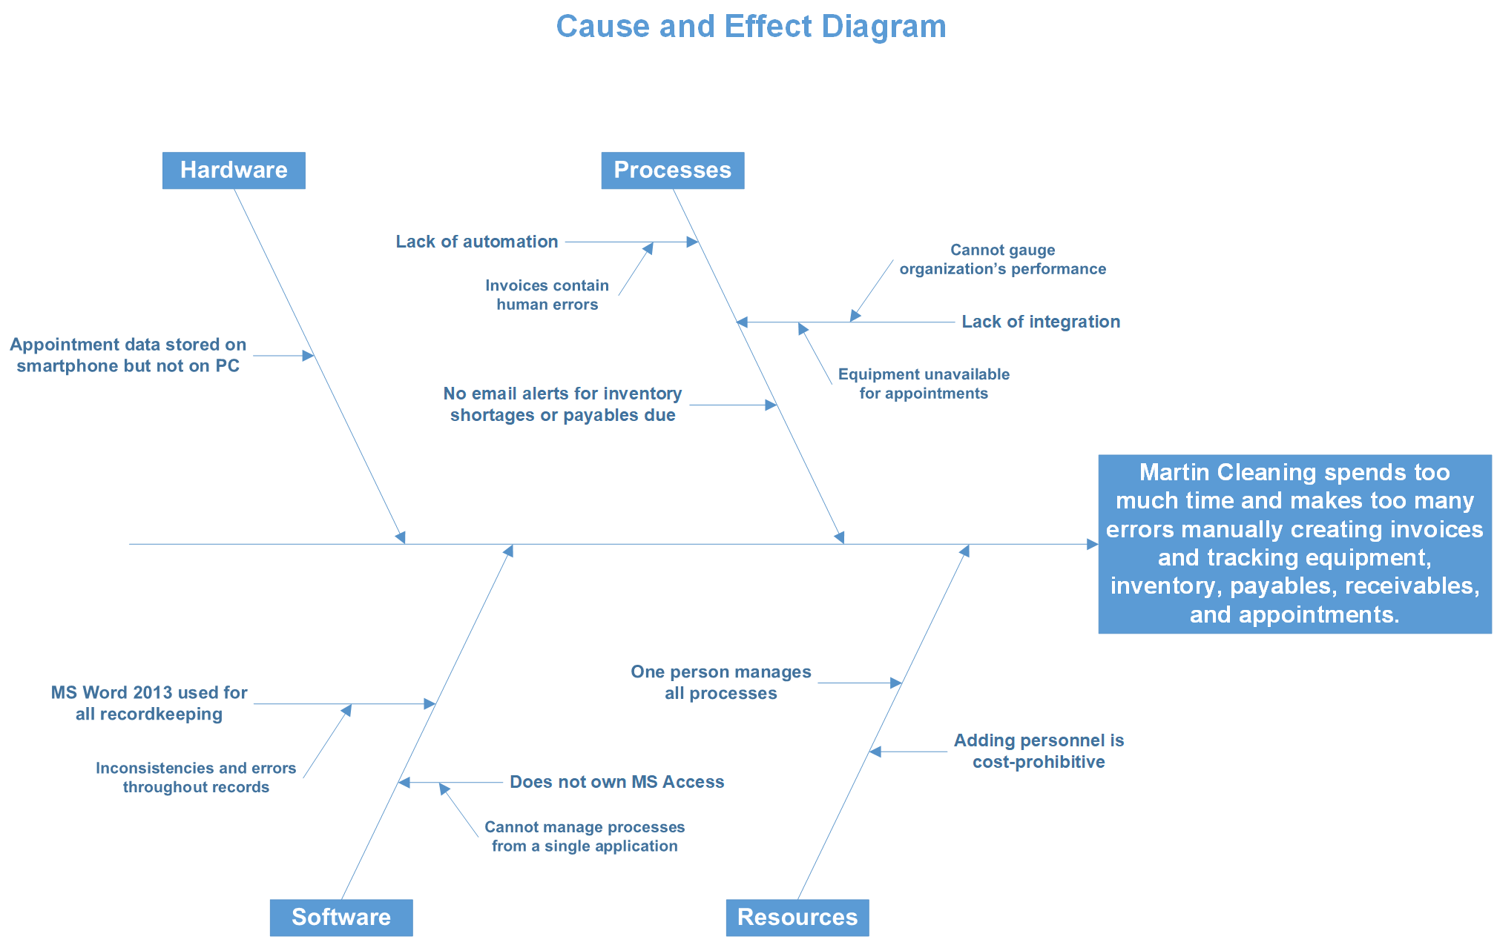
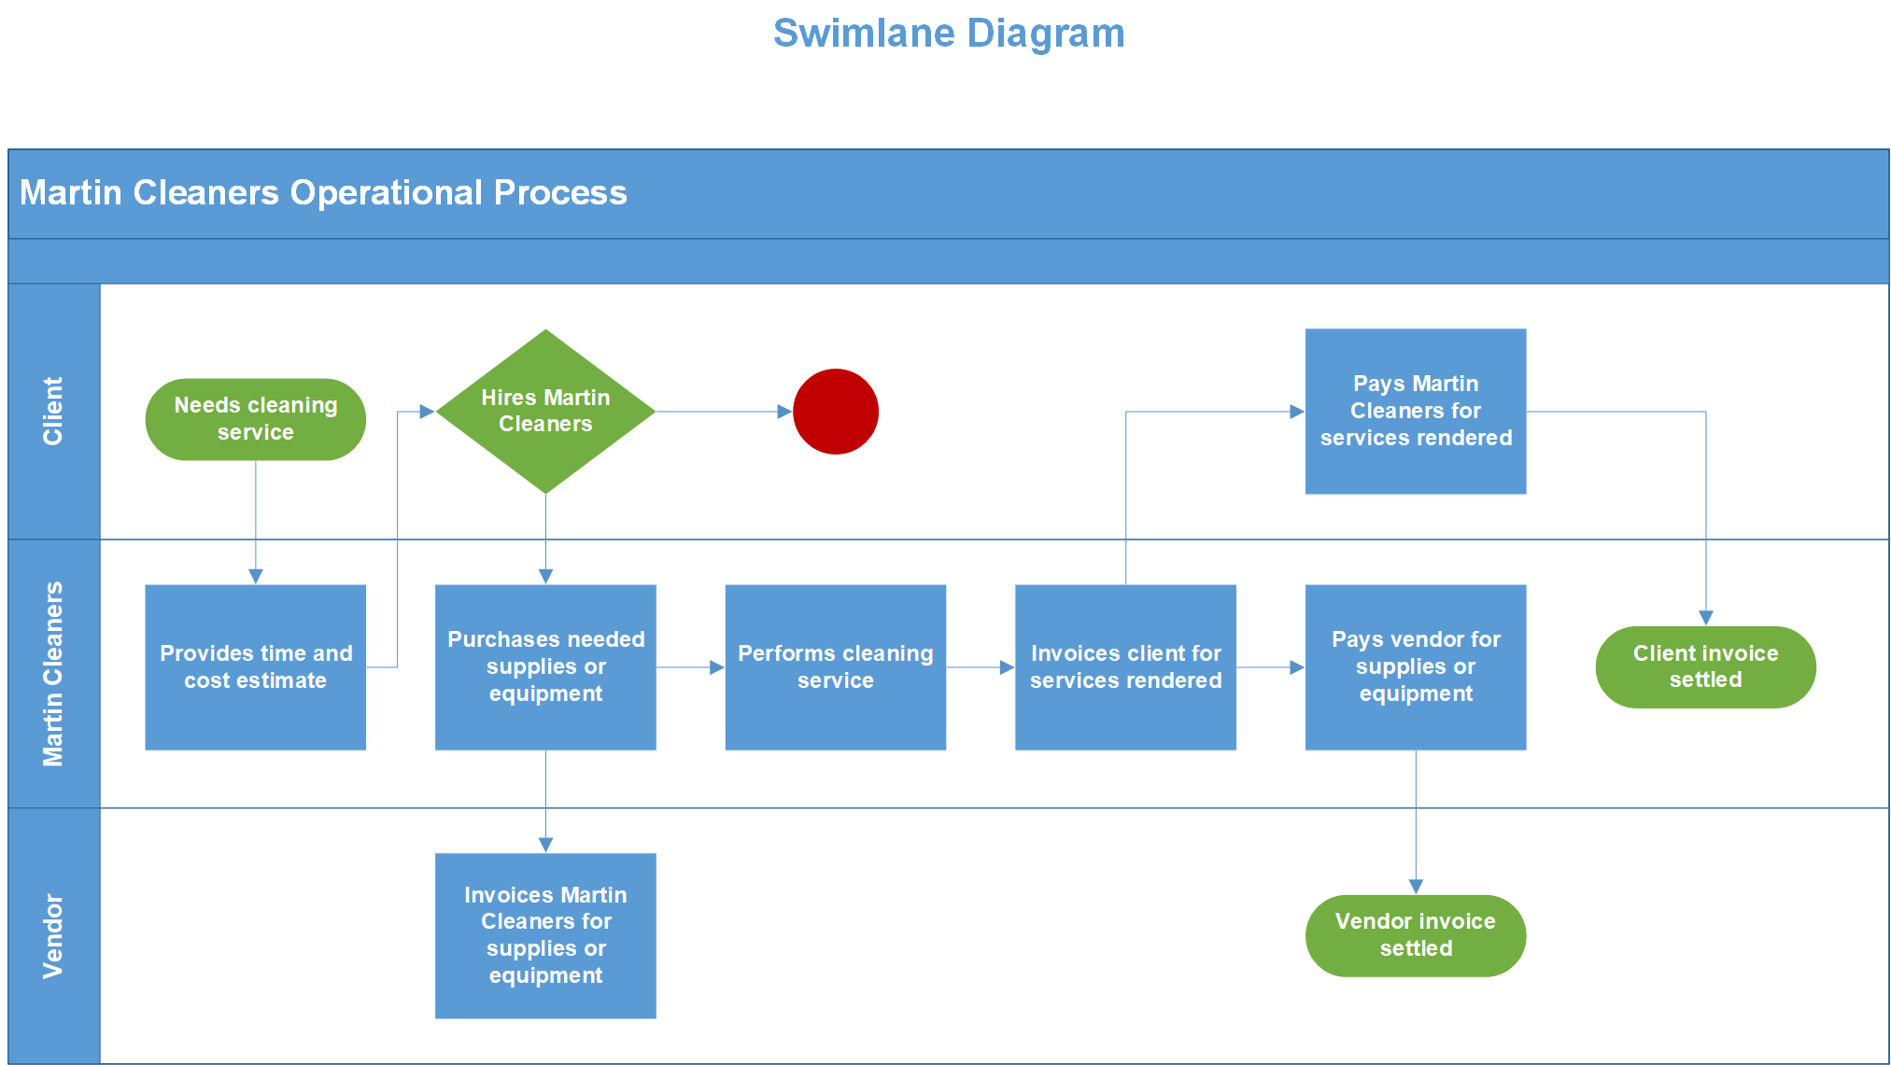
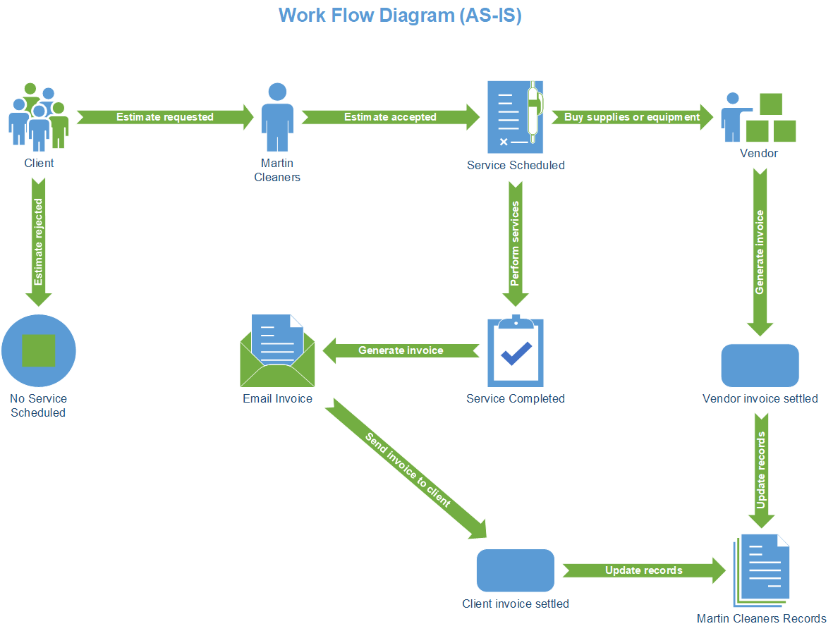
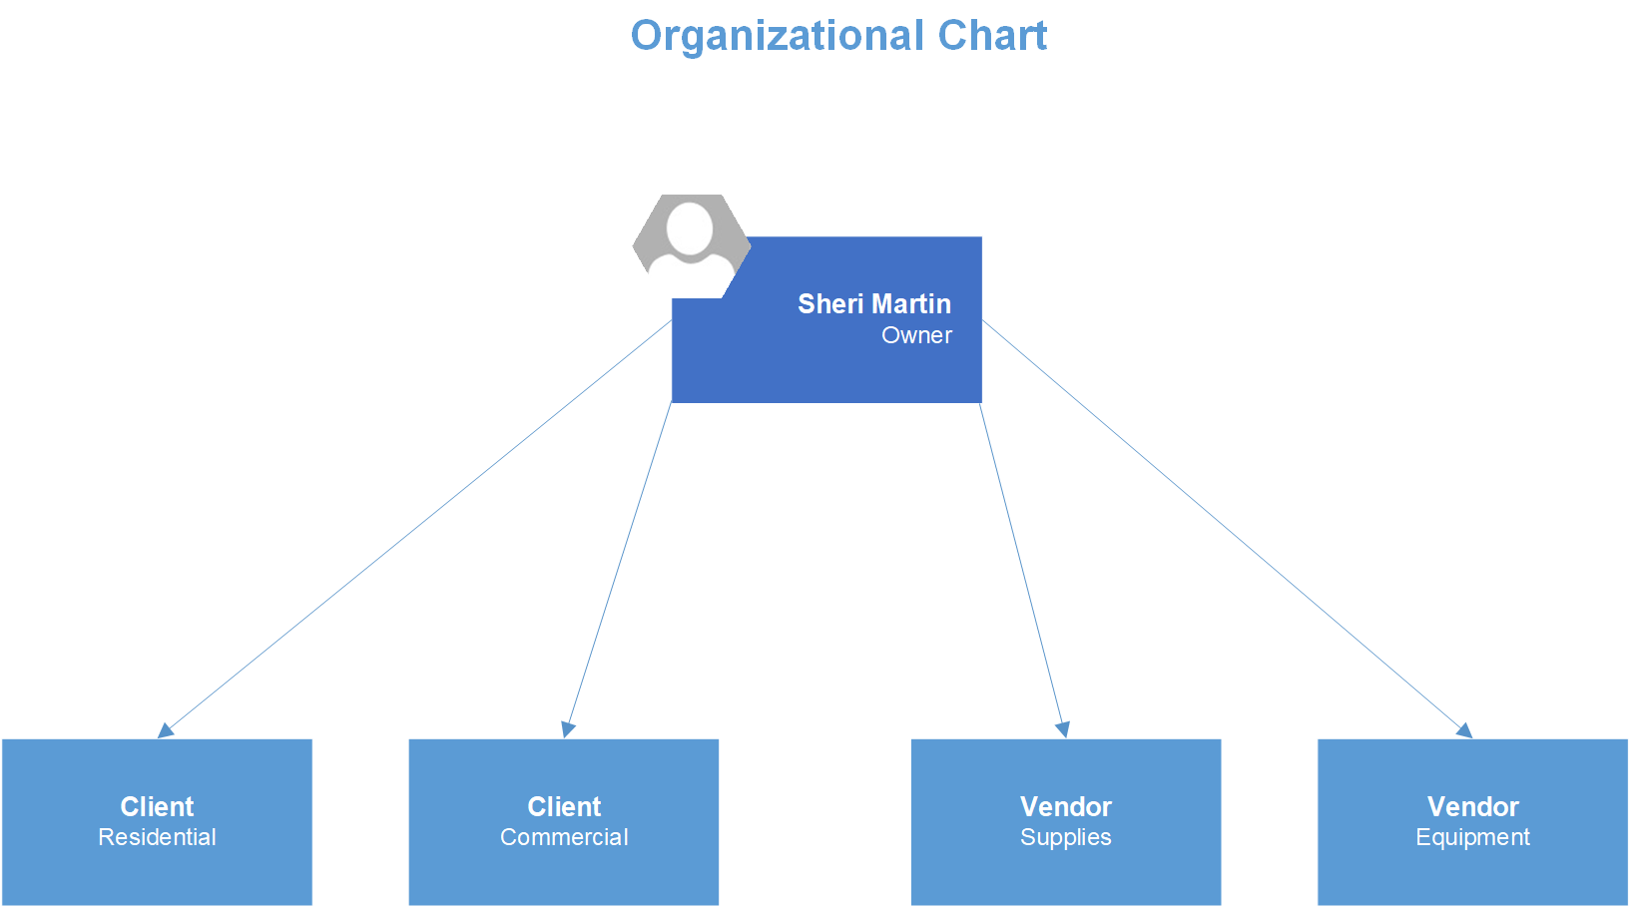

Appendix D: Project Management

Milestone 1 – Task List

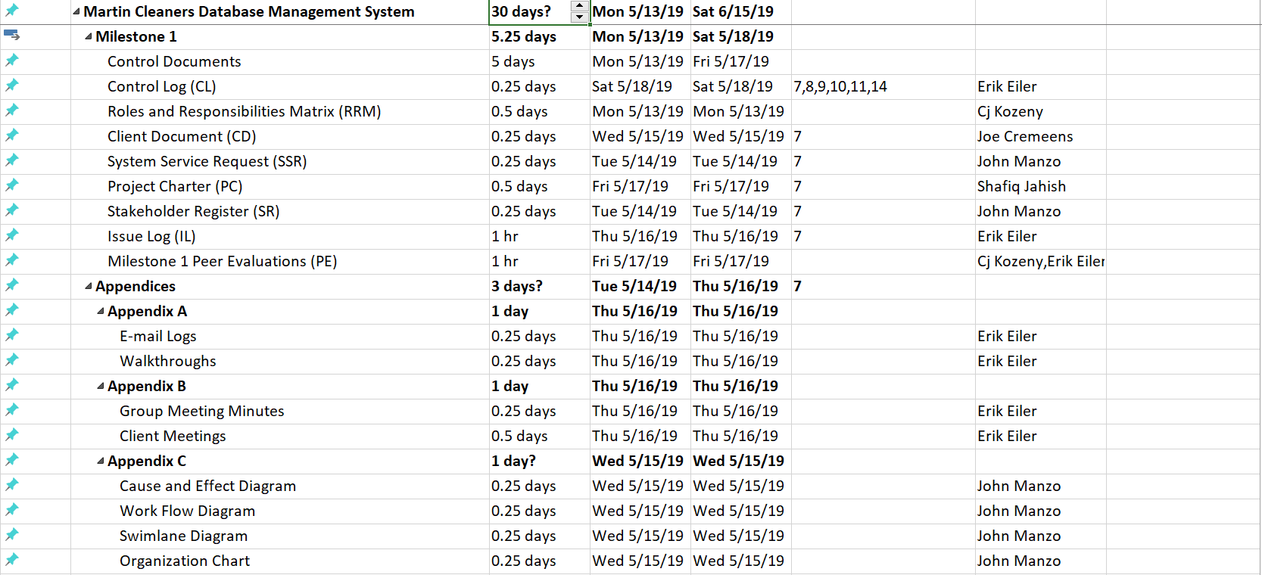
Milestone 1 – Gantt Chart
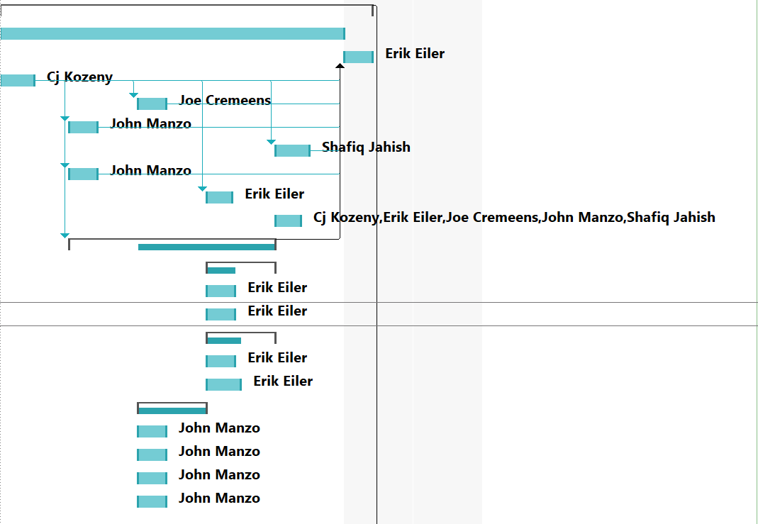

Milestone 2 – Task List

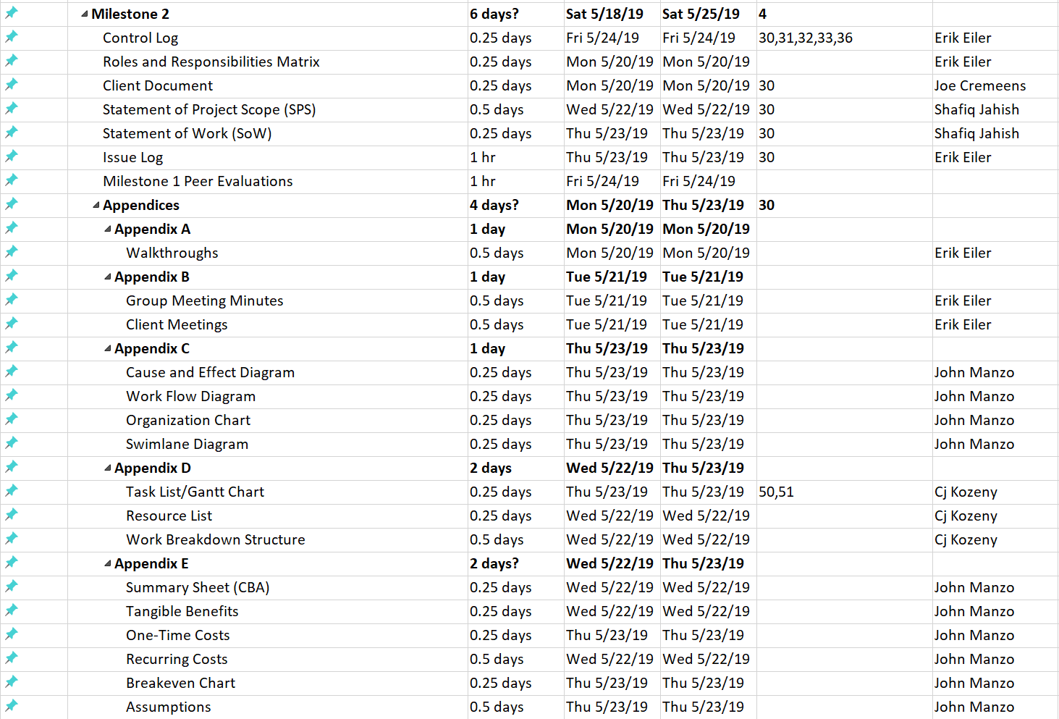
Milestone 2 – Gantt Chart
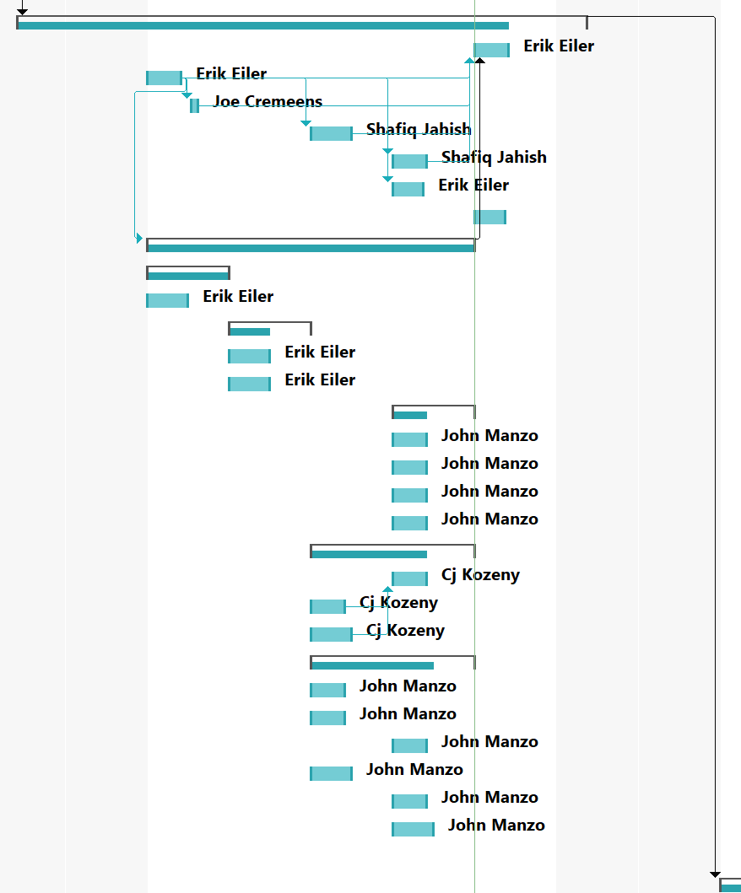

Milestone 3 – Task List

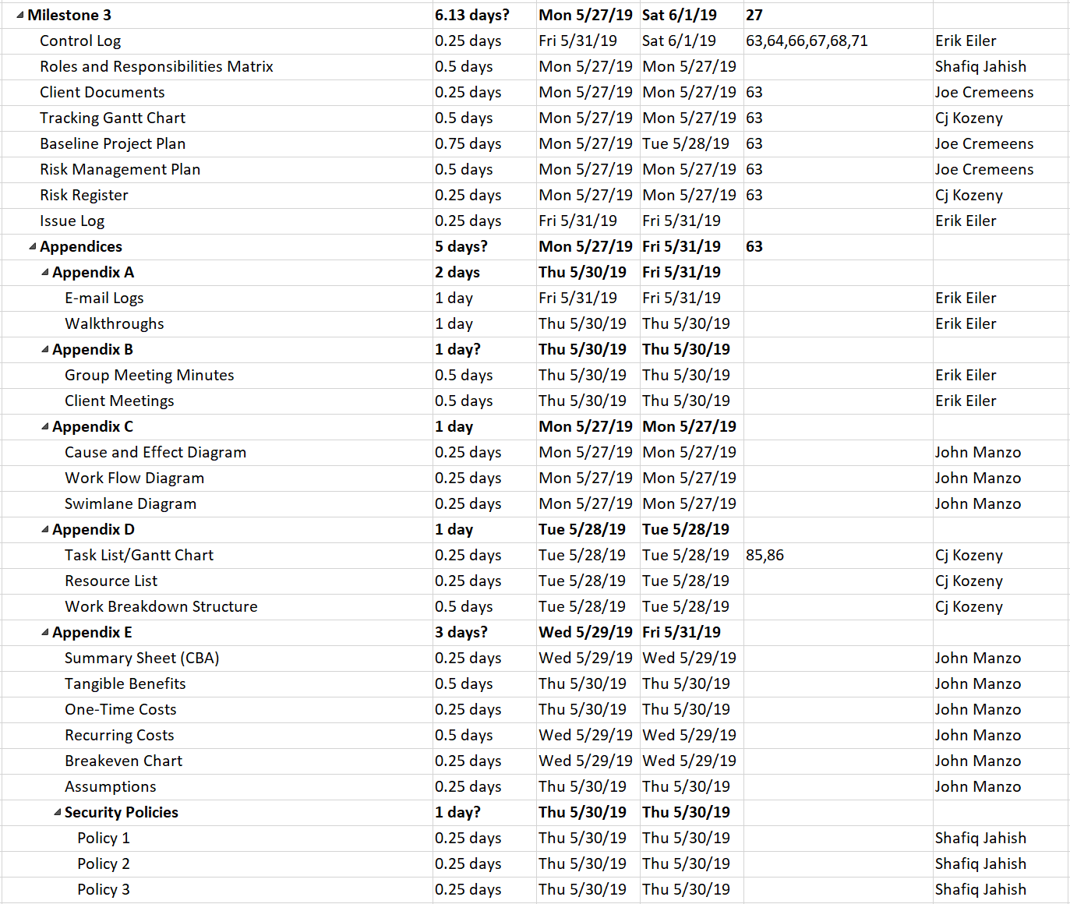

Milestone 3 – Gantt Chart

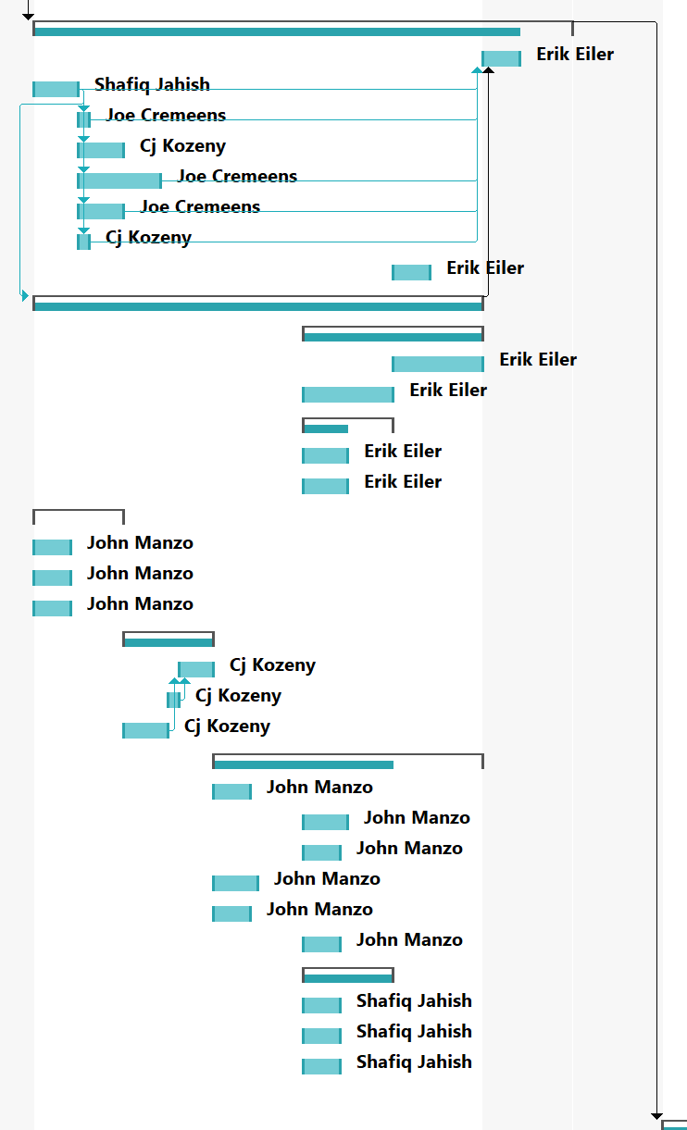

Milestone 4 – Task List

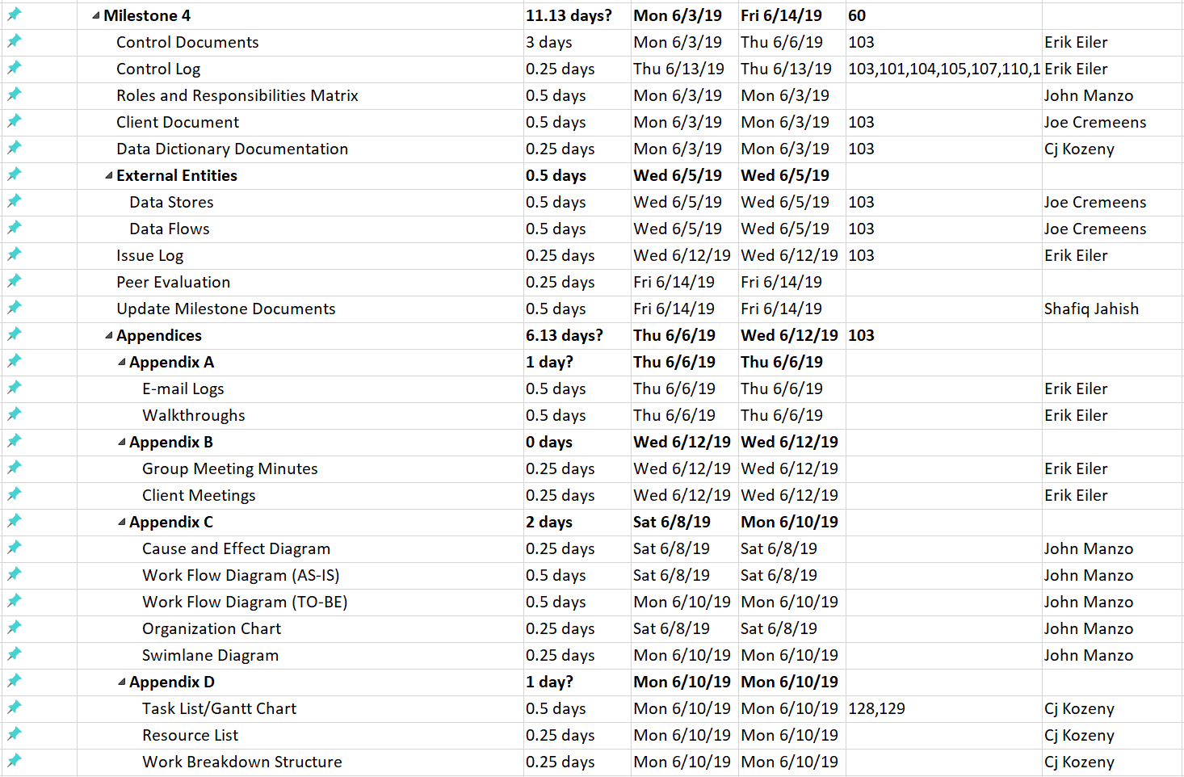

Milestone 4 – Task List

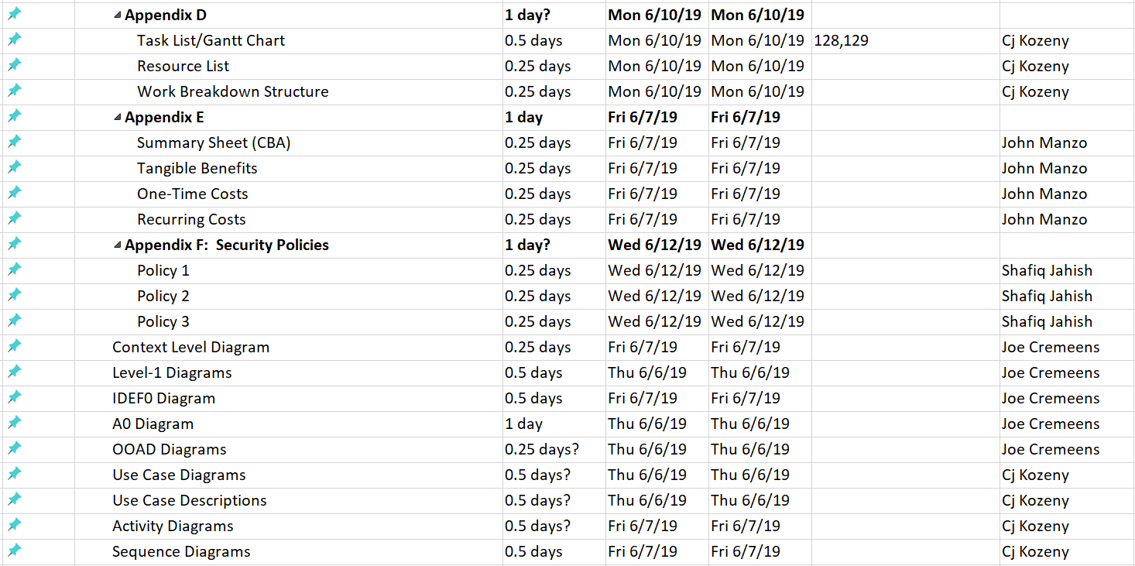

Milestone 4 – Gantt Chart

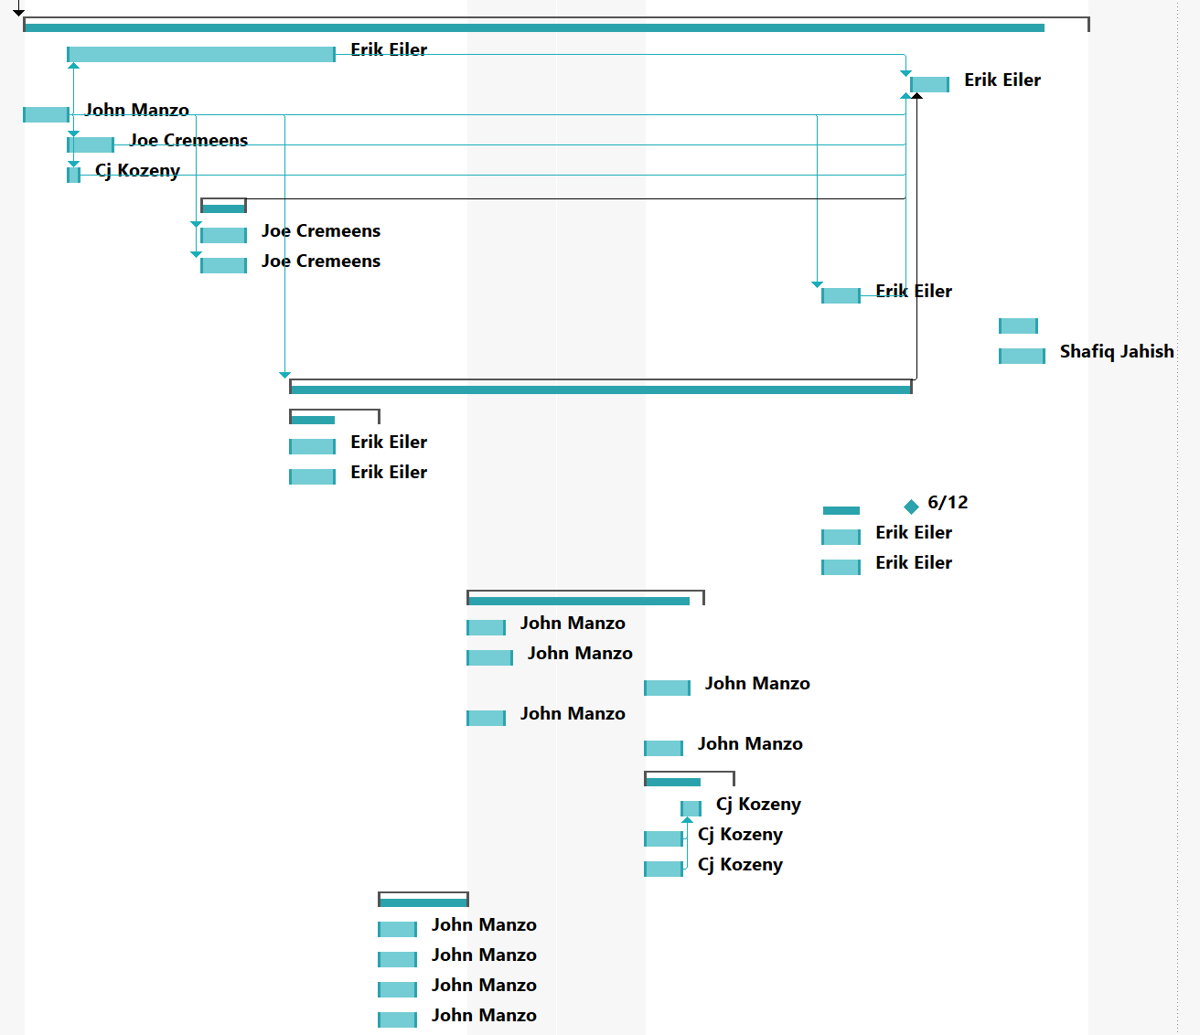

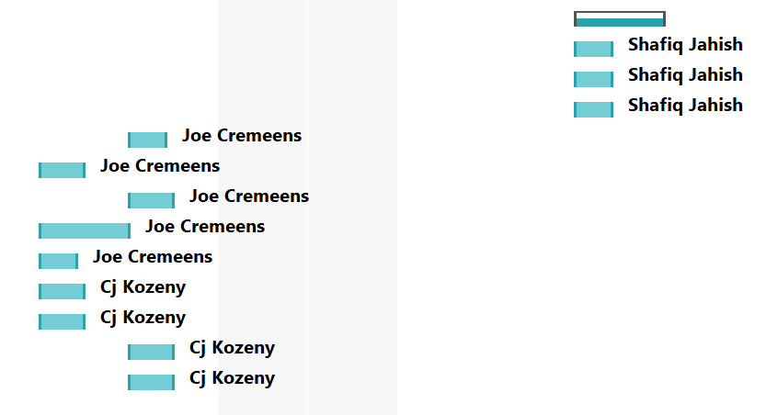

Group Presentation – Task List

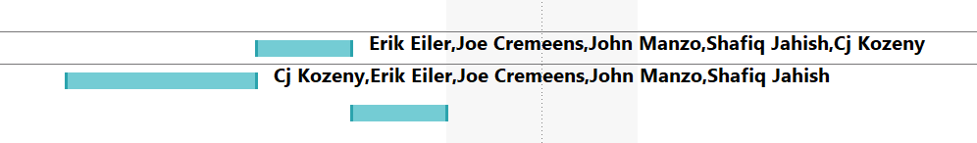

Resource List

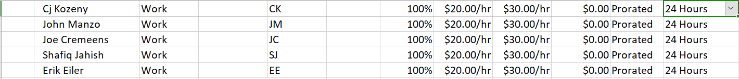

Network Diagrams

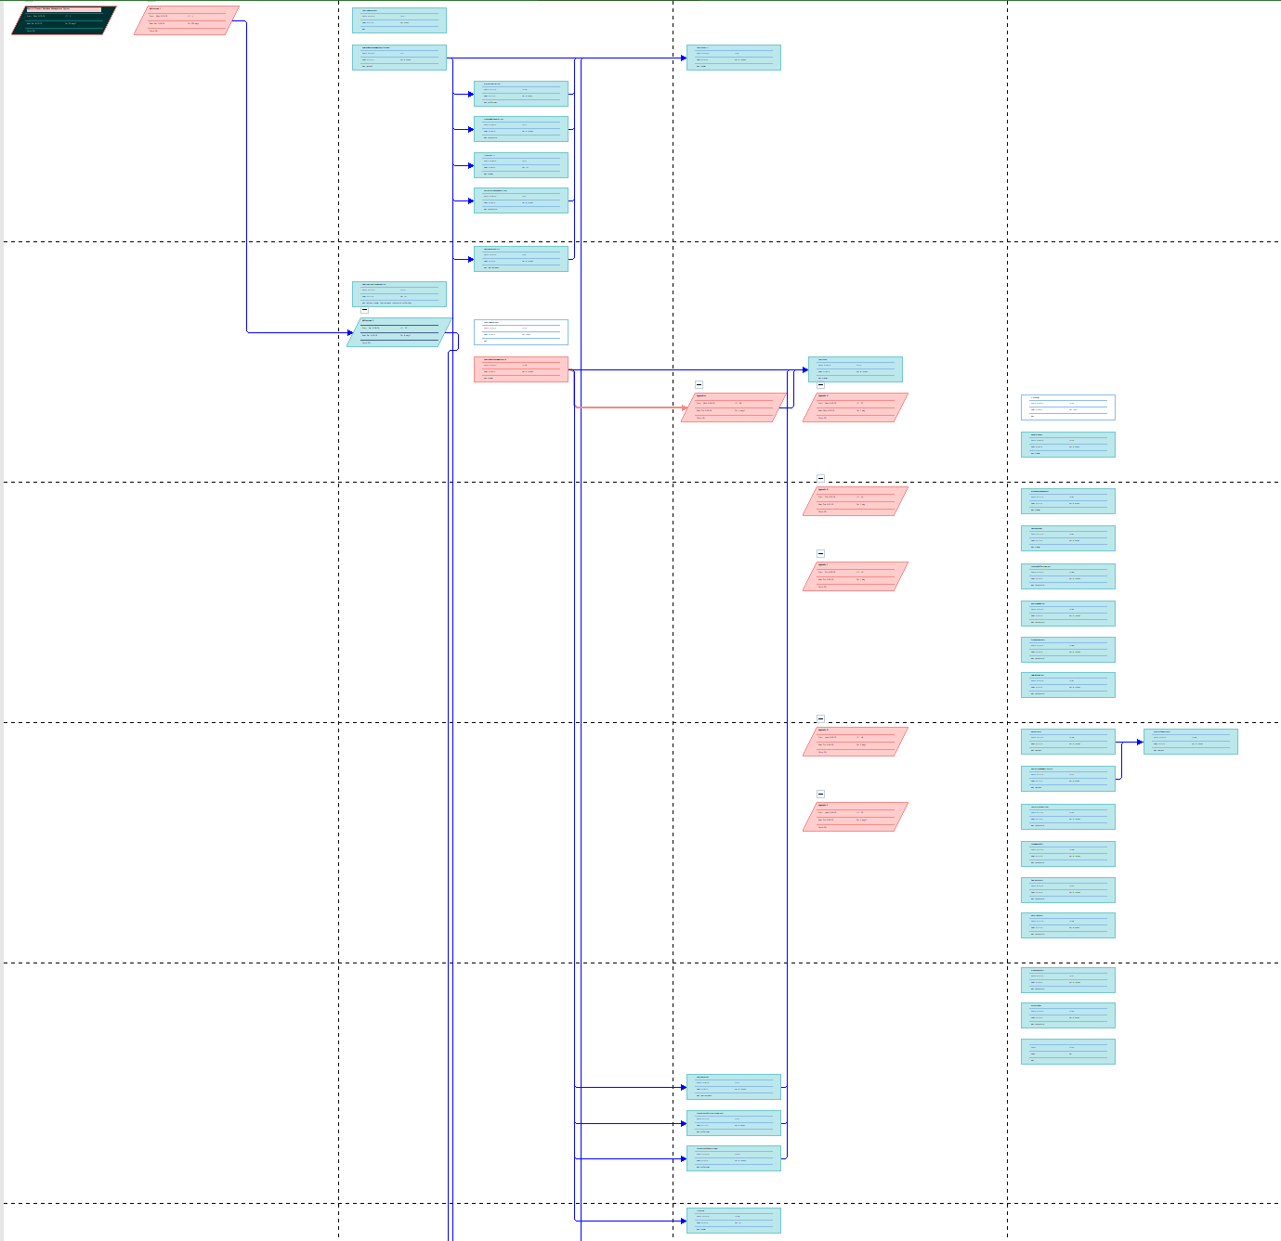

Network Diagrams

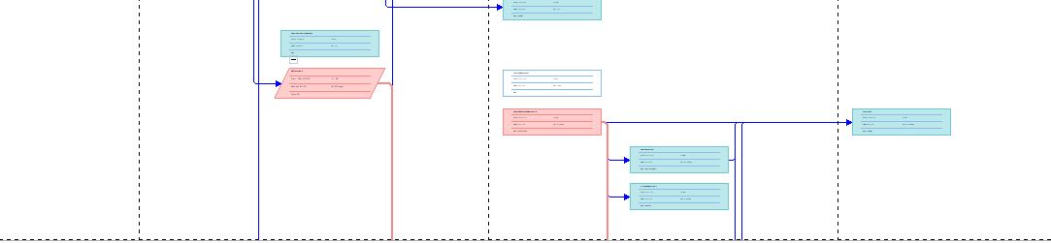

Appendix E: Economic Feasibility Analysis

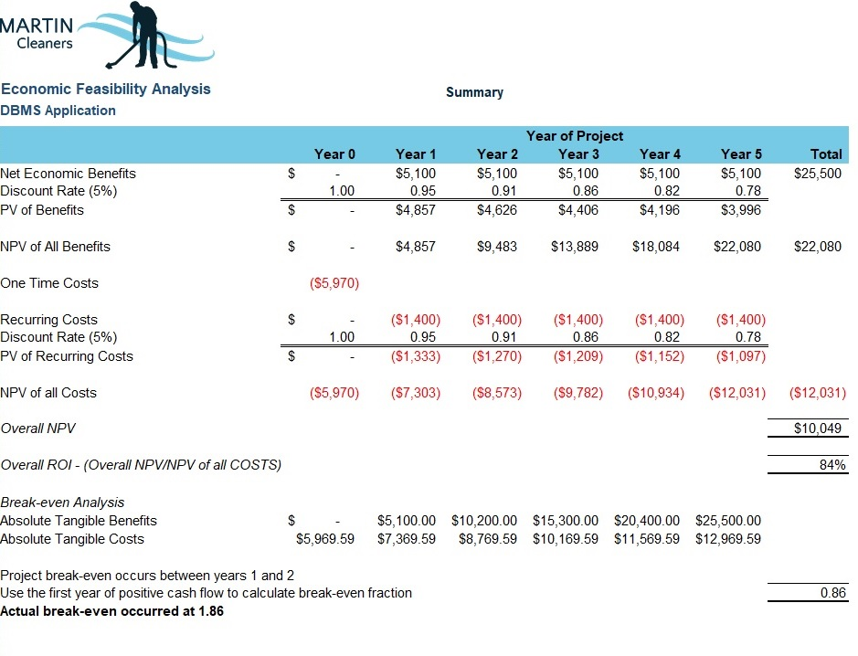

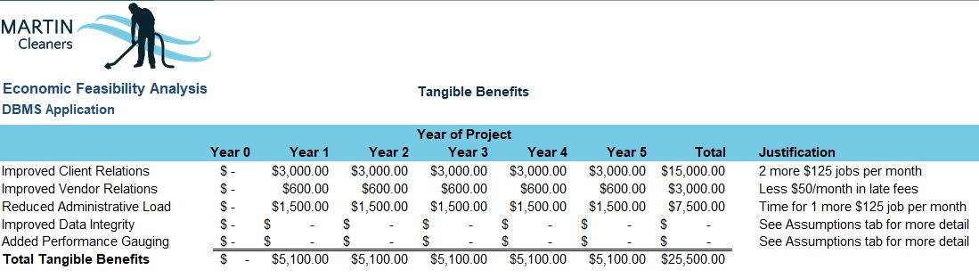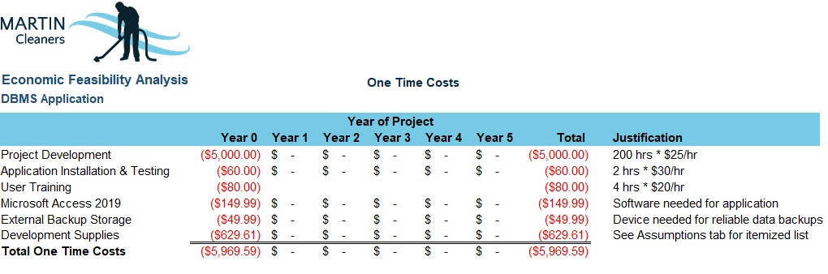

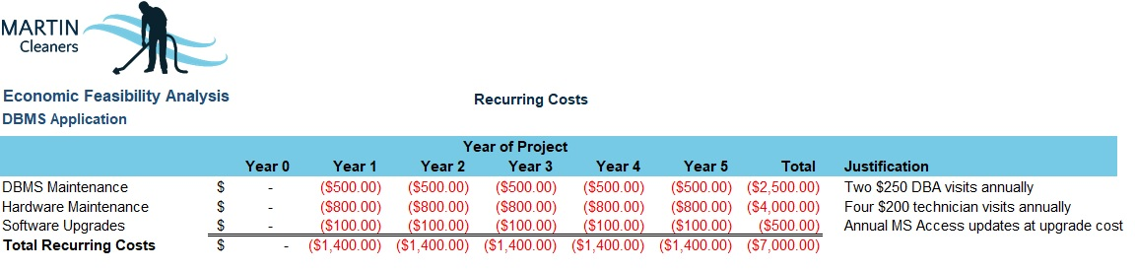
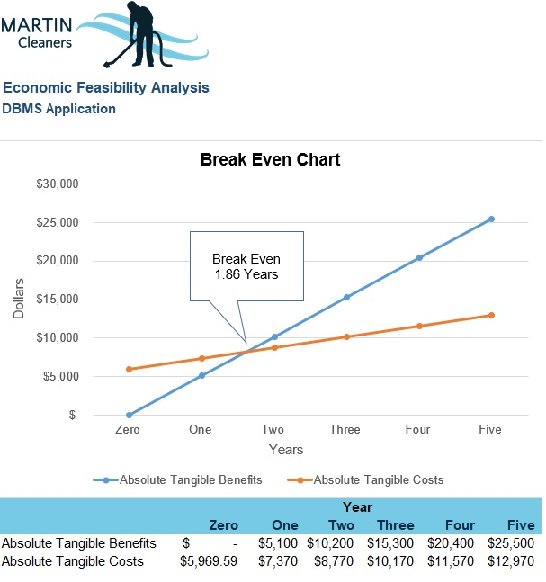

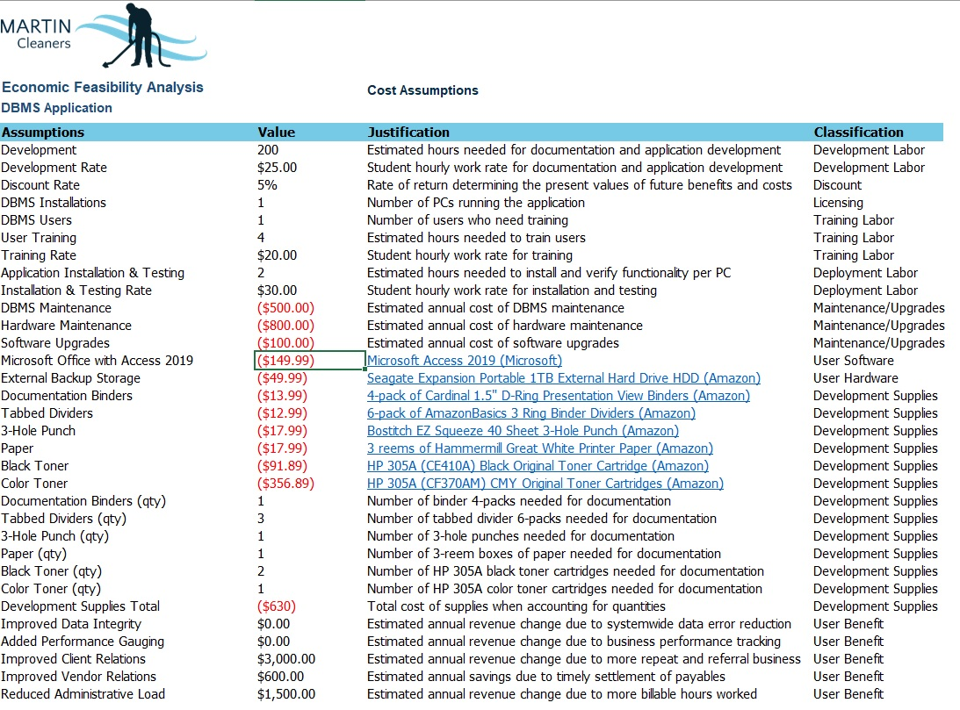

Appendix F: Tracking Gantt Chart

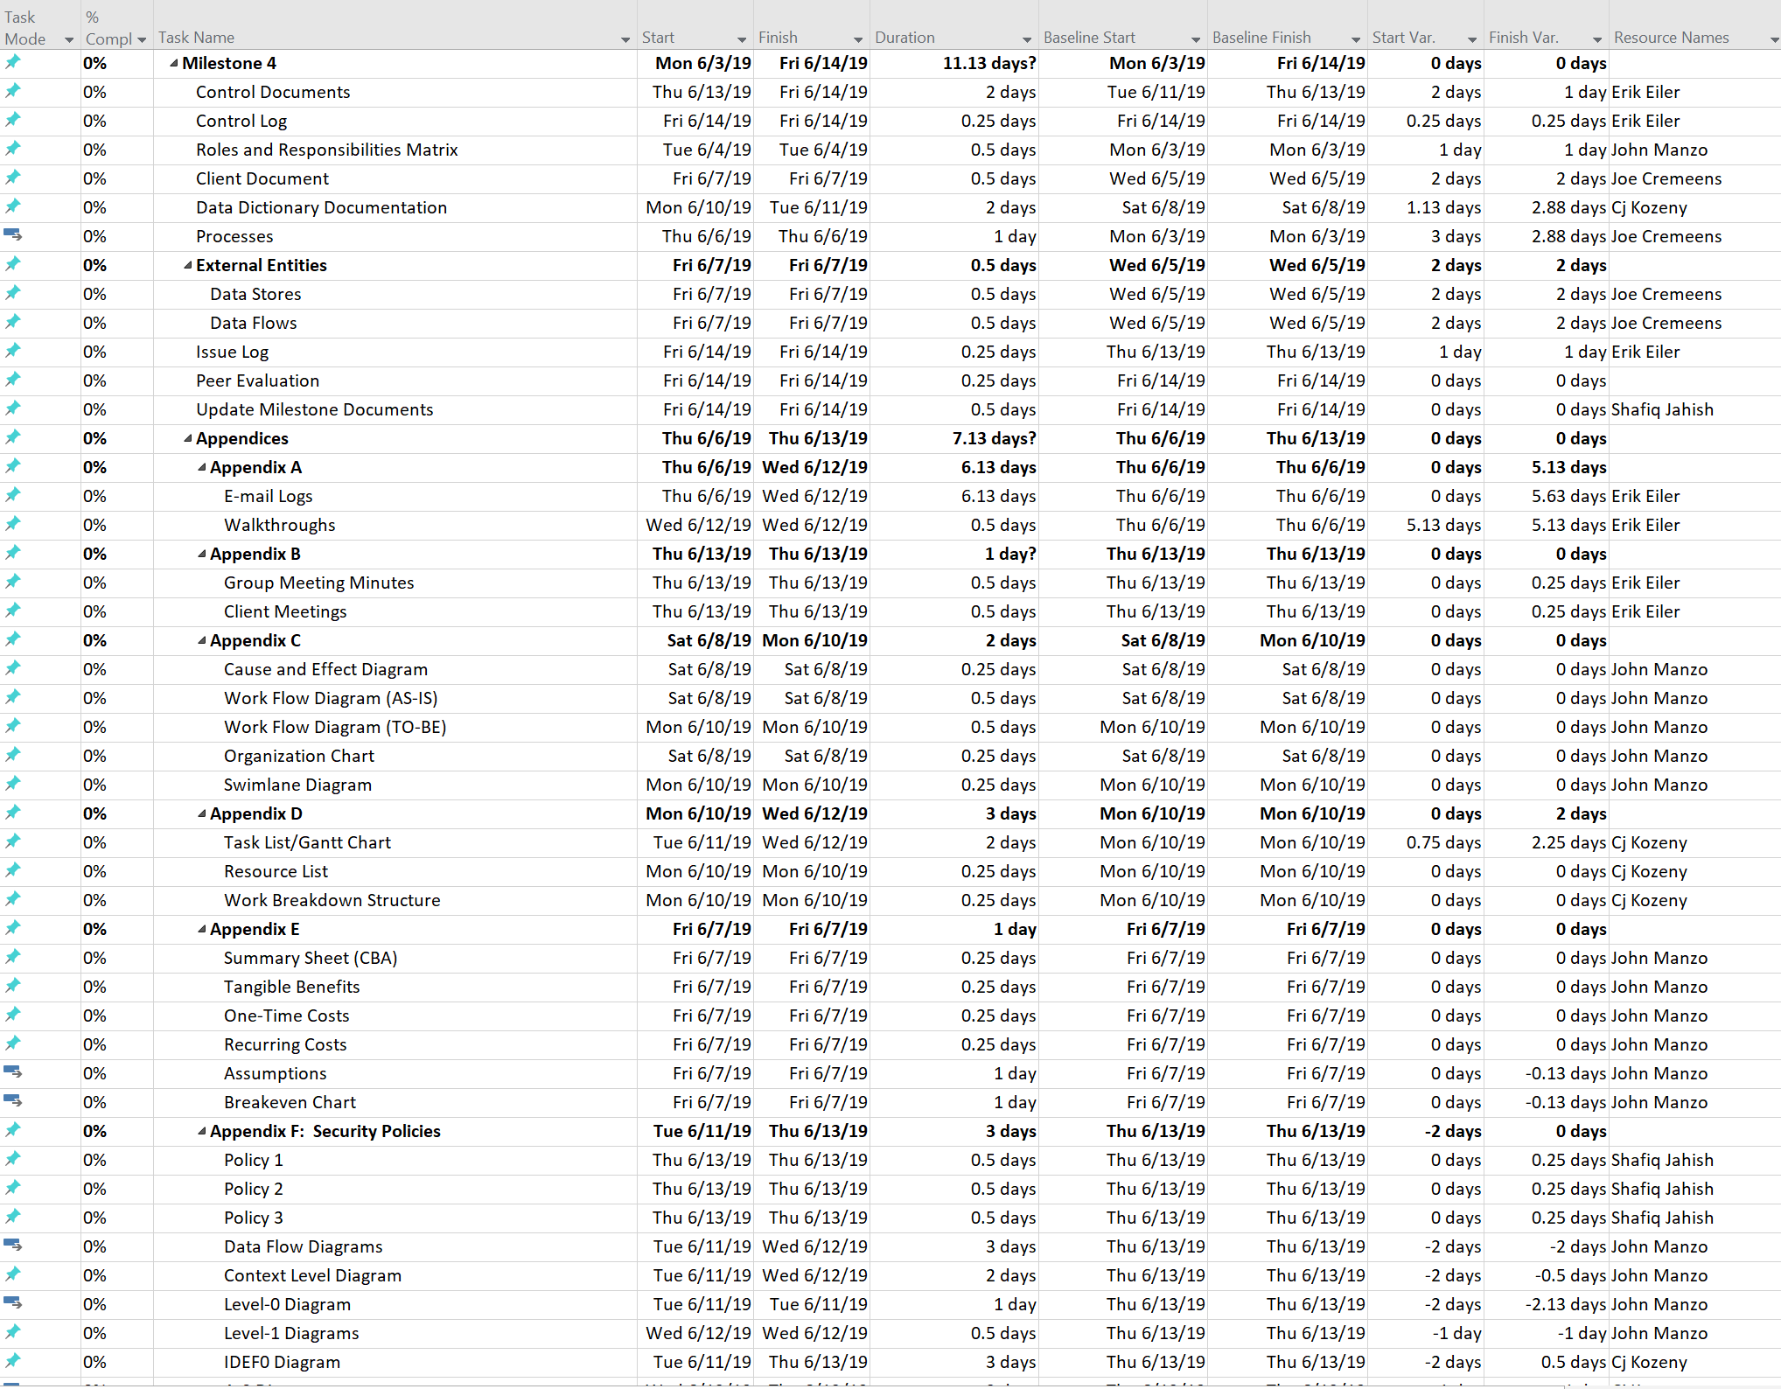

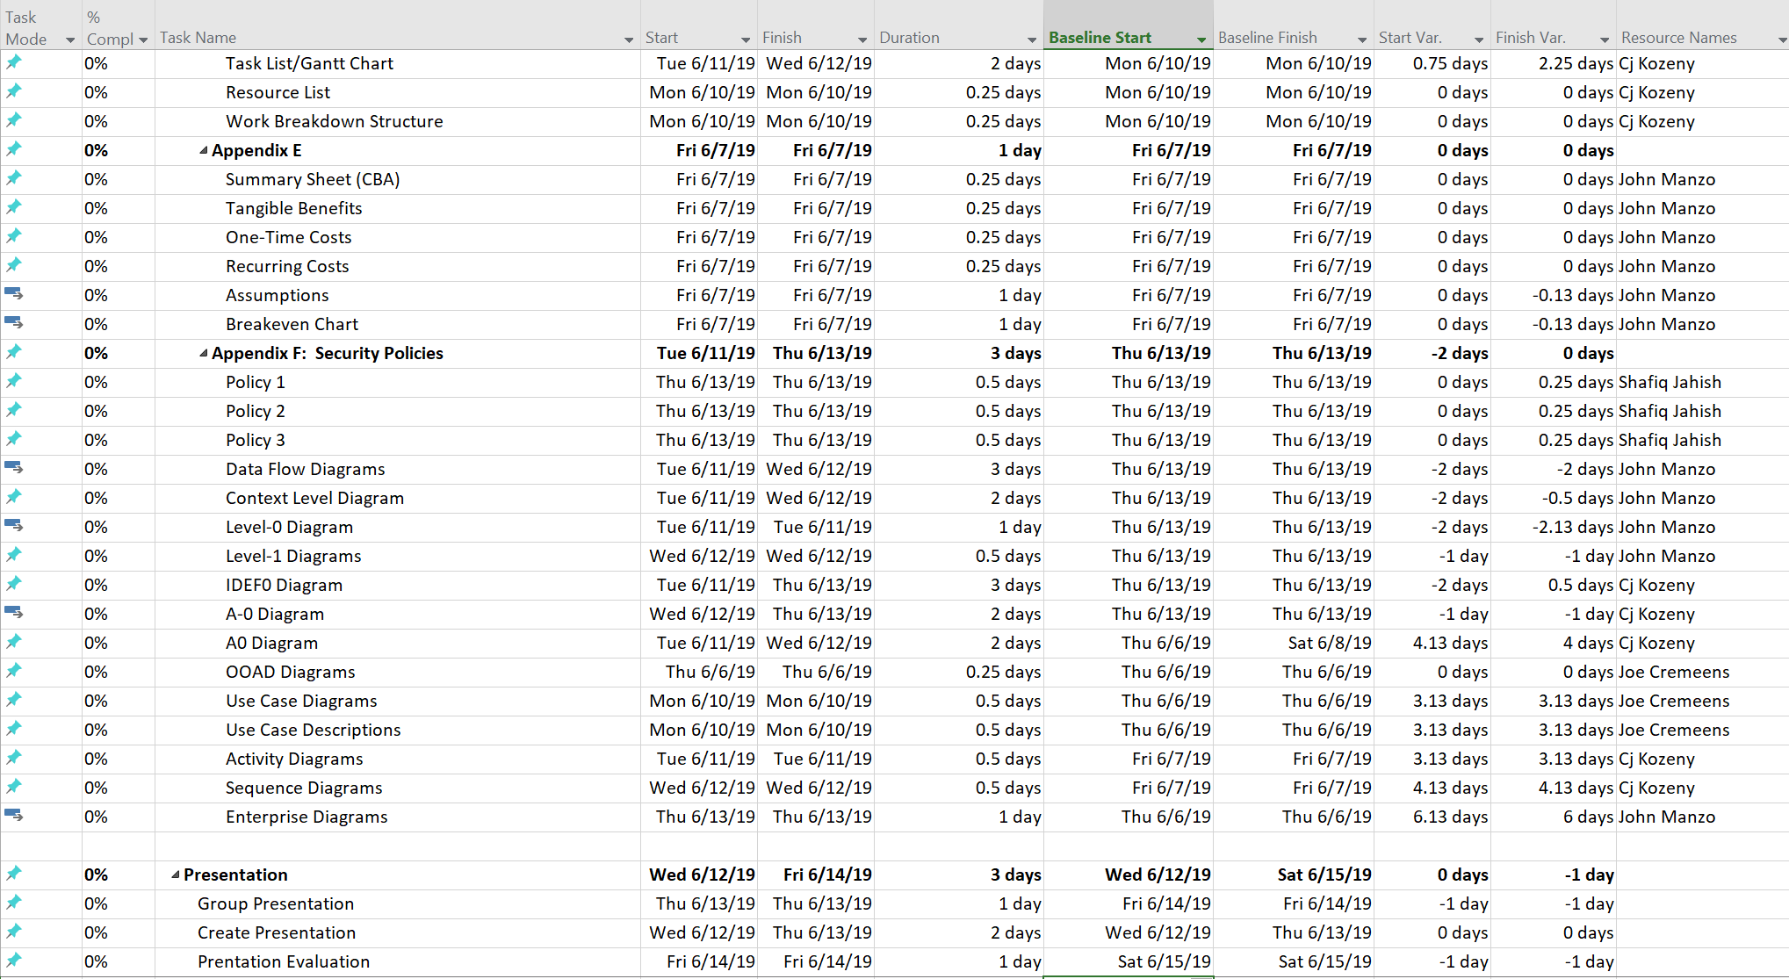

Appendix G: Security Policies

[Mavs] Prepared by: Shafiq Jahish
Security Policies Date: 5/29/2019

Free Use Disclaimer: These policies were created by or for the SANS Institute for the Internet community. All or parts of these policies can be freely used for your organization. There is no prior approval required. If you would like to contribute a new policy or updated version of this policy, please send email to policy-resources@sans.org.
Things to Consider: Please consult the Things to Consider FAQ for additional guidelines and suggestions for personalizing the SANS policies for your organization.
Last Update Status: Updated June 2014

Policy | Description
Acceptable Use | This policy is designed to outline the acceptable use of computer equipment at Martin Cleaners. It helps employees to avoid inappropriate use that will expose Martin Cleaners to outside risks.
Password Protection | This policy is to establish standards for passwords and to protect the existing passwords.
Disaster Recovery Plan | This policy establishes requirements for disaster recovery and how to recover IT systems and data in case of a disaster.
Ethics | This policy establishes culture of openness, trust and emphasize on fair business. This policy is to guide business behavior that ensures ethical conduct.
Email | This policy ensures proper use of the email system at Martin Cleaners and makes users aware of the system.
End User Encryption Key Protection | This policy outlines the requirements for how to protect the encryption keys of the end users. The policy helps to prevent fraudulent activities.
Clean Desk | This policy establishes minimum requirements to make sure all information about employees, customers, and vendors are securely locked in safe area.
Security Response Plan | This policy helps businesses to develop a security response plan. The policy ensures that management team has all the information to respond to possible security incidents.

Acceptable Use Policy
- Overview
InfoSec’s intentions for publishing an Acceptable Use Policy are not to impose restrictions that are contrary to Martin Cleaner’s established culture of openness, trust and integrity. InfoSec is committed to protecting Martin Cleaner's employees, partners and the company from illegal or damaging actions by individuals, either knowingly or unknowingly.
Internet/Intranet/Extranet-related systems, including but not limited to computer equipment, software, operating systems, storage media, network accounts providing electronic mail, WWW browsing, and FTP, are the property of Martin Cleaners. These systems are to be used for business purposes in serving the interests of the company, and of our clients and customers in the course of normal operations. Please review Human Resources policies for further details.
Effective security is a team effort involving the participation and support of every Martin Cleaners employee and affiliate who deals with information and/or information systems. It is the responsibility of every computer user to know these guidelines, and to conduct their activities accordingly.
- Purpose
The purpose of this policy is to outline the acceptable use of computer equipment at Martin Cleaners. These rules are in place to protect the employee and Martin Cleaners. Inappropriate use exposes Martin Cleaners to risks including virus attacks, compromise of network systems and services, and legal issues.
- Scope
This policy applies to the use of information, electronic and computing devices, and network resources to conduct Martin Cleaners business or interact with internal networks and business systems, whether owned or leased by Martin Cleaners, the employee, or a third party. All employees, contractors, consultants, temporary, and other workers at Martin Cleaners and its subsidiaries are responsible for exercising good judgment regarding appropriate use of information, electronic devices, and network resources in accordance with Martin Cleaners policies and standards, and local laws and regulation. Exceptions to this policy are documented in section 5.2
This policy applies to employees, contractors, consultants, temporaries, and other workers at Martin Cleaners, including all personnel affiliated with third parties. This policy applies to all equipment that is owned or leased by Martin Cleaners.
- Policy
  - General Use and Ownership
    - Martin Cleaners proprietary information stored on electronic and computing devices whether owned or leased by Martin Cleaners, the employee or a third party, remains the sole property of Martin Cleaners. You must ensure through legal or technical means that proprietary information is protected in accordance with the Data Protection Standard.
    - You have a responsibility to promptly report the theft, loss or unauthorized disclosure of Martin Cleaners proprietary information.
    - You may access, use or share Martin Cleaners proprietary information only to the extent it is authorized and necessary to fulfill your assigned job duties.
    - Employees are responsible for exercising good judgment regarding the reasonableness of personal use. Individual departments are responsible for creating guidelines concerning personal use of Internet/Intranet/Extranet systems. In the absence of such policies, employees should be guided by departmental policies on personal use, and if there is any uncertainty, employees should consult their supervisor or manager.
    - For security and network maintenance purposes, authorized individuals within Martin Cleaners may monitor equipment, systems and network traffic at any time, per InfoSec’s Audit Policy.
    - Martin Cleaners reserves the right to audit networks and systems on a periodic basis to ensure compliance with this policy.

  - Security and Proprietary Information
    - All mobile and computing devices that connect to the internal network must comply with the Minimum Access Policy.
    - System level and user level passwords must comply with the Password Policy. Providing access to another individual, either deliberately or through failure to secure its access, is prohibited.
    - All computing devices must be secured with a password-protected screensaver with the automatic activation feature set to 10 minutes or less. You must lock the screen or log off when the device is unattended.
    - Postings by employees from a Martin Cleaners email address to newsgroups should contain a disclaimer stating that the opinions expressed are strictly their own and not necessarily those of Martin Cleaners, unless posting is in the course of business duties.
    - Employees must use extreme caution when opening e-mail attachments received from unknown senders, which may contain malware.

  - Unacceptable Use
The following activities are, in general, prohibited. Employees may be exempted from these restrictions during the course of their legitimate job responsibilities (e.g., systems administration staff may have a need to disable the network access of a host if that host is disrupting production services).
Under no circumstances is an employee of Martin Cleaners authorized to engage in any activity that is illegal under local, state, federal or international law while utilizing Martin Cleaners-owned resources.
The lists below are by no means exhaustive, but attempt to provide a framework for activities which fall into the category of unacceptable use.
    - System and Network Activities
The following activities are strictly prohibited, with no exceptions:
- Violations of the rights of any person or company protected by copyright, trade secret, patent or other intellectual property, or similar laws or regulations, including, but not limited to, the installation or distribution of "pirated" or other software products that are not appropriately licensed for use by Martin Cleaners.
- Unauthorized copying of copyrighted material including, but not limited to, digitization and distribution of photographs from magazines, books or other copyrighted sources, copyrighted music, and the installation of any copyrighted software for which Martin Cleaners or the end user does not have an active license is strictly prohibited.
- Accessing data, a server or an account for any purpose other than conducting Martin Cleaners business, even if you have authorized access, is prohibited.
- Exporting software, technical information, encryption software or technology, in violation of international or regional export control laws, is illegal. The appropriate management should be consulted prior to export of any material that is in question.
- Introduction of malicious programs into the network or server (e.g., viruses, worms, Trojan horses, e-mail bombs, etc.).
- Revealing your account password to others or allowing use of your account by others. This includes family and other household members when work is being done at home.
- Using a Martin Cleaners computing asset to actively engage in procuring or transmitting material that is in violation of sexual harassment or hostile workplace laws in the user's local jurisdiction.
- Making fraudulent offers of products, items, or services originating from any Martin Cleaners account.
- Making statements about warranty, expressly or implied, unless it is a part of normal job duties.
- Effecting security breaches or disruptions of network communication. Security breaches include, but are not limited to, accessing data of which the employee is not an intended recipient or logging into a server or account that the employee is not expressly authorized to access, unless these duties are within the scope of regular duties. For purposes of this section, "disruption" includes, but is not limited to, network sniffing, pinged floods, packet spoofing, denial of service, and forged routing information for malicious purposes.
- Port scanning or security scanning is expressly prohibited unless prior notification to InfoSec is made.
- Executing any form of network monitoring which will intercept data not intended for the employee's host, unless this activity is a part of the employee's normal job/duty.
- Circumventing user authentication or security of any host, network or account.
- Introducing honeypots, honeynets, or similar technology on the Martin Cleaners network.
- Interfering with or denying service to any user other than the employee's host (for example, denial of service attack).
- Using any program/script/command, or sending messages of any kind, with the intent to interfere with, or disable, a user's terminal session, via any means, locally or via the Internet/Intranet/Extranet.
- Providing information about, or lists of, Martin Cleaners employees to parties outside Martin Cleaners.

    - Email and Communication Activities
When using company resources to access and use the Internet, users must realize they represent the company. Whenever employees state an affiliation to the company, they must also clearly indicate that "the opinions expressed are my own and not necessarily those of the company". Questions may be addressed to the IT Department
- Sending unsolicited email messages, including the sending of "junk mail" or other advertising material to individuals who did not specifically request such material (email spam).
- Any form of harassment via email, telephone or paging, whether through language, frequency, or size of messages.
- Unauthorized use, or forging, of email header information.
- Solicitation of email for any other email address, other than that of the poster's account, with the intent to harass or to collect replies.
- Creating or forwarding "chain letters", "Ponzi" or other "pyramid" schemes of any type.
- Use of unsolicited email originating from within Martin Cleaners' networks of other Internet/Intranet/Extranet service providers on behalf of, or to advertise, any service hosted by Martin Cleaners or connected via Martin Cleaners' network.
- Posting the same or similar non-business-related messages to large numbers of Usenet newsgroups (newsgroup spam).

    - Blogging and Social Media
- Blogging by employees, whether using Martin Cleaners’ property and systems or personal computer systems, is also subject to the terms and restrictions set forth in this Policy. Limited and occasional use of Martin Cleaners’ systems to engage in blogging is acceptable, provided that it is done in a professional and responsible manner, does not otherwise violate Martin Cleaners’ policy, is not detrimental to Martin Cleaners’ best interests, and does not interfere with an employee's regular work duties. Blogging from Martin Cleaners’ systems is also subject to monitoring.

- Martin Cleaners’ Confidential Information policy also applies to blogging. As such, Employees are prohibited from revealing any Martin Cleaners confidential or proprietary information, trade secrets or any other material covered by Martin Cleaners’ Confidential Information policy when engaged in blogging.

- Employees shall not engage in any blogging that may harm or tarnish the image, reputation and/or goodwill of Martin Cleaners and/or any of its employees. Employees are also prohibited from making any discriminatory, disparaging, defamatory or harassing comments when blogging or otherwise engaging in any conduct prohibited by Martin Cleaners’ Non-Discrimination and Anti-Harassment policy.

- Employees may also not attribute personal statements, opinions or beliefs to Martin Cleaners when engaged in blogging. If an employee is expressing his or her beliefs and/or opinions in blogs, the employee may not, expressly or implicitly, represent themselves as an employee or representative of Martin Cleaners. Employees assume any and all risk associated with blogging.

- Apart from following all laws pertaining to the handling and disclosure of copyrighted or export controlled materials, Martin Cleaners’ trademarks, logos and any other Martin Cleaners intellectual property may also not be used in connection with any blogging activity
- Policy Compliance
  - Compliance Measurement
The InfoSec team will verify compliance to this policy through various methods, including but not limited to, business tool reports, internal and external audits, and feedback to the policy owner.
  - Exceptions
Any exception to the policy must be approved by the InfoSec team in advance.
  - Non-Compliance
An employee found to have violated this policy may be subject to disciplinary action, up to and including termination of employment.
- Related Standards, Policies and Processes
- Data Classification Policy
- Data Protection Standard
- Social Media Policy
- Minimum Access Policy
- Password Policy
- Definitions and Terms
The following definition and terms can be found in the SANS Glossary located at:
https://www.sans.org/security-resources/glossary-of-terms/

- Blogging
- Honeypot
- Honeynet
- Proprietary Information
- Spam
- Revision History
Date of Change | Responsible | Summary of Change
June 2014 | SANS Policy Team | Updated and converted to new format

Password Protection Policy
Last Update Status: Updated October, 2017
- Overview
Passwords are an important aspect of computer security. A poorly chosen password may result in unauthorized access and/or exploitation of our resources. All staff, including contractors and vendors with access to Martin Cleaners systems, is responsible for taking the appropriate steps, as outlined below, to select and secure their passwords.

- Purpose
The purpose of this policy is to establish a standard for creation of strong passwords and the protection of those passwords.

- Scope
The scope of this policy includes all personnel who have or are responsible for an account (or any form of access that supports or requires a password) on any system that resides at any Martin Cleaners facility, has access to the Martin Cleaners network, or stores any non-public Martin Cleaners information.

- Policy
  - Password Creation
    - All user-level and system-level passwords must conform to the Password Construction Guidelines.
    - Users must use a separate, unique password for each of their work related accounts. Users may not use any work related passwords for their own, personal accounts.
    - User accounts that have system-level privileges granted through group memberships or programs such as sudo must have a unique password from all other accounts held by that user to access system-level privileges. In addition, it is highly recommend that some form of multi-factor authentication is used for any privileged accounts

  - Password Change
    - Passwords should be changed only when there is reason to believe a password has been compromised.
    - Password cracking or guessing may be performed on a periodic or random basis by the InfoSec Team or its delegates. If a password is guessed or cracked during one of these scans, the user will be required to change it to be in compliance with the Password Construction Guidelines.
  - Password Protection
    - Passwords must not be shared with anyone, including supervisors and coworkers. All passwords are to be treated as sensitive, Confidential Martin Cleaners information. Corporate Information Security recognizes that legacy applications do not support proxy systems in place. Please refer to the technical reference for additional details.
    - Passwords must not be inserted into email messages, Alliance cases or other forms of electronic communication, nor revealed over the phone to anyone.
    - Passwords may be stored only in “password managers” authorized by the organization.
    - Do not use the "Remember Password" feature of applications (for example, web browsers).
    - Any user suspecting that his/her password may have been compromised must report the incident and change all passwords.
  - Application Development
Application developers must ensure that their programs contain the following security precautions:
    - Applications must support authentication of individual users, not groups.
    - Applications must not store passwords in clear text or in any easily reversible form.
    - Applications must not transmit passwords in clear text over the network.
    - Applications must provide for some sort of role management, such that one user can take over the functions of another without having to know the other's password.

  - Multi-Factor Authentication
    - Multi-factor authentication is highly encouraged and should be used whenever possible, not only for work related accounts but personal accounts also.

- Policy Compliance
  - Compliance Measurement
The Infosec team will verify compliance to this policy through various methods, including but not limited to, periodic walk-thrus, video monitoring, business tool reports, internal and external audits, and feedback to the policy owner.
  - Exceptions
Any exception to the policy must be approved by the Infosec Team in advance.
  - Non-Compliance
An employee found to have violated this policy may be subject to disciplinary action, up to and including termination of employment.
- Related Standards, Policies and Processes
- Password Construction Guidelines

- Revision History
Date of Change | Responsible | Summary of Change
June 2014 | SANS Policy Team | Updated and converted to new format.
October, 2017 | SANS Policy Team | Updated to confirm with new NIST SP800-63.3 standards.

Disaster Recovery Plan Policy
- Overview
Since disasters happen so rarely, management often ignores the disaster recovery planning process. It is important to realize that having a contingency plan in the event of a disaster gives Martin Cleaners a competitive advantage. This policy requires management to financially support and diligently attend to disaster contingency planning efforts. Disasters are not limited to adverse weather conditions. Any event that could likely cause an extended delay of service should be considered. The Disaster Recovery Plan is often part of the Business Continuity Plan.

- Purpose
This policy defines the requirement for a baseline disaster recovery plan to be developed and implemented by Martin Cleaners that will describe the process to recover IT Systems, Applications and Data from any type of disaster that causes a major outage.
- Scope
This policy is directed to the IT Management Staff who is accountable to ensure the plan is developed, tested and kept up-to-date. This policy is solely to state the requirement to have a disaster recovery plan, it does not provide requirement around what goes into the plan or sub-plans.
- Policy
4.1 Contingency Plans
The following contingency plans must be created:
- Computer Emergency Response Plan: Who is to be contacted, when, and how? What immediate actions must be taken in the event of certain occurrences?
- Succession Plan: Describe the flow of responsibility when normal staff is unavailable to perform their duties.
- Data Study: Detail the data stored on the systems, its criticality, and its confidentiality.
- Criticality of Service List: List all the services provided and their order of importance.
- It also explains the order of recovery in both short-term and long-term timeframes.
- Data Backup and Restoration Plan: Detail which data is backed up, the media to which it is saved, where that media is stored, and how often the backup is done. It should also describe how that data could be recovered.
- Equipment Replacement Plan: Describe what equipment is required to begin to provide services, list the order in which it is necessary, and note where to purchase the equipment.
- Mass Media Management: Who is in charge of giving information to the mass media?
- Also provide some guidelines on what data is appropriate to be provided.
After creating the plans, it is important to practice them to the extent possible. Management should set aside time to test implementation of the disaster recovery plan. Table top exercises should be conducted annually. During these tests, issues that may cause the plan to fail can be discovered and corrected in an environment that has few consequences.

The plan, at a minimum, should be reviewed an updated on an annual basis.

- Policy Compliance
  - Compliance Measurement
The InfoSec team will verify compliance to this policy through various methods, including but not limited to, periodic walk-through, video monitoring, business tool reports, internal and external audits, and feedback to the policy owner.
  - Exceptions
Any exception to the policy must be approved by the InfoSec Team in advance.
  - Non-Compliance
An employee found to have violated this policy may be subject to disciplinary action, up to and including termination of employment.
- Related Standards, Policies and Processes
None.

- Definitions and Terms
The following definition and terms can be found in the SANS Glossary located at:
https://www.sans.org/security-resources/glossary-of-terms/
- Disaster
- Revision History
Date of Change | Responsible | Summary of Change
June 2014 | SANS Policy Team | Updated and converted to new format.

Ethics Policy
- Overview
Martin Cleaners is committed to protecting employees, partners, vendors and the company from illegal or damaging actions by individuals, either knowingly or unknowingly. When Martin Cleaners addresses issues proactively and uses correct judgment, it will help set us apart from competitors.
Martin Cleaners will not tolerate any wrongdoing or impropriety at any time. Martin Cleaners will take the appropriate measures act quickly in correcting the issue if the ethical code is broken.
- Purpose
The purpose of this policy is to establish a culture of openness, trust and to emphasize the employee’s and consumer’s expectation to be treated to fair business practices. This policy will serve to guide business behavior to ensure ethical conduct. Effective ethics is a team effort involving the participation and support of every Martin Cleaners employee. All employees should familiarize themselves with the ethics guidelines that follow this introduction.
- Scope
This policy applies to employees, contractors, consultants, temporaries, and other workers at Martin Cleaners, including all personnel affiliated with third parties.
- Policy
  - Executive Commitment to Ethics
    - Senior leaders and executives within Martin Cleaners must set a prime example. In any business practice, honesty and integrity must be top priority for executives.
    - Executives must have an open door policy and welcome suggestions and concerns from employees. This will allow employees to feel comfortable discussing any issues and will alert executives to concerns within the work force.
    - Executives must disclose any conflict of interests regard their position within Martin Cleaners.
  - Employee Commitment to Ethics
    - Martin Cleaners employees will treat everyone fairly, have mutual respect, promote a team environment and avoid the intent and appearance of unethical or compromising practices.
    - Every employee needs to apply effort and intelligence in maintaining ethics value.
    - Employees must disclose any conflict of interests regard their position within Martin Cleaners.
    - Employees will help Martin Cleaners to increase customer and vendor satisfaction by providing quality product s and timely response to inquiries.
    - Employees should consider the following questions to themselves when any behavior is questionable:
- Is the behavior legal?
- Does the behavior comply with all appropriate Martin Cleaners policies?
- Does the behavior reflect Martin Cleaners values and culture?
- Could the behavior adversely affect company stakeholders?
- Would you feel personally concerned if the behavior appeared in a news headline?
- Could the behavior adversely affect Martin Cleaners if all employees did it?

  - Company Awareness
    - Promotion of ethical conduct within interpersonal communications of employees will be rewarded.
    - Martin Cleaners will promote a trustworthy and honest atmosphere to reinforce the vision of ethics within the company.
  - Maintaining Ethical Practices
    - Martin Cleaners will reinforce the importance of the integrity message and the tone will start at the top. Every employee, manager, director needs consistently maintain an ethical stance and support ethical behavior.
    - Employees at Martin Cleaners should encourage open dialogue, get honest feedback and treat everyone fairly, with honesty and objectivity.
    - Martin Cleaners has established a best practice disclosure committee to make sure the ethical code is delivered to all employees and that concerns regarding the code can be addressed.
    - Employees are required to recertify their compliance to Ethics Policy on an annual basis.
  - Unethical Behavior
    - Martin Cleaners will avoid the intent and appearance of unethical or compromising practice in relationships, actions and communications.
    - Martin Cleaners will not tolerate harassment or discrimination.
    - Unauthorized use of company trade secrets & marketing, operational, personnel, financial, source code, & technical information integral to the success of our company will not be tolerated.
    - Martin Cleaners will not permit impropriety at any time and we will act ethically and responsibly in accordance with laws.
    - Martin Cleaners employees will not use corporate assets or business relationships for personal use or gain.
- Policy Compliance
  - Compliance Measurement
The <Employee Resource Team> will verify compliance to this policy through various methods, including but not limited to, business tool reports, internal and external audits, and feedback.
  - Exceptions
None.
  - Non-Compliance
An employee found to have violated this policy may be subject to disciplinary action, up to and including termination of employment.
- Related Standards, Policies and Processes
None.
- Definitions and Terms
None.
- Revision History
Date of Change | Responsible | Summary of Change
June 2014 | SANS Policy Team | Updated and converted to new format.

Email Policy

Overview
Electronic email is pervasively used in almost all industry verticals and is often the primary communication and awareness method within an organization. At the same time, misuse of email can post many legal, privacy and security risks, thus it’s important for users to understand the appropriate use of electronic communications.

Purpose
The purpose of this email policy is to ensure the proper use of Martin Cleaners email system and make users aware of what Martin Cleaners deems as acceptable and unacceptable use of its email system. This policy outlines the minimum requirements for use of email within Martin Cleaners Network.

Scope
This policy covers appropriate use of any email sent from a Martin Cleaners email address and applies to all employees, vendors, and agents operating on behalf of Martin Cleaners.

Policy
  - All use of email must be consistent with Martin Cleaners policies and procedures of ethical conduct, safety, compliance with applicable laws and proper business practices.
  - Martin Cleaners email account should be used primarily for Martin Cleaners business-related purposes; personal communication is permitted on a limited basis, but non-Martin Cleaners related commercial uses are prohibited.
  - All Martin Cleaners data contained within an email message or an attachment must be secured according to the Data Protection Standard.
  - Email should be retained only if it qualifies as a Martin Cleaners business record. Email is a Martin Cleaners business record if there exists a legitimate and ongoing business reason to preserve the information contained in the email.
  - Email that is identified as a Martin Cleaners business record shall be retained according to Martin Cleaners Record Retention Schedule.
  - The Martin Cleaners email system shall not to be used for the creation or distribution of any disruptive or offensive messages, including offensive comments about race, gender, hair color, disabilities, age, sexual orientation, pornography, religious beliefs and practice, political beliefs, or national origin. Employees who receive any emails with this content from any Martin Cleaners employee should report the matter to their supervisor immediately.
  - Users are prohibited from automatically forwarding Martin Cleaners email to a third party email system (noted in 4.8 below). Individual messages which are forwarded by the user must not contain Martin Cleaners confidential or above information.
  - Users are prohibited from using third-party email systems and storage servers such as Google, Yahoo, and MSN Hotmail etc. to conduct Martin Cleaners business, to create or memorialize any binding transactions, or to store or retain email on behalf of Martin Cleaners. Such communications and transactions should be conducted through proper channels using Martin Cleaners-approved documentation.
  - Using a reasonable amount of Martin Cleaners resources for personal emails is acceptable, but non-work related email shall be saved in a separate folder from work related email. Sending chain letters or joke emails from a Martin Cleaners email account is prohibited.
  - Martin Cleaners employees shall have no expectation of privacy in anything they store, send or receive on the company’s email system.
  - Martin Cleaners may monitor messages without prior notice. Martin Cleaners is not obliged to monitor email messages.

Policy Compliance
  - Compliance Measurement
The InfoSec team will verify compliance to this policy through various methods, including but not limited to, periodic walk-through, video monitoring, business tool reports, internal and external audits, and feedback to the policy owner.
  - Exceptions
Any exception to the policy must be approved by the InfoSec team in advance.
  - Non-Compliance
An employee found to have violated this policy may be subject to disciplinary action, up to and including termination of employment.
- Related Standards, Policies and Processes
- Data Protection Standard

- Definitions and Terms
None.
- Revision History
Date of Change | Responsible | Summary of Change
Dec 2013 | SANS Policy Team | Updated and converted to new format.

End User Encryption Key Protection Policy
- Overview
Encryption Key Management, if not done properly, can lead to compromise and disclosure of private keys use to secure sensitive data and hence, compromise of the data. While users may understand it’s important to encryption certain documents and electronic communications, they may not be familiar with minimum standards for protection encryption keys.
- Purpose
This policy outlines the requirements for protecting encryption keys that are under the control of end users. These requirements are designed to prevent unauthorized disclosure and subsequent fraudulent use. The protection methods outlined will include operational and technical controls, such as key backup procedures, encryption under a separate key and use of tamper-resistant hardware.

- Scope
This policy applies to any encryption keys listed below and to the person responsible for any encryption key listed below. The encryption keys covered by this policy are:
- encryption keys issued by Martin Cleaners
- encryption keys used for Martin Cleaners business
- encryption keys used to protect data owned by Martin Cleaners

The public keys contained in digital certificates are specifically exempted from this policy.

- Policy
All encryption keys covered by this policy must be protected to prevent their unauthorized disclosure and subsequent fraudulent use.

  - Secret Key Encryption Keys
Keys used for secret key encryption, also called symmetric cryptography, must be protected as they are distributed to all parties that will use them. During distribution, the symmetric encryption keys must be encrypted using a stronger algorithm with a key of the longest key length for that algorithm authorized in Martin Cleaners’ Acceptable Encryption Policy. If the keys are for the strongest algorithm, then the key must be split, each portion of the key encrypted with a different key that is the longest key length authorized and the each encrypted portion is transmitted using different transmission mechanisms. The goal is to provide more stringent protection to the key than the data that is encrypted with that encryption key.

Symmetric encryption keys, when at rest, must be protected with security measures at least as stringent as the measures used for distribution of that key.

  - Public Key Encryption Keys
Public key cryptography, or asymmetric cryptography, uses public-private key pairs. The public key is passed to the certificate authority to be included in the digital certificate issued to the end user. The digital certificate is available to everyone once it issued. The private key should only be available to the end user to whom the corresponding digital certificate is issued.

    - Martin Cleaners’ Public Key Infrastructure (PKI) Keys
The public-private key pairs used by the Martin Cleaners’ public key infrastructure (PKI) are generated on the tamper-resistant smart card issued to an individual end user. The private key associated with an end user’s identity certificate, which are only used for digital signatures, will never leave the smart card. This prevents the InfoSec Team from escrowing any private keys associated with identity certificates. The private key associated with any encryption certificates, which are used to encrypt email and other documents, must be escrowed in compliance with Martin Cleaners policies.

Access to the private keys stored on a Martin Cleaners issued smart card will be protected by a personal identification number (PIN) known only to the individual to whom the smart card is issued. The smart card software will be configured to require entering the PIN prior to any private key contained on the smart card being accessed.

    - Other Public Key Encryption Keys
Other types of keys may be generated in software on the end user’s computer and can be stored as files on the hard drive or on hardware token. If the public-private key pair is generated on smartcard, the requirements for protecting the private keys are the same as those for private keys associated with Martin Cleaners’ PKI. If the keys are generated in software, the end user is required to create at least one backup of these keys and store any backup copies securely. The user is also required to create an escrow copy of any private keys used for encrypting data and deliver the escrow copy to the local Information Security representative for secure storage.

The InfoSec Team shall not escrow any private keys associated with identity certificates. All backups, including escrow copies, shall be protected with a password or passphrase that is compliant with Martin Cleaners Password Policy. InfoSec representatives will store and protect the escrowed keys as described in the Martin Cleaners Certificate Practice Statement Policy.

      - Commercial or Outside Organization Public Key Infrastructure (PKI) Keys
In working with business partners, the relationship may require the end users to use public-private key pairs that are generated in software on the end user’s computer. In these cases, the public-private key pairs are stored in files on the hard drive of the end user. The private keys are only protected by the strength of the password or passphrase chosen by the end user. For example, when an end user requests a digital certificate from a commercial PKI, such as VeriSign or Thawte, the end user’s web browser will generate the key pair and submit the public key as part of the certificate request to the CA. The private key remains in the browser’s certificate store where the only protection is the password on the browser’s certificate store. A web browser storing private keys will be configured to require the user to enter the certificate store password anytime a private key is accessed.

      - PGP Key Pairs
If the business partner requires the use of PGP, the public-private key pairs can be stored in the user’s key ring files on the computer hard drive or on a hardware token, for example, a USB drive or a smart card. Since the protection of the private keys is the passphrase on the secret keying, it is preferable that the public-private keys are stored on hardware token. PGP will be configured to require entering the passphrase for every use of the private keys in the secret key ring.

  - Hardware Token Storage
Hardware tokens storing encryption keys will be treated as sensitive company equipment, as described in Martin Cleaners’s Physical Security policy, when outside company offices. In addition, all hardware tokens, smartcards, USB tokens, etc., will not be stored or left connected to any end user’s computer when not in use. For end users traveling with hardware tokens, they will not be stored or carried in the same container or bag as any computer.

  - Personal Identification Numbers (PINs), Passwords and Passphrases
All PINs, passwords or passphrases used to protect encryption keys must meet complexity and length requirements described in Martin Cleaners’ Password Policy.

  - Loss and Theft
The loss, theft, or potential unauthorized disclosure of any encryption key covered by this policy must be reported immediately to The InfoSec Team. InfoSec personnel will direct the end user in any actions that will be required regarding revocation of certificates or public-private key pairs.

- Policy Compliance
  - Compliance Measurement
The InfoSec team will verify compliance to this policy through various methods, including but not limited to, periodic walk-through, video monitoring, business tool reports, internal and external audits, and feedback to the policy owner.
  - Exceptions
Any exception to the policy must be approved by the InfoSec Team in advance.
  - Non-Compliance
An employee found to have violated this policy may be subject to disciplinary action, up to and including termination of employment.
- Related Standards, Policies and Processes
- Acceptable Encryption Policy
- Certificate Practice Statement Policy
- Password Policy
- Physical Security policy

- Definitions and Terms
The following definition and terms can be found in the SANS Glossary located at:
https://www.sans.org/security-resources/glossary-of-terms/
- Certificate authority (CA)
- Digital certificate
- Digital signature
- Key escrow
- Plaintext
- Public key cryptography
- Public key pairs
- Symmetric cryptography

- Revision History
Date of Change | Responsible | Summary of Change
June 2014 | SANS Policy Team | Updated and converted to new format.

Clean Desk Policy
- Overview
A clean desk policy can be an import tool to ensure that all sensitive/confidential materials are removed from an end user workspace and locked away when the items are not in use or an employee leaves his/her workstation. It is one of the top strategies to utilize when trying to reduce the risk of security breaches in the workplace. Such a policy can also increase employee’s awareness about protecting sensitive information.
- Purpose
The purpose for this policy is to establish the minimum requirements for maintaining a “clean desk” – where sensitive/critical information about our employees, our intellectual property, our customers and our vendors is secure in locked areas and out of site. A Clean Desk policy is not only ISO 27001/17799 compliant, but it is also part of standard basic privacy controls.
- Scope
This policy applies to all Martin Cleaners employees and affiliates.
- Policy
  - Employees are required to ensure that all sensitive/confidential information in hardcopy or electronic form is secure in their work area at the end of the day and when they are expected to be gone for an extended period.
  - Computer workstations must be locked when workspace is unoccupied.
  - Computer workstations must be shut completely down at the end of the work day.
  - Any Restricted or Sensitive information must be removed from the desk and locked in a drawer when the desk is unoccupied and at the end of the work day.
  - File cabinets containing Restricted or Sensitive information must be kept closed and locked when not in use or when not attended.
  - Keys used for access to Restricted or Sensitive information must not be left at an unattended desk.
  - Laptops must be either locked with a locking cable or locked away in a drawer.
  - Passwords may not be left on sticky notes posted on or under a computer, nor may they be left written down in an accessible location.
  - Printouts containing Restricted or Sensitive information should be immediately removed from the printer.
  - Upon disposal Restricted and/or Sensitive documents should be shredded in the official shredder bins or placed in the lock confidential disposal bins.
  - Whiteboards containing Restricted and/or Sensitive information should be erased.
  - Lock away portable computing devices such as laptops and tablets.
  - Treat mass storage devices such as CDROM, DVD or USB drives as sensitive and secure them in a locked drawer
All printers and fax machines should be cleared of papers as soon as they are printed; this helps ensure that sensitive documents are not left in printer trays for the wrong person to pick up.

- Policy Compliance
  - Compliance Measurement
The InfoSec team will verify compliance to this policy through various methods, including but not limited to, periodic walk-through, video monitoring, business tool reports, internal and external audits, and feedback to the policy owner.
  - Exceptions
Any exception to the policy must be approved by the InfoSec team in advance.
  - Non-Compliance
An employee found to have violated this policy may be subject to disciplinary action, up to and including termination of employment.
- Related Standards, Policies and Processes
None.
- Definitions and Terms
None.
- Revision History
Date of Change | Responsible | Summary of Change
June 2014 | SANS Policy Team | Updated and converted to new format.

Security Response Plan Policy
- Overview
A Security Response Plan (SRP) provides the impetus for security and business teams to integrate their efforts from the perspective of awareness and communication, as well as coordinated response in times of crisis (security vulnerability identified or exploited). Specifically, an SRP defines a product description, contact information, escalation paths, expected service level agreements (SLA), severity and impact classification, and mitigation/remediation timelines. By requiring business units to incorporate an SRP as part of their business continuity operations and as new products or services are developed and prepared for release to consumers, ensures that when an incident occurs, swift mitigation and remediation ensues.

- Purpose
The purpose of this policy is to establish the requirement that all business units supported by the InfoSec team develop and maintain a security response plan. This ensures that security incident management team has all the necessary information to formulate a successful response should a specific security incident occur.

- Scope
This policy applies any established and defined business unity or entity within the Martin Cleaners.

Policy
The development, implementation, and execution of a Security Response Plan (SRP) are the primary responsibility of the specific business unit for whom the SRP is being developed in cooperation with the Infosec Team. Business units are expected to properly facilitate the SRP for applicable to the service or products they are held accountable. The business unit security coordinator or champion is further expected to work with the <organizational information security unit> in the development and maintenance of a Security Response Plan.

  - Service or Product Description
The product description in an SRP must clearly define the service or application to be deployed with additional attention to data flows, logical diagrams, architecture considered highly useful.

4.2 Contact Information
The SRP must include contact information for dedicated team members to be available during non-business hours should an incident occur and escalation be required. This may be a 24/7 requirement depending on the defined business value of the service or product, coupled with the impact to customer. The SRP document must include all phone numbers and email addresses for the dedicated team member(s).

4.3 Triage
The SRP must define triage steps to be coordinated with the security incident management team in a cooperative manner with the intended goal of swift security vulnerability mitigation. This step typically includes validating the reported vulnerability or compromise.

4.4 Identified Mitigations and Testing
The SRP must include a defined process for identifying and testing mitigations prior to deployment. These details should include both short-term mitigations as well as the remediation process.

4.5 Mitigation and Remediation Timelines
The SRP must include levels of response to identified vulnerabilities that define the expected timelines for repair based on severity and impact to consumer, brand, and company. These response guidelines should be carefully mapped to level of severity determined for the reported vulnerability.

- Policy Compliance
  - Compliance Measurement
Each business unit must be able to demonstrate they have a written SRP in place, and that it is under version control and is available via the web. The policy should be reviewed annually.

  - Exceptions
Any exception to this policy must be approved by the Infosec Team in advance and have a written record.

  - Non-Compliance
Any business unit found to have violated (no SRP developed prior to service or product deployment) this policy may be subject to delays in service or product release until such a time as the SRP is developed and approved. Responsible parties may be subject to disciplinary action, up to and including termination of employment, should a security incident occur in the absence of an SRP
- Related Standards, Policies and Processes
None.
- Definitions and Terms
None.
- Revision History
Date of Change | Responsible | Summary of Change
June 2014 | SANS Policy Team | Updated and converted to new format.

Appendix H:

Data Flow Diagrams

DFD Legends

Object Definition | Object Image
Data Flow: A data flow is moving data from one object (process, external entity, or data store) to another.
Process: A process is an activity of set of activities to that the system uses to use, transform, or distribute information.
External Entity: An external entity is origin of new information or destination of a data flow. The entity is external to the system described in the data flow diagram.
Data Store: A data store contains data at rest, usually in a table or database.

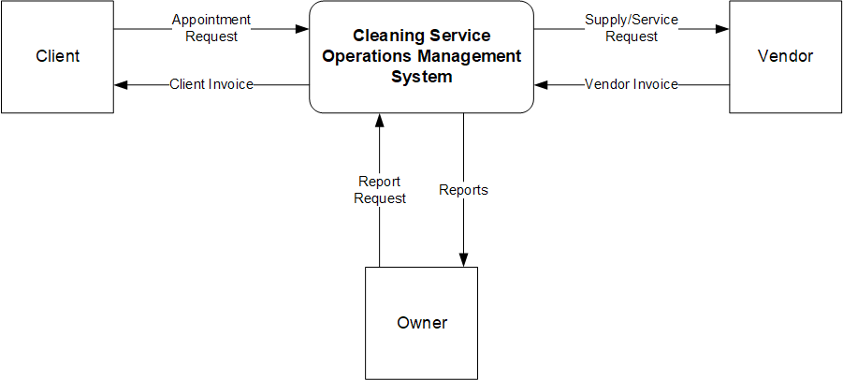

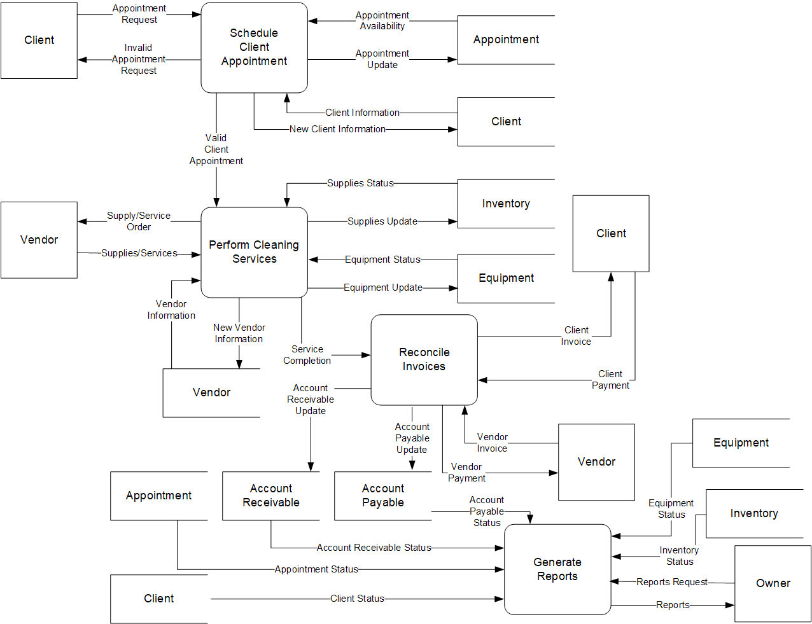

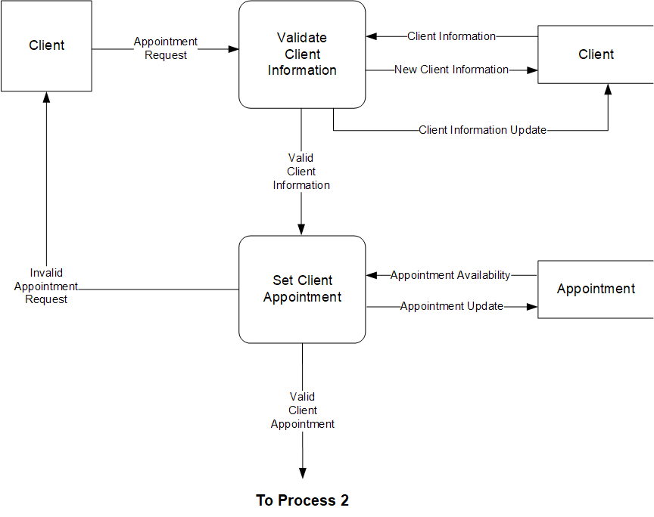

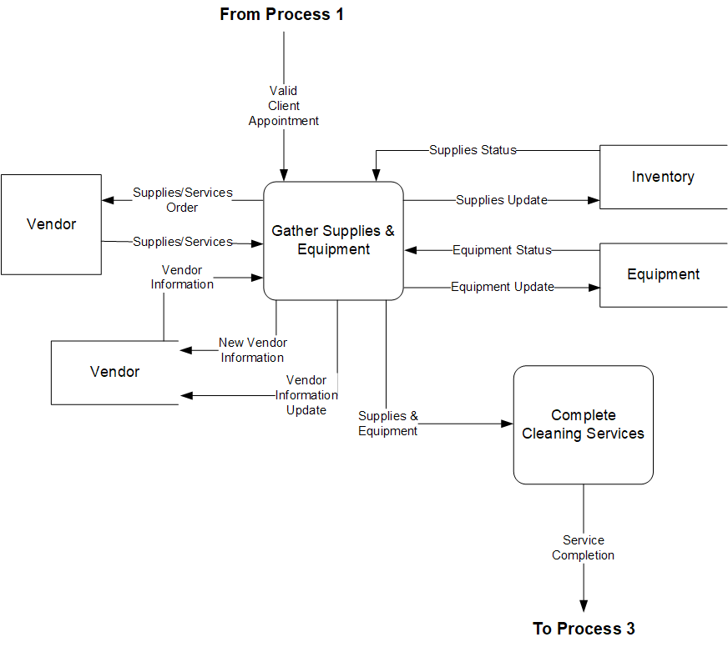

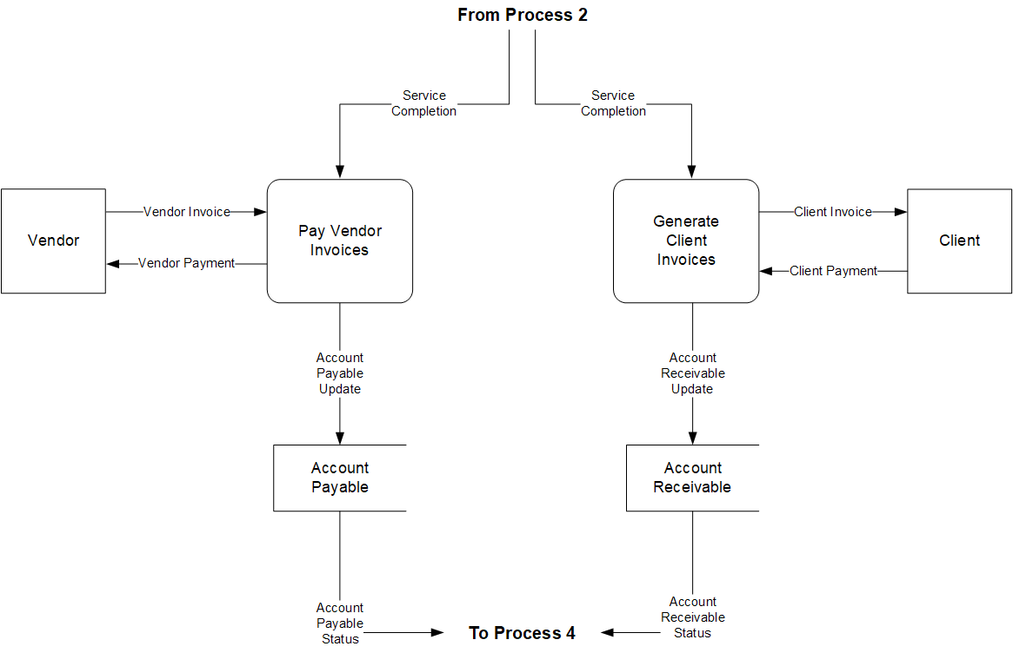

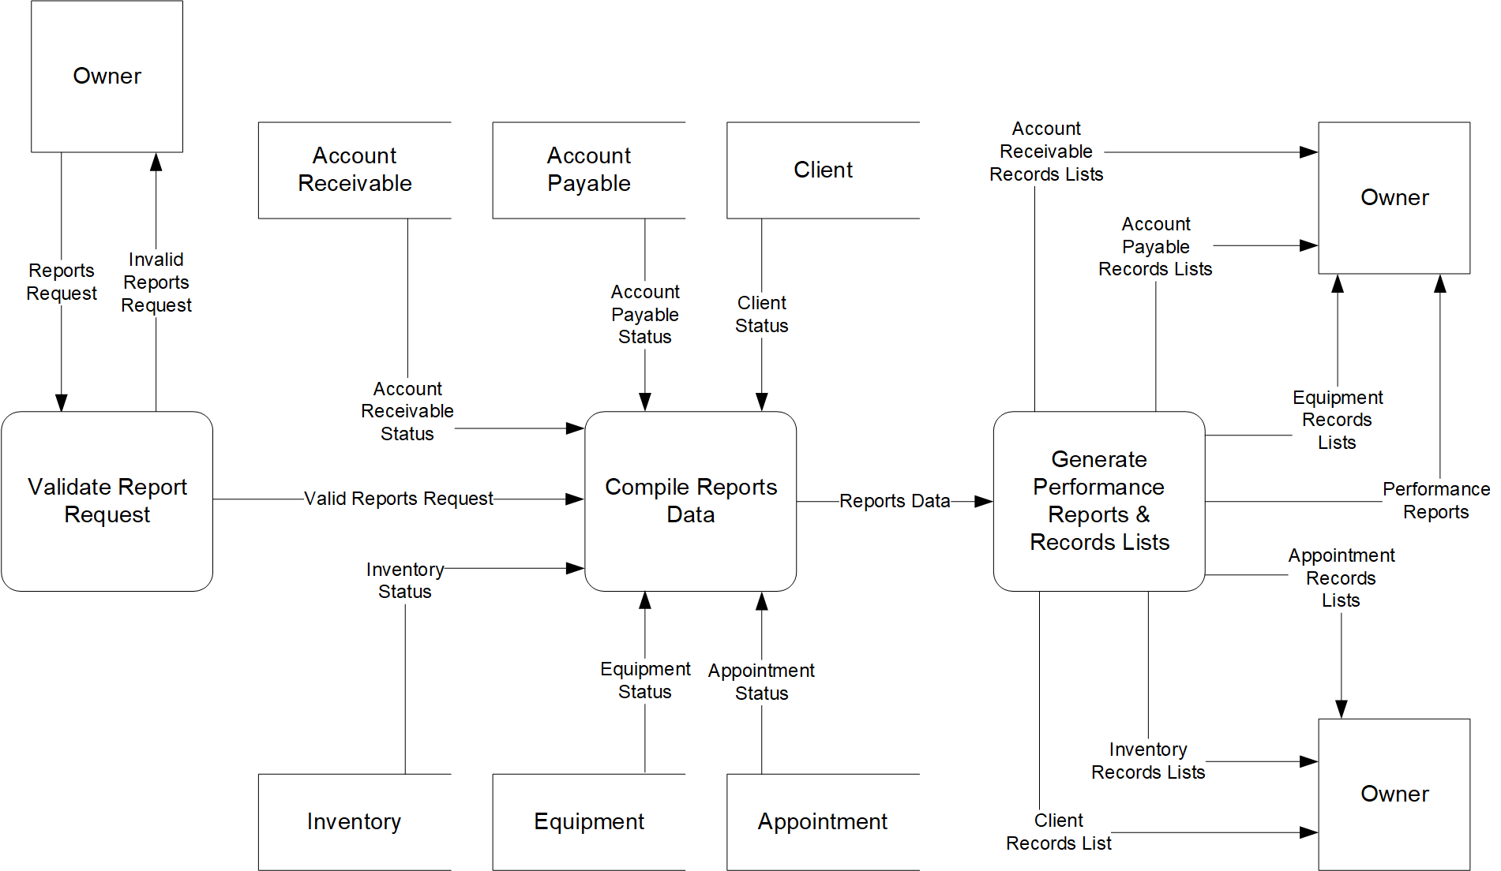

Appendix I: IDEFO Diagrams

IDEF0 Legend
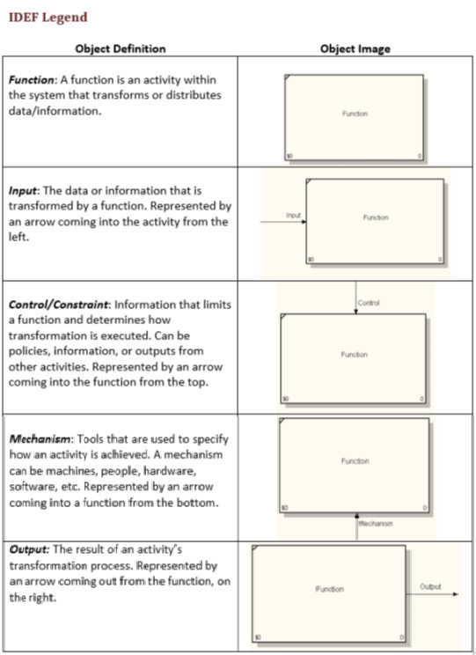
Definition Source: Dr. Leah Pietron

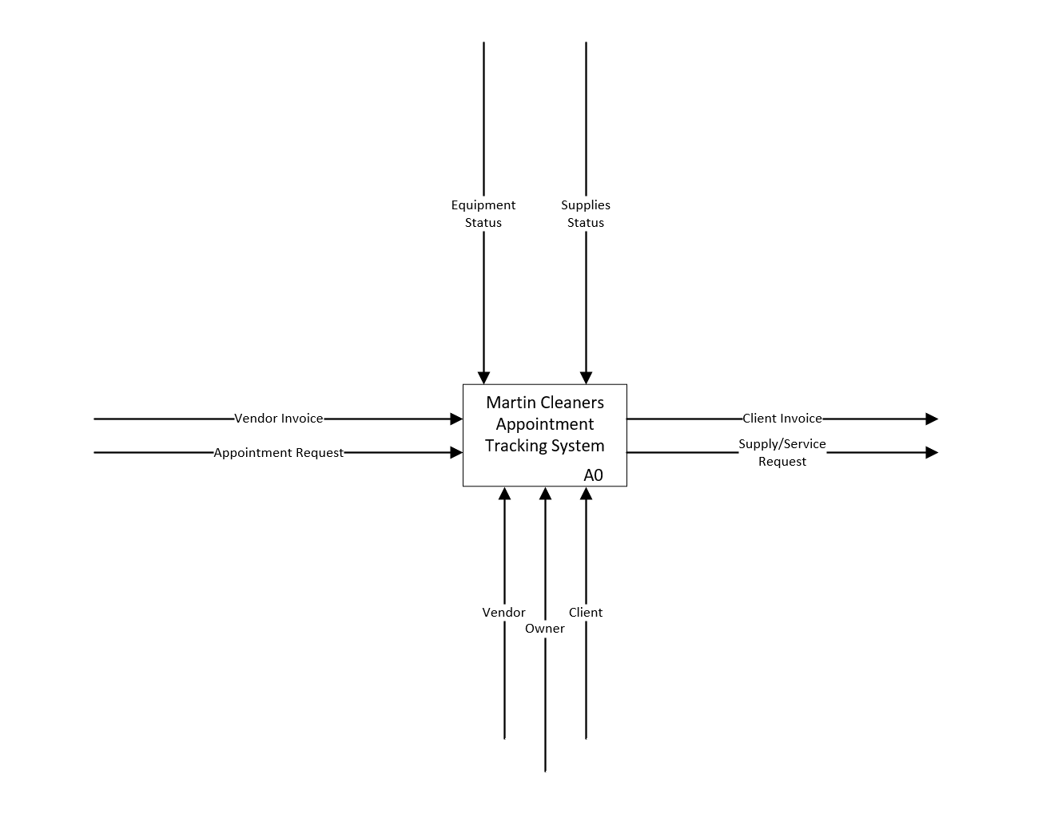
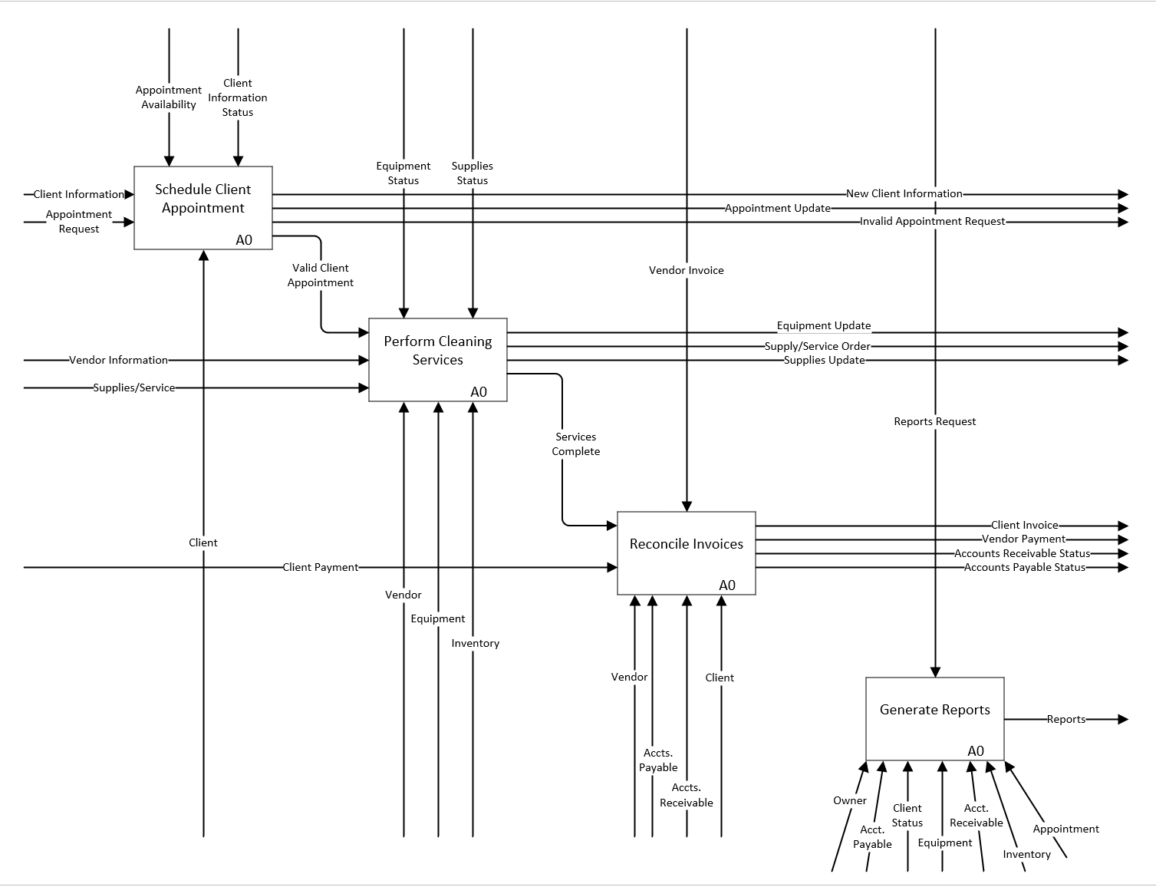

Appendix J: Use Case Diagrams

Use Case Legend
Definition Source: Dr. Leah Pietron

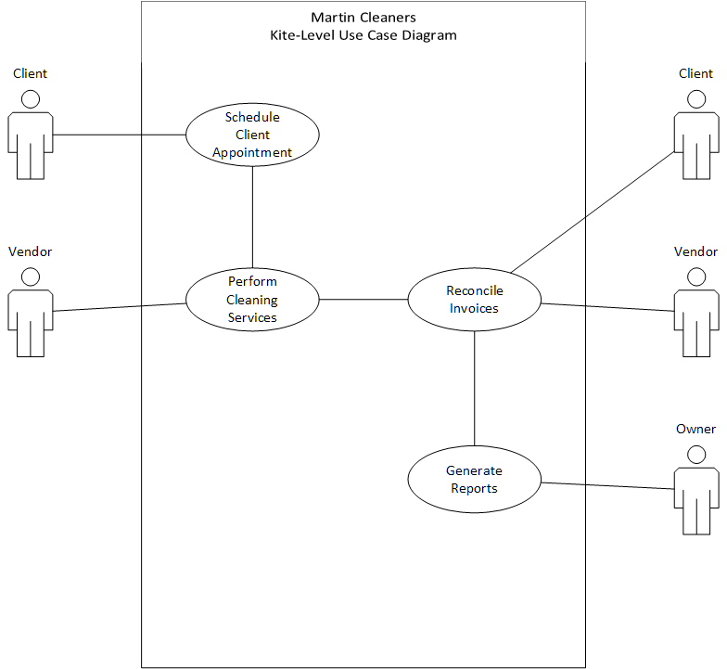
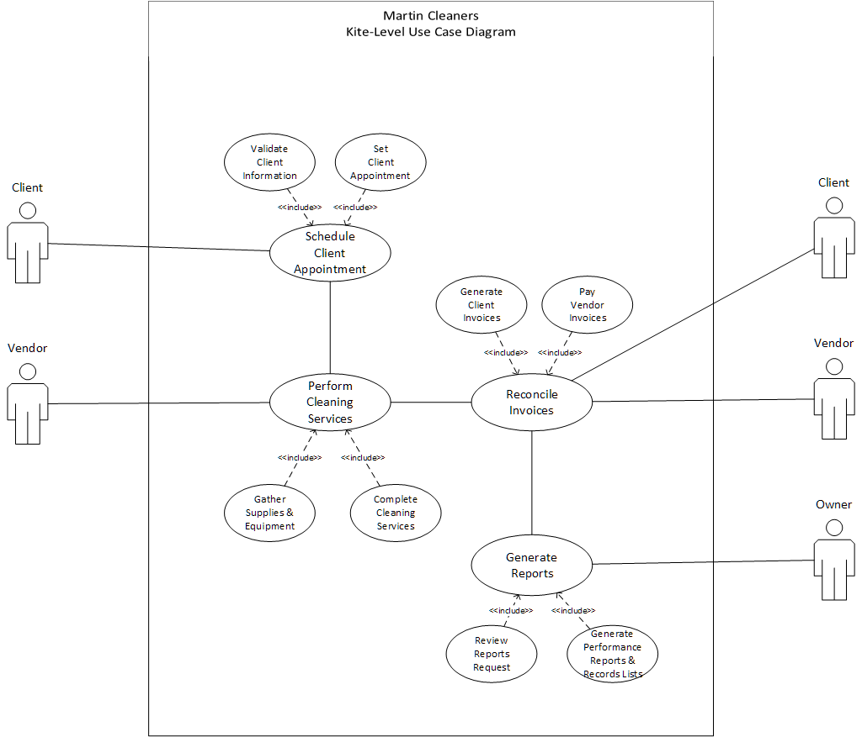

Martin Cleaners Database Management System
Use Case Description
Kite Level Descriptions:

Use Case Name | Schedule Client Appointments
Primary Actor | Client
Level | Kite
Stakeholders | Client
Preconditions | Client contacts Martin Cleaners.
Minimal Guarantees | Martin Cleaners receives the appointment request.
Success Guarantees | Martin Cleaners accepts the appointment request.
Trigger | Client schedules an appointment.
Main Success Scenario | - Client schedules an appointment.  - Martin Cleaners receives the appointment request  - Martin Cleaners accepts the request
Extensions | - Client is unable to contact Martin Cleaners  - Martin Cleaners denies the request

Use Case Name | Perform Cleaning Services
Primary Actor | Vendor
Level | Kite
Stakeholders | Vendor
Preconditions | Check if cleaning supplies are available.
Minimal Guarantees | Cleaning services performed.
Success Guarantees | Cleaning services adhered to client request.
Trigger | Cleaning services requested.
Main Success Scenario | - Check if cleaning suppliers are available.  - If cleaning supplies are available, perform cleaning services.  - Cleaning services performed adhere to what the client requested.
Extensions | - Supplies unavailable or out of stock.  - Cleanings services did not adhere to client request.

Use Case Name | Reconcile Invoices
Primary Actor | Client, Vendor
Level | Kite
Stakeholders | Client, Vendor
Preconditions | Cleaning services completed.
Minimal Guarantees | Invoices generated.
Success Guarantees | Invoices accurately generated and reconciled.
Trigger | Cleaning services performed.
Main Success Scenario | - Invoice for vendor is reconciled.  - Only if supplies were needed.  - Invoice for client is reconciled.
Extensions | - Mistake made when billing client  - Mistake made when tracking supplies

Use Case Name | Generate Reports
Primary Actor | Owner
Level | Kite
Stakeholders | Owner
Preconditions | Invoices have been reconciled.
Minimal Guarantees | Reports are generated.
Success Guarantees | Reports are accurate.
Trigger | Invoices have been reconciled and cleaning services have been performed.
Main Success Scenario | - Reports are generated based on services performed and supplies requested.  - Reports are generated accurately.
Extensions | - Reports are unable to be generated.  - Invoices and/or reports are inaccurate.

Sea Level Descriptions:

Use Case Name | Validate Client Information
Primary Actor | Client
Level | Sea
Stakeholders | Client
Preconditions | Client sends their information.
Minimal Guarantees | Client information is received.
Success Guarantees | Client information is validated.
Trigger | Client requests cleaning appointment.
Main Success Scenario | - Client requests cleaning appointment.  - Client sends information.  - Information is validated successfully.
Extensions | - Client information unable to be received.  - Client information inaccurate.  - Client information is not validated successfully.

Use Case Name | Set Client Appointment
Primary Actor | Client
Level | Sea
Stakeholders | Client
Preconditions | Client requests appointment.
Minimal Guarantees | Client appointment request received.
Success Guarantees | Client appointment approved.
Trigger | Client schedules an appointment.
Main Success Scenario | - Client requests appointment.  - Appointment is received and approved.
Extensions | - Appointment is denied.  - Client cancels appointment.

Use Case Name | Gather Supplies & Equipment
Primary Actor | Vendor
Level | Sea
Stakeholders | Vendor
Preconditions | Supplies are low or out.
Minimal Guarantees | Supplies are requested from vendor.
Success Guarantees | All the supplies and equipment needed are available.
Trigger | Client appointment is successfully set.
Main Success Scenario | - Supplies are requested and equipment is gathered.  - If supplies are low or out, request more.  - Supplies are successfully replenished.
Extensions | - Supplies out, unable to order more from vendor.  - Unable to gather equipment  - Equipment broken.

Use Case Name | Complete Cleaning Services
Primary Actor | Vendor
Level | Sea
Stakeholders | Vendor
Preconditions | Cleaning services performed.
Minimal Guarantees | Cleaning services will have been performed.
Success Guarantees | Cleaning services will have been performed to client standards.
Trigger | Client appointment set successfully, and cleaning services performed.
Main Success Scenario | - Cleaning service is performed  - Cleaning service meets client expectations.
Extensions | - Cleaning service does not meet client expectations.

Use Case Name | Generate Client Invoices
Primary Actor | Client, Vendor
Level | Sea
Stakeholders | Client, Vendor
Preconditions | Cleaning services performed successfully.
Minimal Guarantees | Client invoice is generated.
Success Guarantees | Client invoice is generated accurately.
Trigger | Cleaning services have been completed.
Main Success Scenario | - Client Invoice is generated  - Client invoice is accurate.
Extensions | - Client invoice is not generated.  - Client invoice is inaccurate.

Use Case Name | Pay Vendor Invoices
Primary Actor | Client, Vendor
Level | Sea
Stakeholders | Client, Vendor
Preconditions | Supplies or equipment were needed.
Minimal Guarantees | Vendor invoices are received.
Success Guarantees | Vendor invoices are paid successfully.
Trigger | Supplies or equipment were low before cleaning services were performed.
Main Success Scenario | - Supplies or equipment were ordered.  - Vendor invoice was received.  - Vendor invoice was paid successfully.
Extensions | - Vendor services weren’t needed.  - Vendor invoice wasn’t received.  - Vendor invoice couldn’t be paid.

Use Case Name | Review Reports Request
Primary Actor | Owner
Level | Sea
Stakeholders | Owner
Preconditions | Invoice for client generated and invoice from vendor received.
Minimal Guarantees | Reports are reviewed.
Success Guarantees | Reports successfully viewed.
Trigger | Cleaning services performed and supplies from vendor ordered.
Main Success Scenario | Reports are reviewed successfully.
Extensions | Reports are not reviewed.

Use Case Name | Generate Performance Reports & Records Lists
Primary Actor | Owner
Level | Sea
Stakeholders | Owner
Preconditions | Reports request reviewed.
Minimal Guarantees | Performance reports and records lists are generated.
Success Guarantees | Reports and records lists are generated successfully.
Trigger | Reports request reviewed.
Main Success Scenario | Performance reports and records lists are generated successfully.
Extensions | Performance reports and records lists are not generated successfully.

Appendix K: Legends

Martin Cleaners Database Management System
Legends

Data Flow Legend
Definition Source: Dr. Leah Pietron

IDEF0 Legend
Definition Source: Dr. Leah Pietron
Use Case Legend
Definition Source: Dr. Leah Pietron

Data Dictionary Legend
Definition Source: Dr. Leah Pietron

